Nonprofit Data Warehouse Quickstart with CDM- Deployment Guide

Step by step deployment and configuration guide for the Nonprofit Data Warehouse Quickstart with CDM solution

Reference Information

|  |  |  |  |
| --- | --- | --- | --- |
| Version | Type | Author | Date |
| 1.0 | Final | Microsoft | 22/01/2020 |
| 1.2 | Bug Update | Microsoft | 31/01/2022 |
|  |  |  |  |

**Contents**

1 Introduction 4

2 Deployment Checklist 5

2.1 Pre-deployment Steps 5

2.2 Deployment Steps 5

2.3 Post-deployment steps 6

3 How to deploy from GitHub 7

3.1 Prerequisites 7

3.1.1 Required Tools 7

3.1.2 Required licenses/accounts 8

3.1.3 Required pre-deployment steps 8

3.2 Deployment Process 18

3.2.1 Download the code 18

3.2.2 Orchestration Script 18

3.2.3 Configuring the Orchestration PowerShell script parameters 20

3.2.4 Running the Orchestration PowerShell script 23

3.2.5 Finishing deployment with post-deployment steps 24

3.3 Summary 28

4 How to execute the solution 29

4.1 Finding Solution Resources 29

4.1.1 How to find solution resources 29

4.1.2 How to find the solution orchestrator 31

4.2 Running the solution 33

4.2.1 How to manually execute the solution 33

4.2.2 How to configure Azure Data Factory Time Triggers 35

4.3 Logging & Monitoring 38

4.3.1 ADF in-built logging 38

4.3.2 Custom SQL Logging 39

4.4 Turning solution on/off 41

4.4.1 Enable/Disable the solution 41

5 How to add your own data 44

5.1 Ingestion: Moving data from Source Blob to Azure Data Lake Storage 44

5.1.1 Overview 44

5.1.2 How to upload files to the Blob Storage 44

5.1.3 How to configure Synapse Analytics 45

5.2 Transformation: Moving data from Azure Data Lake Storage to Synapse Analytics 47

5.2.1 Overview 47

5.2.2 How to configure Azure Data Lake Storage 47

5.2.3 How to create Synapse Analytics Objects 49

5.2.4 How to configure Synapse Analytics 56

5.2.5 Power BI Model 57

5.3 Summary 66

6 Power BI Dataflows and the Common Data Model 67

6.1 How to configure Dataflows and Azure Data Lake Storage integration 67

6.1.1 Connecting Azure Data Lake Storage for Dataflow storage 67

6.1.2 Configuring workspace Dataflow settings 70

6.2 How to map external data sources to a CDM entity using a Dataflow 73

6.3 How to add a CDM folder to Power BI as a Dataflow 79

6.4 How to connect to Dataflows in Power BI Desktop 83

7 FAQ’s 85

7.1 Resolving Issues 85

7.1.1 What are the most common execution issues 85

7.1.2 How to reset the solution to the original state 87

7.2 Data Refresh 88

7.2.1 How to refresh Power BI report with fresh data 88

7.3 Removing Solution Resources 90

7.3.1 How to remove the solution from the Azure Portal 90

7.4 Costs 91

7.4.1 What are the average running costs 91

7.4.2 How to minimize running costs 91

7.5 Accessing Azure Resources 92

7.5.1 How to connect to Synapse Analytics 92

7.5.2 How to obtain secrets from Key Vault 93

7.6 Summary 95

# Introduction

The Nonprofit Data Warehouse Quickstart meets nonprofits where they’re at in their data journey, providing them with simple tools built on industry best practices to transform completely disparate data sources. By aggregating data, nonprofits can connect dots that have previously been difficult to trace when comparing data for specific projects or analyzing trends across the organization.

Nonprofit Data Warehouse Quickstart is a pre-packaged “one-click” Azure-based warehousing deployment designed to help nonprofits quickly and easily set up a sample data architecture from a representative sample data files.

This “one-click” deployment enables nonprofit data managers to get familiar with Azure architecture and run sample files through the solution to see each component (E.G. Azure Data Lake, Synapse Analytics) in action. Users’ own data can then be added to form the foundation of their own Data Analytics solution.

This solution uses PowerShell and Azure Resource Manager (ARM) at its core. Following initial configuration, pre-built PowerShell scripts can be utilised to deploy each of the required Azure resources, and deploy sample files and the code base to the solution.

This document is designed to provide a step-by-step guide on how to deploy the Nonprofit Data Warehouse Quickstart from GitHub, configure the components, and execute the solution.

For a technical overview of the architecture and the purpose of each resource used within this solution, please see the Nonprofit Data Warehouse Quickstart – Technical Overview document.

The remainder of this document contains the following sections:

* Deployment checklist
* How to deploy from GitHub
* Execute the solution
* How to add your own data
* Power BI Dataflows and the Common Data Model
* FAQ’s

# Deployment Checklist

The list below summarises each step that needs to be carried out in order to deploy the solution. For further details on each step please refer to the “Reference Section” in this document.

## Pre-deployment Steps

|  |  |  |  |  |
| --- | --- | --- | --- | --- |
| Step | Activity | Deployment Software | Reference Section | Complete?  (Yes/No) |
| 1 | Download and Install prerequisites tools. | Installation | 3.1.1 |  |
| 2 | Configure PowerShell. | PowerShell Console (Admin) | 3.1.3.1 |  |
| 2.1 | Set the execution policy to be unrestricted. ‘Set-ExecutionPolicy unrestricted -Scope LocalMachine -Force’. | PowerShell Console (Admin) | 3.1.3.1 |  |
| 2.2 | Install the “AzureRM” PowerShell modules.  ‘Install-Module AzureRm -AllowClobber -Force -Scope LocalMachine’. | PowerShell Console (Admin) | 3.1.3.1 |  |
| 3 | Create two AAD groups, one for admins and one for developers, with appropriate names. | Azure Portal | 3.1.3.2 |  |
| 4 | Create a resource group, providing an appropriate name and assigning tags and permissions. | Azure Portal | 3.1.3.2 |  |
| 4.1 | Create Resource Group. | Azure Portal | 3.1.3.2 |  |
| 4.2 | Assign the admin AAD group to have “Owner” role permissions, within the resource group’s ‘Access control (IAM)’. | Azure Portal | 3.1.3.3 |  |
| 4.3 | Assign the developer AAD group to have “Contributor” role permissions, within the resource group’s ‘Access control (IAM)’ settings. | Azure Portal | 3.1.3.3 |  |

## Deployment Steps

|  |  |  |  |  |
| --- | --- | --- | --- | --- |
| Step | Activity | Deployment Software | Reference Section | Complete?  (Yes/No) |
| 1 | Download the code from the Nonprofit Data Warehouse GitHub [repository](https://github.com/microsoft/nonprofits) to the local machine. | GitHub | 3.2.1 |  |
| 2 | Deploy Solution Resources and Configuration. |  | 3.2.2 |  |
| 2.1 | Open the “DeployOrchestrator.ps1” PowerShell script and configure parameters if necessary. Ensure that execution context and path in the PowerShell ISE execution log matches the solution’s folder location. | PowerShell ISE | 3.2.2 |  |
| 2.3 | Obtain the Azure Subscription ID from Azure Portal and query External IP Address with a search enging on choice. | Internet Browser/Azure Portal | 3.2.3 |  |
| 2.4 | Execute Script (F5) and provide the mandatory parameters when requested:   * Azure Subscription ID ($SubscriptionId), * IP Address ($OrganisationPublicIPAddress) * Project name ($Project). | PowerShell ISE | 3.2.3 |  |
| 2.5 | Login to Azure Portal by providing the Azure credentials to the new PowerShell Script’s Login window. | PowerShell ISE | 3.2.4 |  |
| 2.6 | When PowerShell execution is finished check if there were any errors in ISE execution log. | PowerShell ISE | 3.2.4 |  |

## Post-deployment steps

|  |  |  |  |  |
| --- | --- | --- | --- | --- |
| Step | Activity | Deployment Software | Reference Section | Complete?  (Yes/No) |
| 1 | Connect to the Synapse Analytics data warehouse, using the credentials stored in the Key Vault resource. | SSMS/Azure Portal | 3.2.5.1 |  |
| 2 | Open the post deployment scripts that can be found in the location ‘/Warehouse/Project/Scripts/PostDeployment’. These scripts are named:   1. Control.CurationStage.Populate 2. Control.Entity.Populate 3. Control.PipelineStatusType.Populate 4. Control.SourceSystem.Populate. | Visual Studio | 3.2.5.1 |  |
| 3 | Run each SQL script as a query against the data warehouse. Confirm that the appropriate objects have been populated thereafter. The objects are named:   1. Control.CurationStage 2. Control.Entity 3. Control.PipelineStatusType 4. Control.SourceSystem. | SSMS | 3.2.5.1 |  |
| 4 | Open the Azure Data Factory resource in the Azure portal, and then select ‘Author & Monitor’ to open the ADF solution. | Azure Portal | 3.2.5.2 |  |
| 5 | Change the ‘KeyVaultName’ variable in the ‘PL_ChangeSynapseAnalyticsState’ pipeline to the name of the resource group’s Key Vault. Publish the changes. | Visual Studio/PowerShell ISE | 3.2.5.2 |  |
| 6 | Create a new workspace within Power BI, providing an appropriate name and description. | Power BI Portal | 3.2.5.3 |  |
| 7 | Open the Power BI report from the solution, found within the ‘PowerBI’ folder. Publish the report to the workspace. | Power BI Desktop | 3.2.5.3 |  |
| 8 | Set the access policy to the report within the workspace. Users can be added individually by email address, or by using the AAD groups created. | Power BI Portal | 3.2.5.3 |  |

The following sections detail each step in the checklists above and give a click by click description of each step with helpful tips or changes that can be made, where required.

# How to deploy from GitHub

Nonprofit Data Warehouse Quickstart is built utilising Azure Resources. As a first step, these resources need to be deployed to your organisation’s Azure Tenant and appropriately configured. There are deployment scripts available that automate the majority of this process, but a release manager is still required to prepare your Azure Tenant for the configuration and execution of scripts according to your organisation’s operations. This section outlines everything that is required for a successful Nonprofit Data Warehouse deployment.

The remainder of this section is broken down into the following subsections:

* Prerequisites
* Deployment Process and Configuration

## Prerequisites

The deployment process requires the following list of tools to be installed. Following these steps will ensure that the environment is setup and ready for deployment to begin.

### Required Tools

The solution requires a set of tools to be installed on the machine where scripts are executed, as listed in the table below. It is recommended to use the versions specified.

|  |  |  |  |
| --- | --- | --- | --- |
| Tool | Stage | Version | Description |
| Sql Server Management Studio (SSMS) | Deployment | Latest Version | Required for the connection to the database and execution of the post deployment scripts |
| .NET Framework | Deployment | Latest Version | Required for the deployment of the SQL |
| PowerShell | Deployment | V 5.0 | Required for the orchestration of the deployment process. In Windows 10, the ISE console comes with correct version of PowerShell. In older operational systems, an update of PowerShell may be required |
| AzureRM PowerShell Modules | Deployment | Latest Version | Required for the deployment |
| Power BI Desktop | Development/Presentation | Latest Version | Opening and deploying reports to Power BI Portal |
| Visual Studio / Visual Studio Code | Development | 2019 | Required to open and modify and enhance the solution *Visual Studio Code will allow users to open/edit all files but does not support the project configuration files for Synapse Analytics. |

### Required licenses/accounts

The deployment process requires access to accounts for the following services:

1. On the Local Machine
   1. Administrator rights to install tools
   2. Access to PowerShell Administrator Console
2. Within the [Microsoft Azure](https://azure.microsoft.com/) tenant
   1. Azure Release Manager with permissions defined below
      1. Access to Subscription
      2. Owner on Subscription/Resource Group where solution will be deployed
      3. Active Directory Admin - Create AAD Groups and assign their members (this can be delegated to IT Security Department if required)
3. Within the [Power BI](https://www.microsoft.com/en-us/nonprofits/power-bi) tenant
4. Power BI Pro License – required to publish to PowerBI Portal, with permission to create Power BI workspaces

Note: If you do not currently have a Power BI Pro license, you can start a free trial [here](https://signup.microsoft.com/signup?sku=a403ebcc-fae0-4ca2-8c8c-7a907fd6c235&email=&ru=https%3A%2F%2Fapp.powerbi.com%3Fpbi_source%3Dweb%26redirectedFromSignup%3D1%26noSignUpCheck%3D1).

For full use of the Common Data Model and integration with the Common Data Service a Power Apps license is required (or the use of Microsoft Dynamics), see [here](https://powerapps.microsoft.com/en-us/pricing/) for details. Note, the Common Data Model light approach used in this solution does not require a license.

### Required pre-deployment steps

Before executing the deployment script, the steps described below should be carried out:

1. Install all tools described in “Required Tools”
2. Configure PowerShell
3. Make required registry change to allow for Legacy Path Handling
4. Make sure the Release manager has access to Azure Tenant, as described in “Required licenses/accounts”
5. Create Azure Active Directory (AAD) Groups
6. Assign Release Manager to Admin Group
7. Create a Resource Group
8. Assign AAD Groups to Resource Group

#### Configuring PowerShell

The PowerShell orchestration script will require the installation of certain modules and the configuration of the execution policy for the local machine. This module will contain description of the steps that would make PowerShell ready for the deployment.

###### Execution Policy

PowerShell will not be able to execute scripts and install modules if the PowerShell execution policy is not configured on the local machine where scripts are executed.

To configure the execution policy on PowerShell, follow the steps below:

1. Open the PowerShell console as an admin, by right clicking on the Windows Start button and then choosing ‘Windows PowerShell (Admin)’. If this option is not available, right click on PowerShell and choose the option ‘Run as Administrator’.

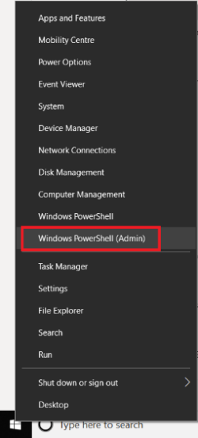

1. In the PowerShell Console, enter “Set-ExecutionPolicy unrestricted -Scope AllUsers -Force”. This code should also work with PowerShell ISE console, when executed as an administrator.



1. The setting of the execution policy will have been successful if there is no output from the command. A red error message will appear if there’s a failure.
2. Close the admin console.

If the Execution Policy is configured correctly, the ability to install the required modules will be enabled.

###### PowerShell Modules

As the AzureRM modules for PowerShell are being depreicated, the Data Warehouse Quickstart code deployments scripts have been updated to use the Az modules as this is the current Azure modules.

PowerShell will require the Azure “Az” modules to be installed. These modules allow PowerShell to create resources and configure resources in Azure Tenant.

This can be achieved by following the below steps:

1. Open the PowerShell Console as administrator.
2. In the PowerShell Console, enter “Install-Module -Name Az -Repository PSGallery -AllowClobber -Force -Scope AllUsers”. This may take a few moments to run, but installation progress will be displayed during the execution.

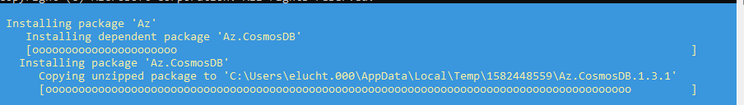

1. When the console displays an empty line and no error, installation will have been successful.

PowerShell also needs to be able to read Legacy Paths in the OS to provide copy of the source files to Azure. The following needs to be run from PowerShell to add a registry key.

$registryPath = "HKLM:\SOFTWARE\Microsoft\.NETFramework\AppContext"

New-Item -Path $registryPath

New-ItemProperty -Path $registryPath -Name "Switch.System.IO.UseLegacyPathHandling" -Value "false"

PowerShell then needs to be restarted.

After successful installation of the module, configuration of the PowerShell is finished.

#### Creating AAD groups and assigning Members

Release Managers and Developers will require access to the resources in Azure. Access to the resources are controlled via Azure Active Directory (AAD) Groups. Deployment scripts will assign these AAD groups to the Azure resources during the deployment process. The script does not create the AAD Groups, therefore the Groups need to be created beforehand. The following section provides and overview of what AAD Groups are and how to set them up.

##### Overview

**Groups**

There are two Azure Active Directory (AAD) groups required

| Access Level | AAD Group Name | Description |
| --- | --- | --- |
| Admin | AAD-GRP-MSTSIDH-DEV-ADMIN | Allows universal management, including access to the resources |
| Developer | AAD-GRP-MSTSIDH-DEV-DEVELOPER | Allows universal management, excluding access to the resources |

**Naming Convention**

Names should be descriptive enough to allow easy identification of a group by name, for example:

* Pattern: AAD-GRP-{proj}-{env}-{AccessLevel}
* Group Example: AAD-GRP-MSTSIDH-DEV-ADMIN

**AAD** – defines that Group is an Azure Active Directory object

**GRP** – defines that this is a group

**MSTSIDH** – defines the project name (this should be updated according to the project name)

**DEV** – defines the environment

**ADMIN/DEVELOPER** – defines the type of the group

Each organisation may require a different naming convention. Adjust the names accordingly and take off the names as they will be required to update the master orchestration PowerShell Script.

##### AAD groups

Creation of Azure Active Directory (AAD) Groups requires administrative rights on Azure Active Directory (AAD). Depending on the individual organisation’s policy, this step may need to be delegated to the IT department. Groups can be created by following the steps below:

1. Login to Azure Portal using the following [link](https://azure.microsoft.com/).
2. Navigate to Azure Active Directory (AAD).

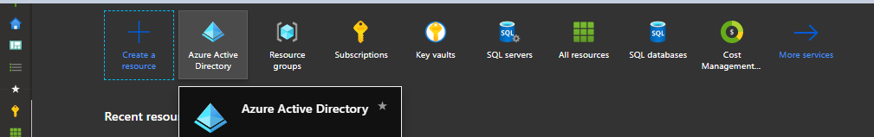

1. Choose Groups on the AAD Navigation Panel.

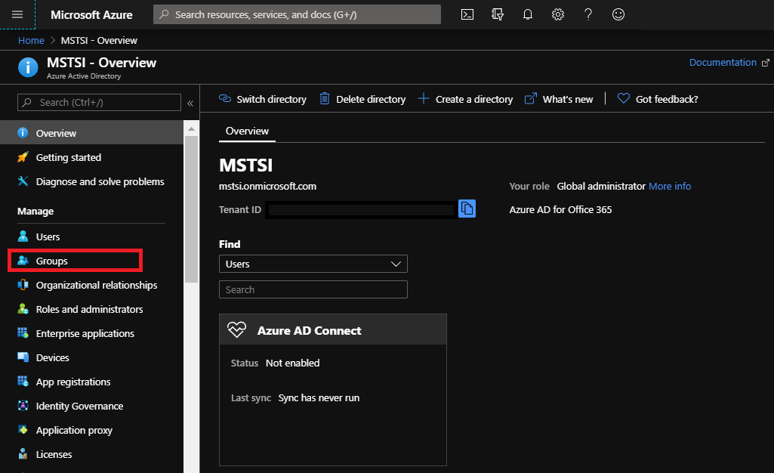

1. Click “+ New Group” button on the top panel.

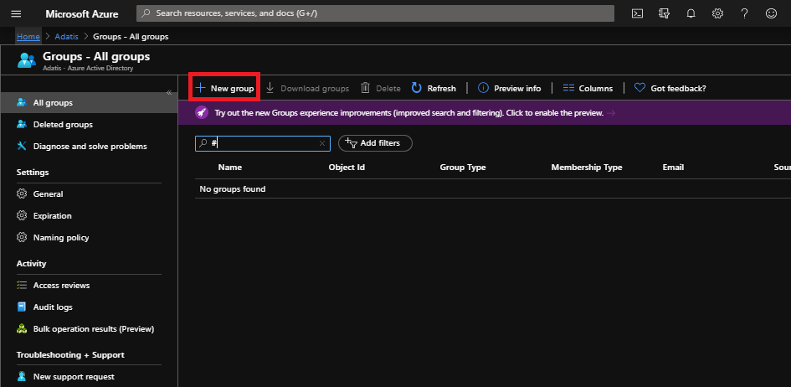

1. Fill in the details for Group Name, Owner and Members. At a very minimum, the Owner and Member should be the account used to logon to the Portal. Click “Create”.
2. Check if the group has been successfully created by verifying the AAD All Groups panel and providing the name in the text box filter
3. This whole process needs to be repeated for Developer Group

When both groups are successfully created and all required users assigned to them, the AAD tab can be closed.

**PowerShell Script –** User can execute the ‘Create-AADGroup.ps1’ PowerShell Script included in the solution, instead of manually creating the AAD groups. The Release Manager that executes the script requires Azure Active Directory admin rights (Create AAD Groups/Add users to AAD Groups). The process to run the script is as follows:

1. Open the Create/Deployment/Scripts/Create-AADGroup.ps1 Powershell script with ISE Console (double click)
2. Modify the parameter values in the parameter section at the top of the script according to the naming convention required for resource groups.

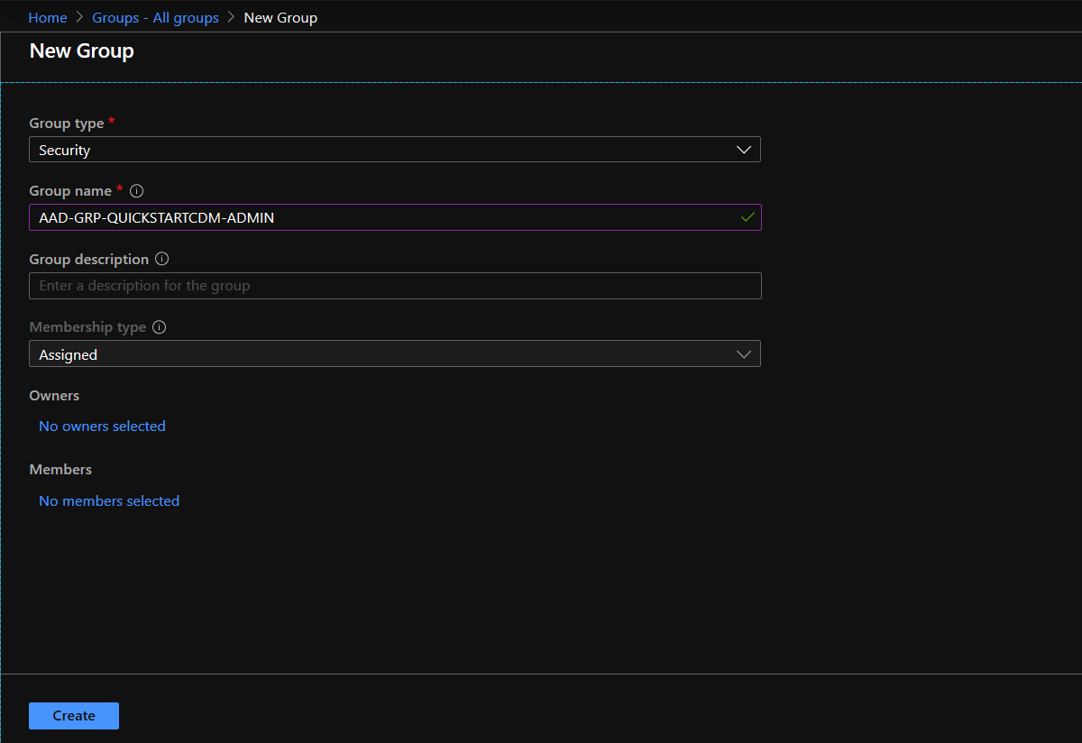

1. Execute the script in the ISE Console by clicking “play” or by using the F5 key

#### Creating Resource Groups and assigning AAD Groups

The solution requires a Resource Group to be created in the Azure Portal Subscription to act as the logical grouping container for the other resources. All resources will be deployed to this Resource Group.

##### Resource Groups

To create the Resource Group (RG), follow the below steps:

1. Login to the Azure Portal using any browser by following this [link](https://azure.microsoft.com/).
2. Navigate to the Resource Group Tab, and click the “+ Create” button.

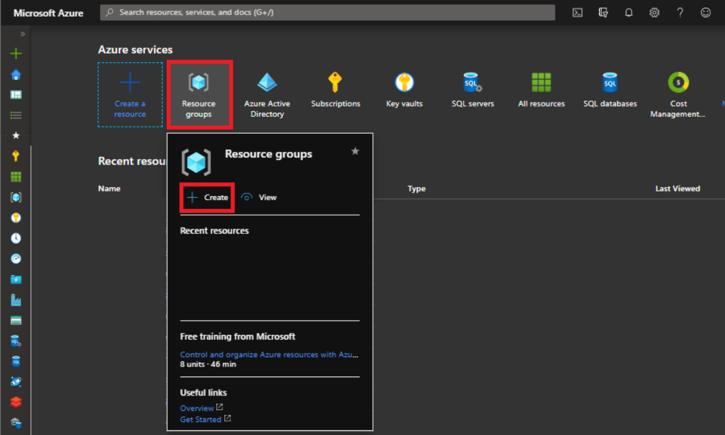

1. Choose a Subscription, provide a Resource Group name, and choose a location from the list. The name should follow the naming convention specific to your organisation. More information about available locations can be found [here](https://azure.microsoft.com/en-gb/global-infrastructure/geographies/)).

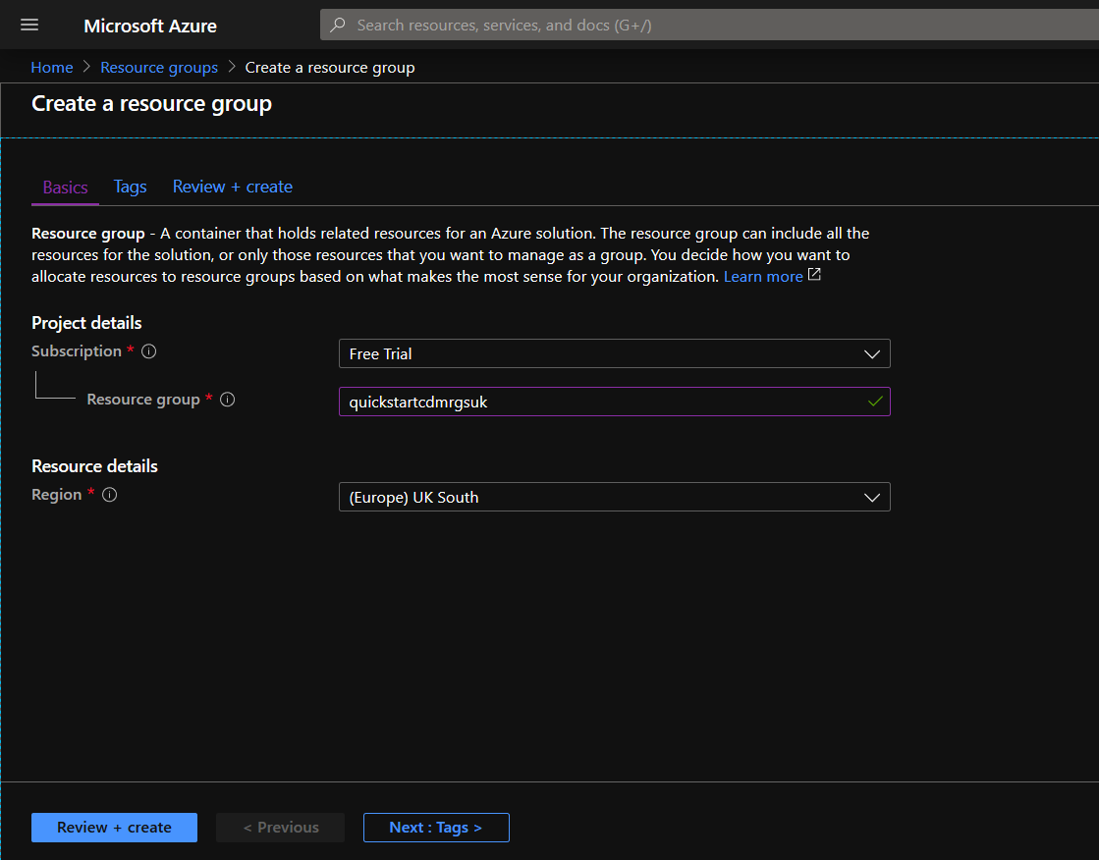

1. Click on “Next: Tags >” button on the bottom of the page to navigate to the “Tags” Tab – this section allows additional metadata such as Environment, Project Name and Owner to be added to the resource group. Some organisations require tagging of all the resources as this can be beneficial during Azure Cost Analysis. Adding tags is a good practice, however, if not required, this point can be skipped.

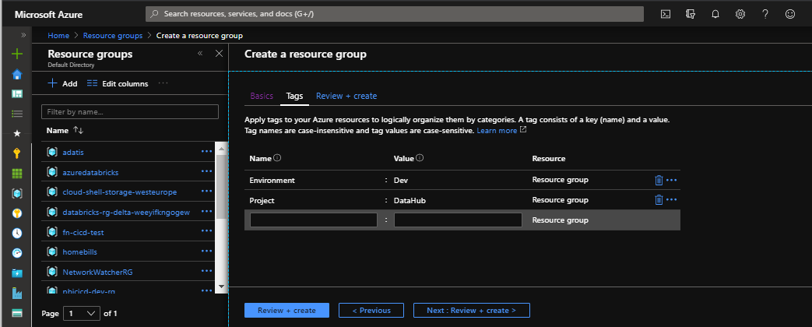

1. Click the “Review + create”– this will open the summary tab and display the provided parameters and any validation message. If there are validation errors, go back to the Basics tab and fix the errors.

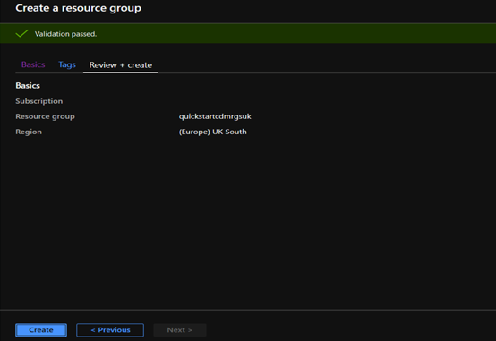

1. Click the “Create” button – After this button is clicked, a request will be sent to the Portal to create the Resource Group. It may take a moment to create the resource. A successful creation should be visible within the Azure notification panel (bell icon) on the top right corner of Azure Portal.

##### AAD Groups

The Resource Group is where permissions for the Azure Active Directory (AAD) groups, as created in the previous step, must be assigned. This is the recommended way to provide permissions to developers and admins, allowing them to manage resources created in the resource group in later steps.

###### AAD Resource Group Access

Solution requires the access described below:

| Group | Role Permissions | Description |
| --- | --- | --- |
| Admin e.g.  AAD-GRP-MSTSIDH-DEV-ADMIN | Owner | Allows universal management of resources including permissions to the resources |
| Developer e.g.  AAD-GRP-MSTSIDH-DEV-DEVELOPER | Contributor | Allows management of resources excluding permissions to the resources |

To assign Azure Active Directory groups to the Resource Group, follow the process described below. Release Manager should use AAD Groups created as part of pre-release steps.

1. Login to Azure Portal
2. Navigate to the Resource Group tab from the Azure Portal

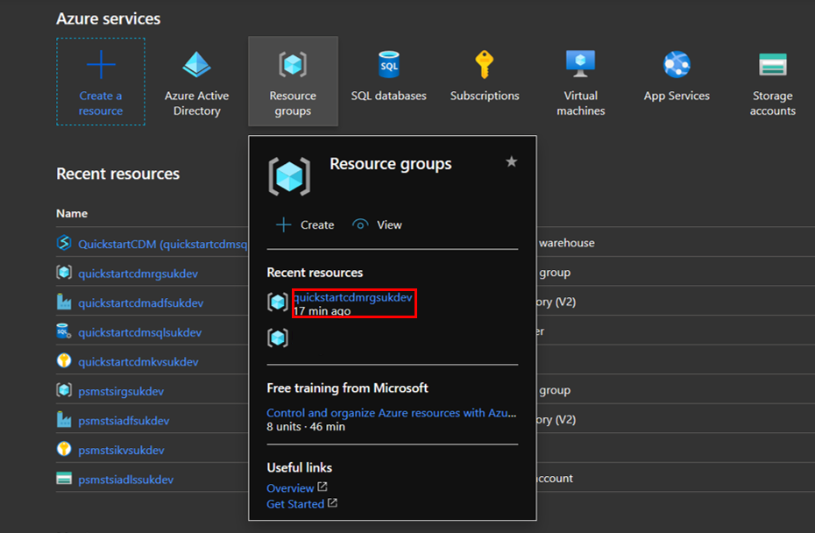

1. Select the required resource group from the menu, and then select “Access Control (IAM)” from the sidebar presented. This is the area that allows permissions to be assigned to the AAD Groups.

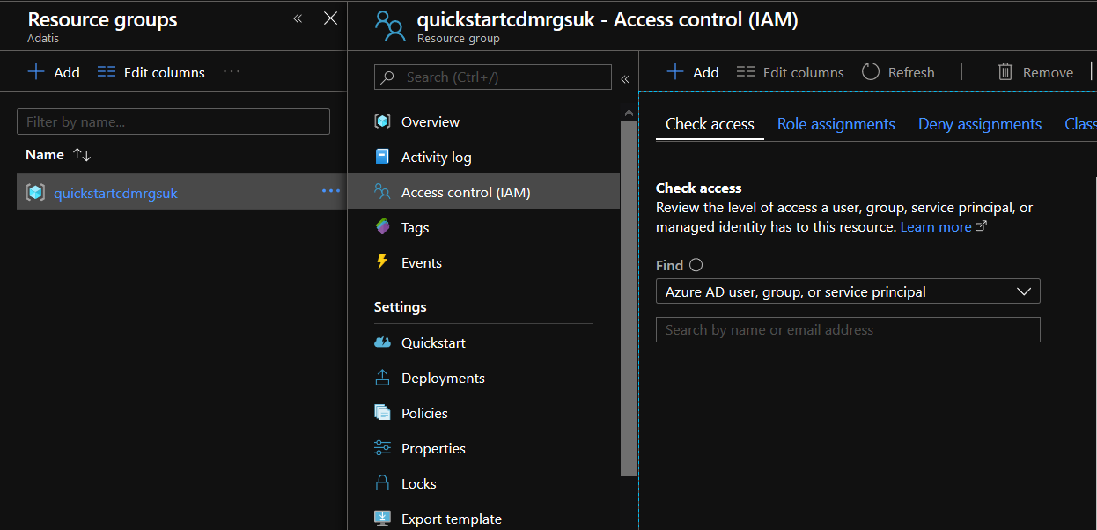

1. Click the ‘Add’ button, and then select ‘Add role assignment’.

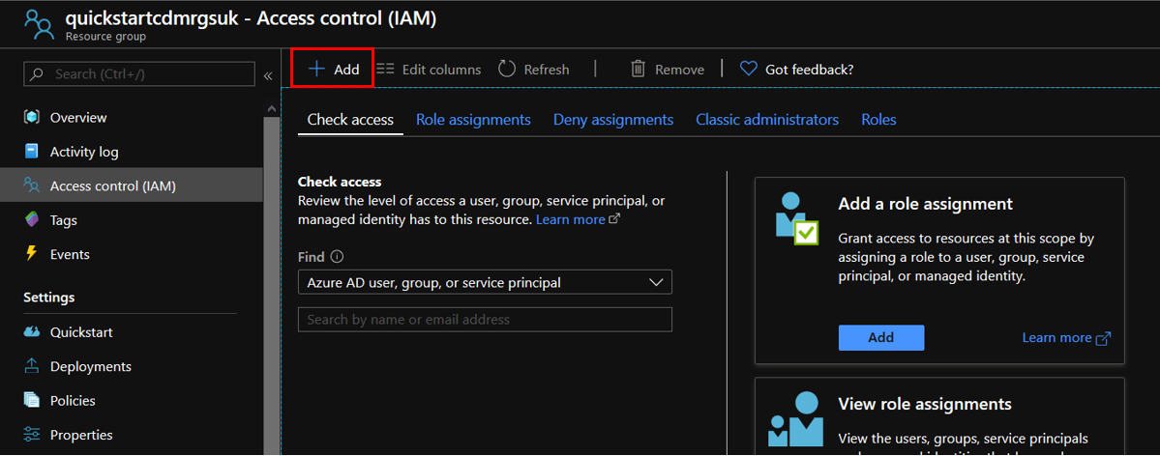

1. Select the role required for the AAD Group to be assigned. This step may require one user to be added at a time. For the developer group, select ‘Contributor’. For the Admin group select ‘Owner’. For the ‘Assign access to’ option, select ‘Azure AD user, group or service principal’, and then provide group name to search text box, to find the user in AAD. Left click on the user found and left click on save button to complete the assignment.
2. Check that the groups have been assigned by checking the Role Assignment Tab.

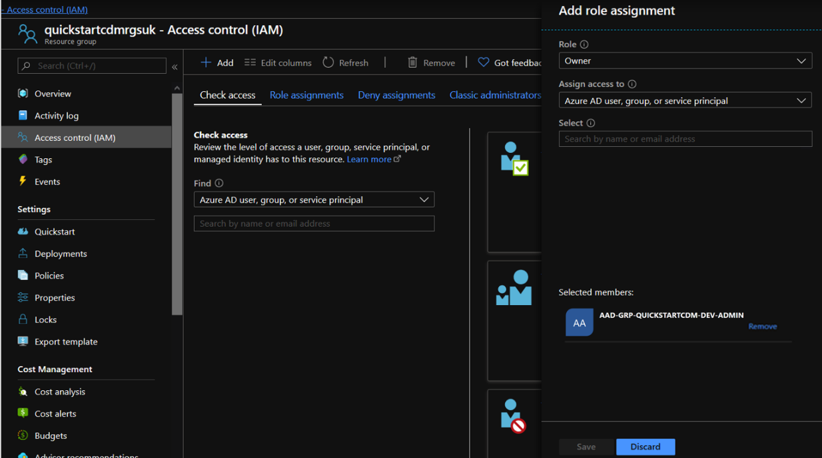

## Deployment Process

The deployment process ensures all resources are created and fully configured, the solution is fully operational and ready for execution.

High level steps required for successful deployment and configuration of the platform are listed below:

1. Download the code
2. Follow the pre-deployment steps to get the required software
3. Configure the deployment parameters
4. Execute the deployment
5. Execute the post-deployment steps

These steps are outlined in detail in the following sections.

### Download the code

Deployment of the solution requires a host for the execution of the scripts. It is therefore required to download the solution from GitHub to a local machine.

Permission requirements for the release manager have been described in the section “2.a

It is recommended to have the solution stored on the local file system as described:

1. Navigate to the “C:/” drive and create a sub folder named “src”.
2. In “src” create a project subfolder called “NonprofitDataWarehouseQuickstart”
3. Navigate to GitHub using the following [link](https://github.com/microsoft/nonprofits) and download the solution code to the project folder from the previous step - C:/src/MSTSIDH.
4. When the code is downloaded, it should look like the figure below.

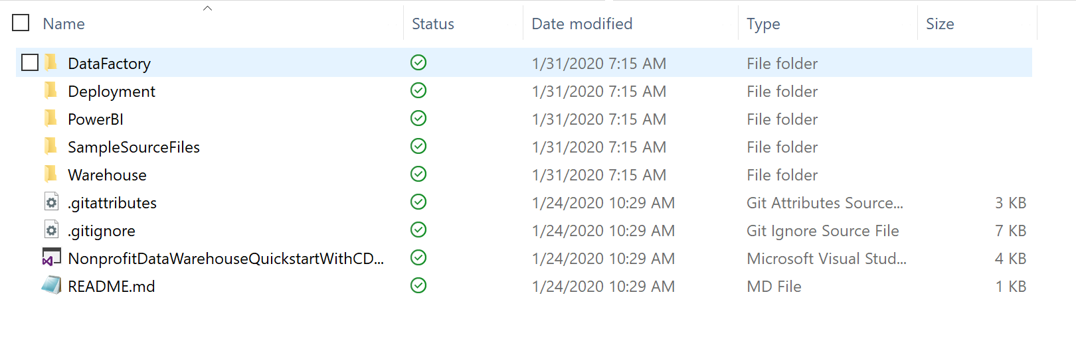

### Orchestration Script

The deployment process is orchestrated via the main PowerShell Script called DeployOrchestrator. This script is responsible for the deployment of the solution’s infrastructure, and for applying the majority of the required configuration. The script is a single entry point that orchestrates the child PowerShell (PS1) scripts. The release manager should only execute the parent orchestration script, avoiding execution of the child PowerShell scripts. The script is located in the solution’s Deployment folder, as shown in the example below:

***{solutionRoot}/Deployment/DeployOrchestrator.ps1***

If the solution was downloaded as recommended in the “Download the code” section, then the path to the script is as follows:

***C:/src/NonprofitDataWarehouseQuickstart/Deployment/DeployOrchestrator.ps1***

To open the script, navigate to the VisualStudio solution explorer. Right click on the script and then choose option “Open With…”. 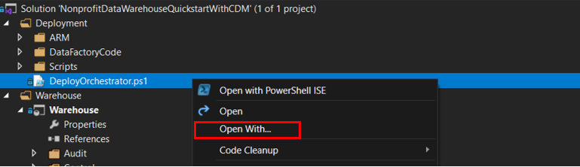

When the new window pops up, select “Windows PowerShell ISE” and “Set Default”, and then click the “OK” button.

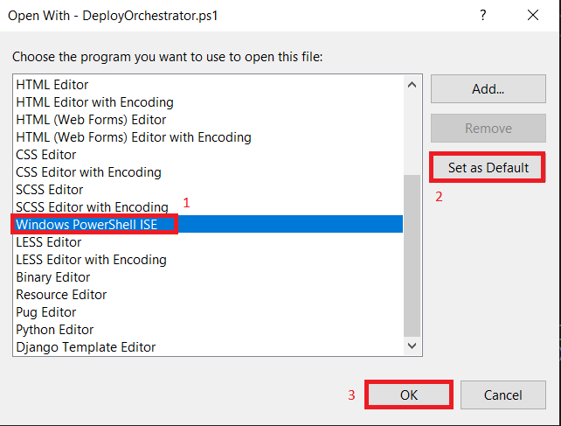

A new PowerShell ISE window will open, as shown below. The path displayed in the Execution Log should match the path of where the solution was downloaded. If not, use bash commands (cd.. , cd folder) to navigate to the correct location.

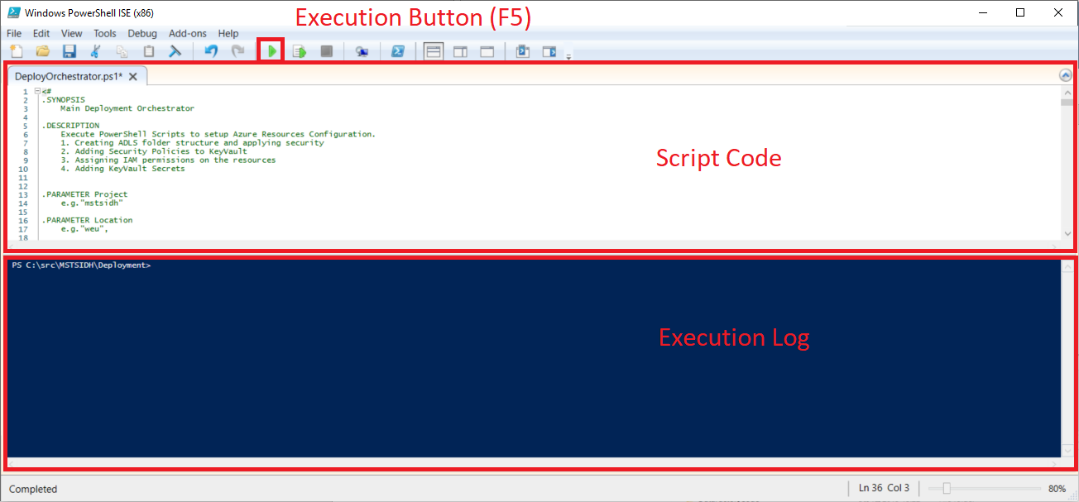

### Configuring the Orchestration PowerShell script parameters

The name of all resources (except the database name) used in the solution must be globally unique. The script will ask for three mandatory parameters during the execution (SubscriptionId, OrganisationPublicIPAddress, and Project). The Project Name provided must make names of the resources globally unique, not only unique within the organisation. This has been described in detail, in the next section:

If more control regarding the naming convention is required then there are two places in the script where parameters can be updated:

1. Parameters section (param)
2. Naming Configuration Setup

If the naming convention defined in the Orchestrator script is satisfactory, no modification will be required to the script. This section would provide all the details about the parameter configuration in the deployment script.

#### Parameters Overview

The Parameters section is present at the top of the Orchestration script. This section defines the input parameters that are expected by the script. The parameter values are the elementary building blocks to create the resource names. Modification of the parameters would result in the solution being deployed to a different subscription, different location, or under a different name.

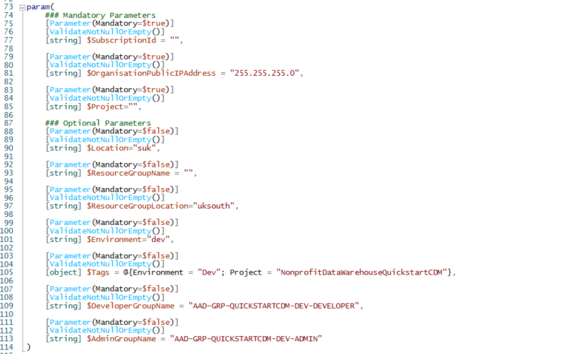

There are two types of parameters; mandatory and optional.

Mandatory parameters ignore assigned default values, and request parameter definition during the execution. These parameters have been carefully chosen as they need be specific to the organisation. Not providing these parameters during the execution will cause the deployment to fail.

Optional parameters take default values defined on the right side of equality sign. They can be modified when more control is required, but not changing them would not cause a solution to fail.

###### Mandatory Parameters

**$SubscriptionId** – This is the ID of the subscription where resources will be deployed. This value can be obtained from the Azure Portal in the Subscriptions tab or by using the following [link](https://portal.azure.com/#blade/Microsoft_Azure_Billing/SubscriptionsBlade). Subscription ID will then be displayed on the list.

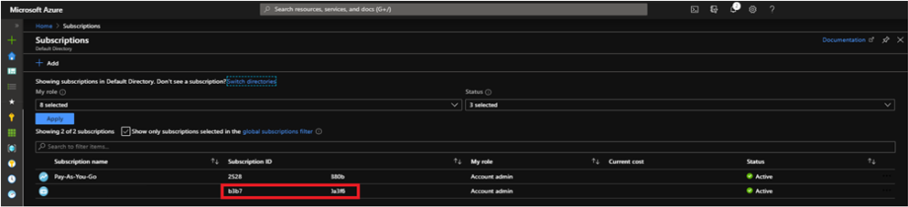  
  
**$OrganisationPublicIPAddress** – This is the public Internet protocol address (IP v4) of your organisation e.g. (190.200.99.37). This value can be obtained by querying “my ip address” in the browser or following the below [link](http://whatismyip.host/)

**$Project** –This parameter should be specific to the organisation that is going to use this solution. Administrators must make their solution unique across all deployments, not only in their organisation. This value can be a shortcut of the organisation name and project name. This is the element that makes resources unique from other organisations’ resources that deploy this solution. The name should have fewer than 10 alpha-numeric, lowercase characters.

###### Optional Parameters

**$Location** – defines the location prefix, e.g. weu – West Europe, suk – South UK. This value should conform to “$ResourceGroupLocation” parameter. This parameter only accepts maximum of 3 alphanumeric and lowercase characters.

**$ResourceGroupName** – defines the Resource Group Name. This is the only parameter that can be empty. If an empty value is provided, the resource group name will be generated. E.g. mstsidhrgweudev.

**$ResourceGroupLocation** – defines the Azure Region where the resource group will be deployed. The recommended value is the location of the closest [Microsoft datacentre](https://azure.microsoft.com/en-gb/global-infrastructure/).

**$Environment** – defines the Environment (e.g. dev). The same resource in two different environment would differ by this flag. E.g. for kv. This parameter only accepts maximum of 4 alphanumeric and lowercase characters e.g. “dev”.

Dev environment: mstsidhkvweu**dev**

Test environment: mstsidhkvweu**test**

**$Tags** – PowerShell objects that defines the tags that are going to be assign to all deployed resources. E.g. for billing purpose. E.g. to assign two tags: “Environment” with value of “Dev” and “Project” with value of “NonProfitDataWarehouseQuickStart” define object like below.

@{Environment = "Dev"; Project = "NonProfitDataWarehouseQuickStart”}

Remarks: To add more tags just add additional TagName = "TagValue"; Tag Names and Values must not contain spaces. This parameter is optional and have default value assigned as above example. Environment should conform with “$Environment” parameter.

**$DeveloperGroupName** – defines the name for the developer group name that had been created in Azure Active Directory. This Group will be assigned to allow developer access to all resources.

Name should be exactly the same as created in the prerequisites step.

e.g. **AAD-GRP-MSTSIDH-DEV-DEVELOPER**

**$AdminGroupName**– defines the name for the administrator group name that had been created in Azure Active Directory. This Group will be assigned to allow admin access to all resources.

Name should be exactly the same as created in the prerequisites step.

e.g. **AAD-GRP-MSTSIDH-DEV-ADMIN**

#### Naming Configuration Setup

This section describes how the naming conventions are created for the Azure Resources. This process is executed as part of the PowerShell deployment script. The script contains code that converts the provided parameters into resource names. It is recommended not to change this section unless needed. This section of code does not have to be modified unless different naming conventions are required. Modification to this section may cause script to fail.

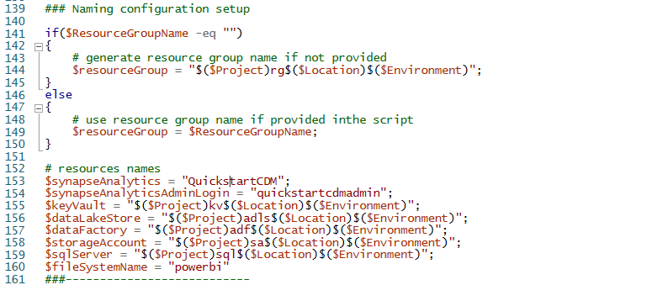

Azure resource names are composed from parameters defined in param as stated below:

E.g. for parameters supplied in param section like this:

$ProjectName = mstsidh

$Location = suk

$Environment = dev

The name of the Key Vault will be

$keyVault = $ProjectName + “kv” + $Location + $Environment => “mstsidh” + “ks” + “suk” + “dev” => “mstsidhkssukdev”

If the code responsible for the naming convention is modified, the Release Manager would need to make sure that the new names are going to be compatible with the naming convention required by each Azure resource.

### Running the Orchestration PowerShell script

To run the PowerShell script, open it in Windows PowerShell ISE console. When the script opens, modify the parameters (if required) and hit the Run button or the F5 key as in the below example:



1. First, the console will ask for mandatory parameters which need to be provided during execution. Parameters can be typed/pasted in and accepted by hitting “Enter”.
2. When the last mandatory parameter is provided, a new window requesting to login to Azure portal will pop up. Provide the admin credentials used in the previous steps.
3. Once the script starts the execution, events should appear in the output log. The script will execute for approximately 15 minutes, but may take longer depending on the speed of the resource’s deployment.
4. The script will check the progress and log it to console. The script will finish successfully when it logs the message “### Script Executed Successfully - DeployOrchestrator”.

Failure of the script can be identified when there are exceptions outputted in red in the PowerShell ISE console. The message “### Script Executed with Errors - DeployOrchestrator” will be logged to the output console in red.

A detailed way of checking the deployment would be to perform a manual check for all the resources:

1. Azure Data Factory (ADF)
   1. ADF is present in resource group
   2. All ADF objects deployed
   3. Linked Services Connections can be tested successfully in Azure Data Factory Portal
   4. ADF executes pipelines successfully (after post deployment scripts executed)
2. Key Vault (KV)
   1. Policies are present for AAD Groups and Managed Service Identities (MSI) for ADF and SQL Server
   2. Secrets are deployed
3. SQL Server and Synapse Analytics
   1. SQL Server is present in the resource group
   2. Synapse Analytics is present in resource group
   3. SQL Object are deployed
   4. All post deployment scripts execute successfully, control tables populated with the test entities
   5. IAM Permissions are assigned for ADF and SQL Server MSI
   6. SQL Azure Active Directory Admin is assigned to SQL Server
4. Azure Data Lake Storage (ADLS)
   1. ADLS is present in resource group
   2. User can see folder structure in ADLS
   3. Folders in ADLS have permissions for ADF, SQL Server and AAD Groups
   4. IAM permissions are assigned
5. Storage Account - Blob Storage (SA)
   1. SA is present in resource group
   2. User can see data sources container in SA
   3. Test files are present in SA
   4. IAM permissions are assigned for ADF, SQL Server and AAD Groups

**Remarks:**

It is important to note that even a failed execution might create expensive Azure Resources. After executing the script, check if resources are deployed and are active, especially the Synapse Analytics. Azure Resources that are no longer used or required should be disabled or deleted accordingly. To disable the Synapse Analytics follow the guide provided in **4.4.1.1 How to enable/disable Synapse Analytics via Azure Portal.**

If the script fails, the simplest way to remove the resources is to delete the Resource Group. For guidelines on how to delete the resources can be found in **“How to remove the solution”**.

### Finishing deployment with post-deployment steps

After a successful deployment, there are additional required steps to resolve before the solution can be executed.

Follow the below steps to finish the deployment.

1. Execute SQL Server Post Deployment Scripts
2. Modify Azure Data Factory Pipeline Variables
3. Deployment of the Power BI reports (optional)

#### Executing SQL Server Post-Deployment scripts

The solution requires control metadata tables to be populated. These scripts cannot be executed as part of the deployment process, so they need to be executed manually on the Synapse Analytics database.

To connect to Synapse Analytics using SQL Server Management Studio (SSMS) follow the guide in the FAQ section.

There are 4 post-deployment scripts that need to be executed on Synapse Analytics:

1. Control.CurationStage.Populate.sql
2. Control.Entity.Populate.sql
3. Control.PipelineStatusType.Populate.sql
4. Control.SourceSystem.Populate.sql

To execute these scripts, follow the below steps:

1. Navigate to Visual Studio and open solution explorer.
2. Open the Database project called Warehouse and navigate to “/Project/Scripts/PostDeployment”

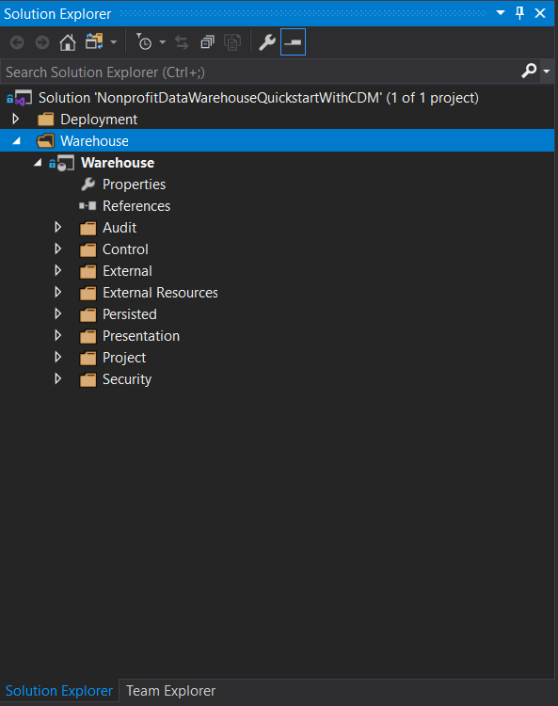

1. Open the scripts, one at a time, and copy the content to the clipboard.
2. Open SQL Server Management Studio and connect to the database (1,2) make sure that the database is displayed as below (3).
3. Click “New Query” (4) and past in the code from the clipboard (6). Make sure that the dropdown shows the correct Synapse Analytics Database, “Quickstart” (5).

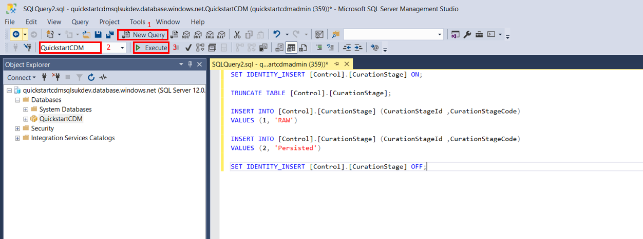

1. Execute the script by clicking the Execute (7) button or the F5 key. Message console should display rows affected (8).
2. Perform this action to the remaining scripts

#### Modifying Azure Data Factory Pipeline Variables

After deployment of the Azure Data Factory (ADF), there are two pipeline variables that need to be updated. Without these values, ADF will not work correctly.

1. To supply these values, open the ADF Portal.
2. Open the Author (1) tab.
3. Open Pipelines/Management/PL_ChangeSynapseAnalyticState (2) pipeline.

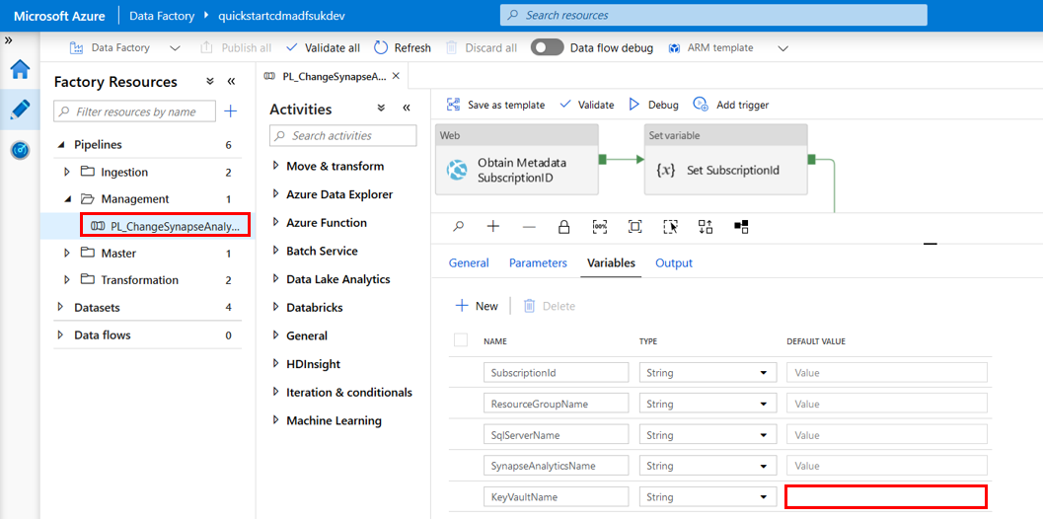

1. Go to the Variables Tab and provide a Default Value for KeyVaultName (3). The value needs to be obtained from Azure Portal (Navigate to the Resource Group where the solution was deployed and find the Key Vault resource).
2. When the change is made, hit “Publish All” (4) button on the top of the page to publish the changes to Azure Data Factory.

After changes have been published to Azure Data Factory there will be the notification message on the top right corner of the ADF Portal. If everything was successful, the ADF is ready for the execution.

#### Deploying Power BI reports

Power BI reports are often accessed by multiple people in an organisation. Accessing the same pbix file simultaneously would be inefficient. The best way to share reports with multiple people is to publish to a Power BI Portal workspace. The advantage is that the report is in a central location, where an administrator can assign access permissions for individual users or groups as appropriate.

Note: A [Power BI Pro License](https://powerbi.microsoft.com/en-us/pricing/) is required to share content with other users.

To begin the deployment, a workspace must be created first.

This is described in the steps below:

1. Login to Power BI Portal by following this [link](https://app.powerbi.com/home)
2. Create a new workspace by selecting the “Workspaces” tab from the sidebar, and then selecting “Create a workspace”. Fill the details and select “Save”.

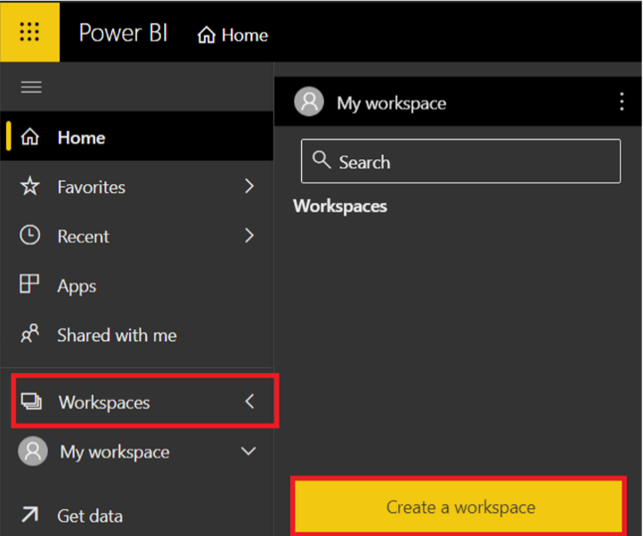 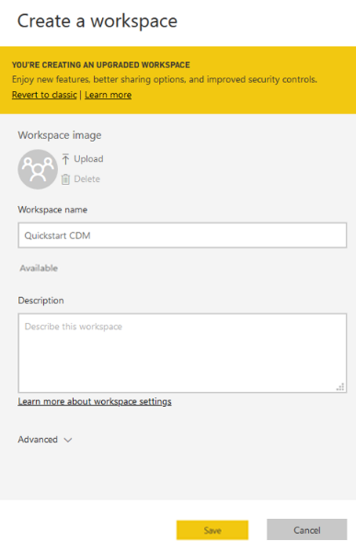

1. Fill the details and then select “Save”

Once the workspace has been created, the Power BI report for the solution can then be published to it. This requires the user to have [Power BI Desktop](https://powerbi.microsoft.com/en-us/desktop/) installed and a [Power BI Pro license](https://powerbi.microsoft.com/en-us/pricing/).

The report can then be opened with Power BI Desktop and published to the workspace using the following steps:

1. Open solution folder with windows file explorer
2. Navigate to the Presentation folder and open the PBIX report file with Power BI Desktop.
3. Select the ‘Publish’ icon on the “Home” tab.

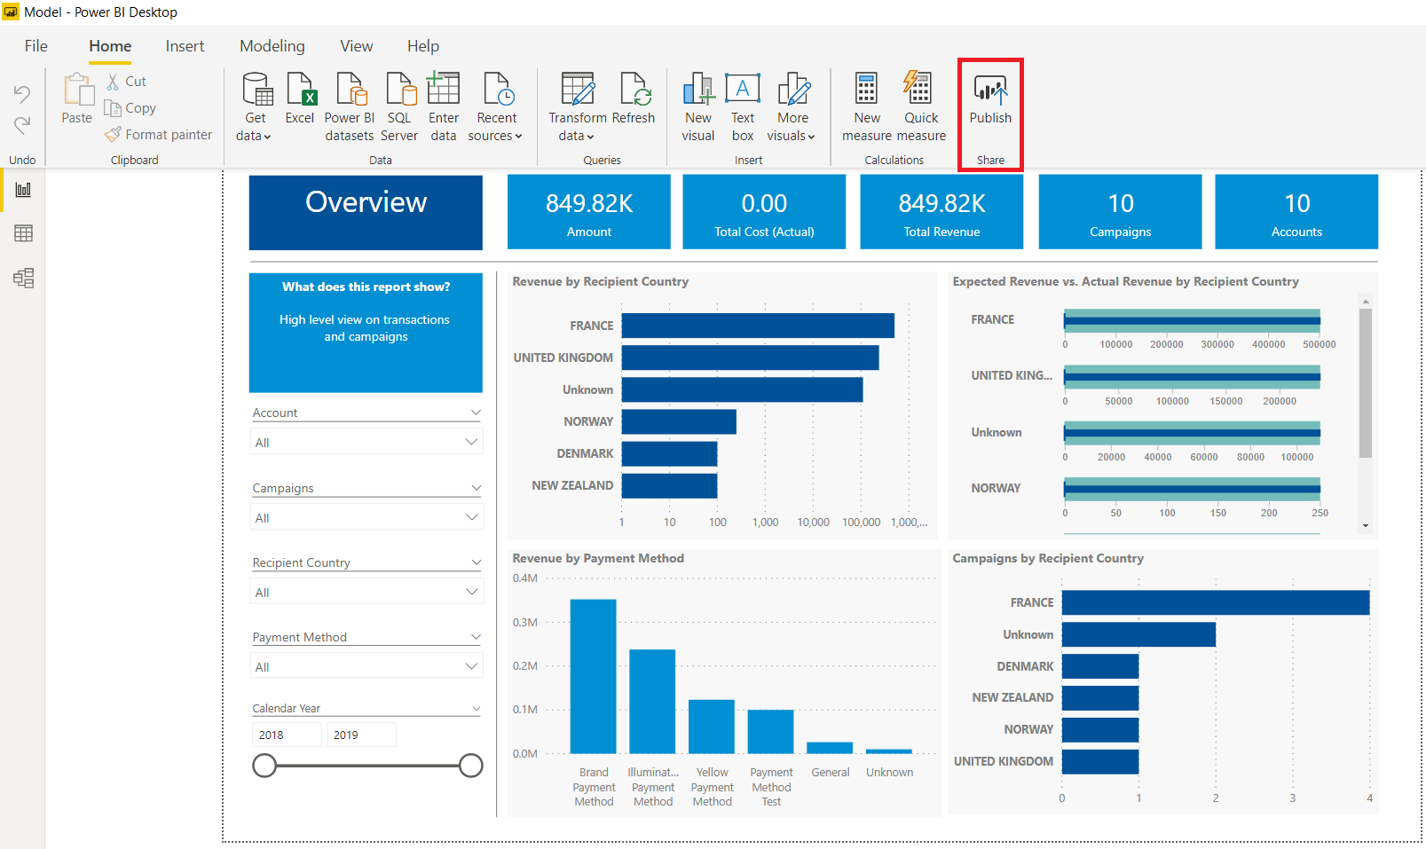

1. Select the previously created workspace and click “Select” to publish the report to the workspace.

To define viewing permissions, carry the following steps:

1. Open the appropriate workspace and select “Access” from the toolbar at the top.

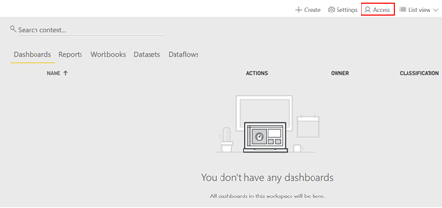

1. Users can be added using an email address. Only users that are part of the same Office 365 tenant will be available, unless added as a Guest.
2. The access options are:

* Admin – full access to the workspace
* Member – same access as Admin, except cannot make another user an admin.
* Contributor – can modify the content of a workspace but cannot perform permission related operations.
* Viewer – can only view reports

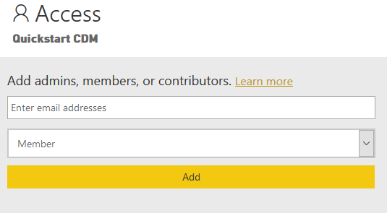

Alternatively, Azure Active Directory security groups can be used to assign access to the Power BI workspace, allowing an integrated access strategy between the Azure resources and Power BI workspaces.

Further information on refreshing the datasets in Power BI can be found within the FAQs section.

## Summary

The previous sections have covered everything that is required for the configuration and the successful deployment of the solution. If all the steps have been followed the solution should be deployed to the organisation’s tenant and ready for the execution with the test files provided. If there were problems found during the deployment process help can be found in the “FAQ’s” section.

# How to execute the solution

Once the solution has been deployed, as described in the previous section, the solution can be executed to process the test files provided. These files are going to be used to feed data through the solution and into the Power BI reports. This section covers how to find the Azure resources, how to trigger the solution and also how to identify if the execution was successful. Finally, at the end of this chapter there is a description on how to disable/enable the solution so that the execution/run costs can be minimised.

## Finding Solution Resources

The section begins by describing where the different resources can be found, using both the Azure portal to see the specific resources and Azure Data Factory in order to display the pipelines that will be ingesting and transforming the data. Following this, methods to run the solution both manually and automatically will be given, allowing the data to be utilised.

### How to find solution resources

All solution resources are deployed into a single Azure resource group. These resources can be accessed via the Azure Portal. To get quicker access to all Azure resources, follow the below steps:

1. Login to the Azure Portal by following this [link](https://portal.azure.com/#blade/HubsExtension/BrowseResourceGroups) – it links to the Resource Groups tab in Azure Portal, which will help locate the Azure Data Factory Resource. Please note only users that are members of the Admin or Developer groups will have access to this resource.
2. Find the resource group on the list and open it – if an organisation has many resource groups, a specific resource group may be difficult to find on the list. By typing part of the name of the Azure Resource Group in the text box, the list can be filtered by name.

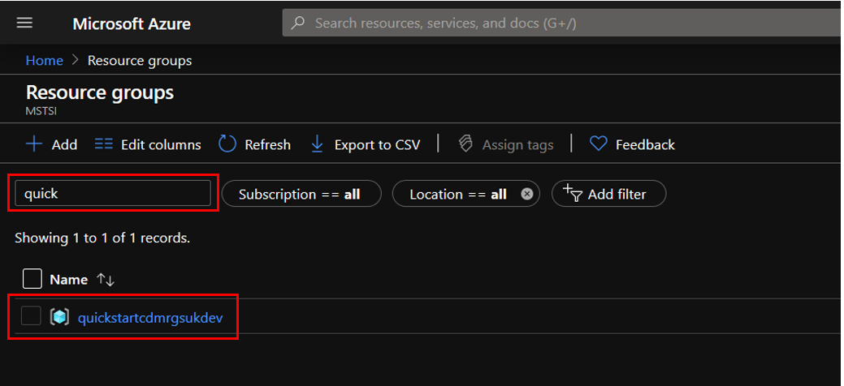

The list of resources that are part of the solution are listed when the resource group is opened.

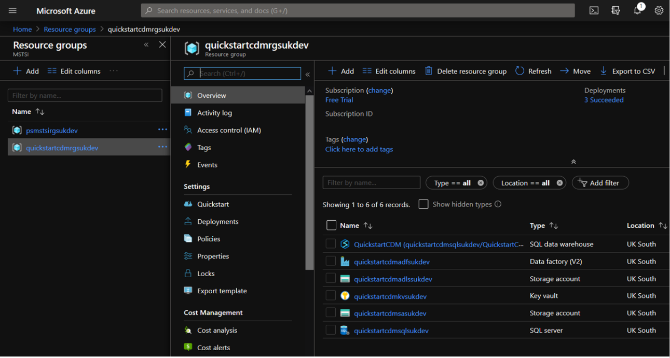

1. This page can be bookmarked (in most browsers ctrl + D), to gain quicker access to the solution resources.

### How to find the solution orchestrator

The solution is orchestrated by Azure Data Factory (ADF). To find the Azure Data Factory Portal, follow the below steps:

1. Navigate to the Azure Resource Group
2. Click on the resource with a blue factory icon and with the Type Data Factory (V2)

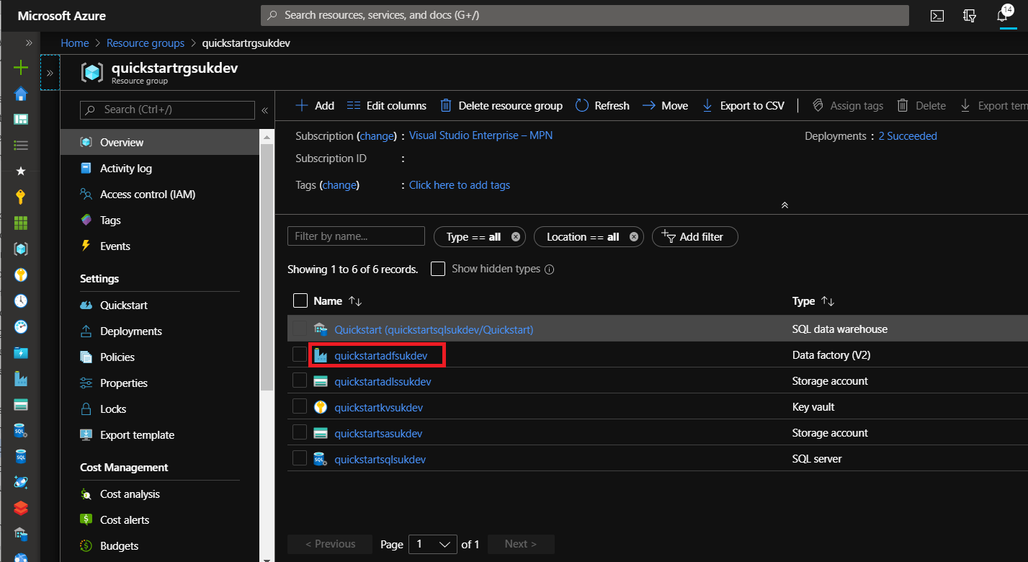

1. Click on the “Author and Monitor” button in the middle of the screen

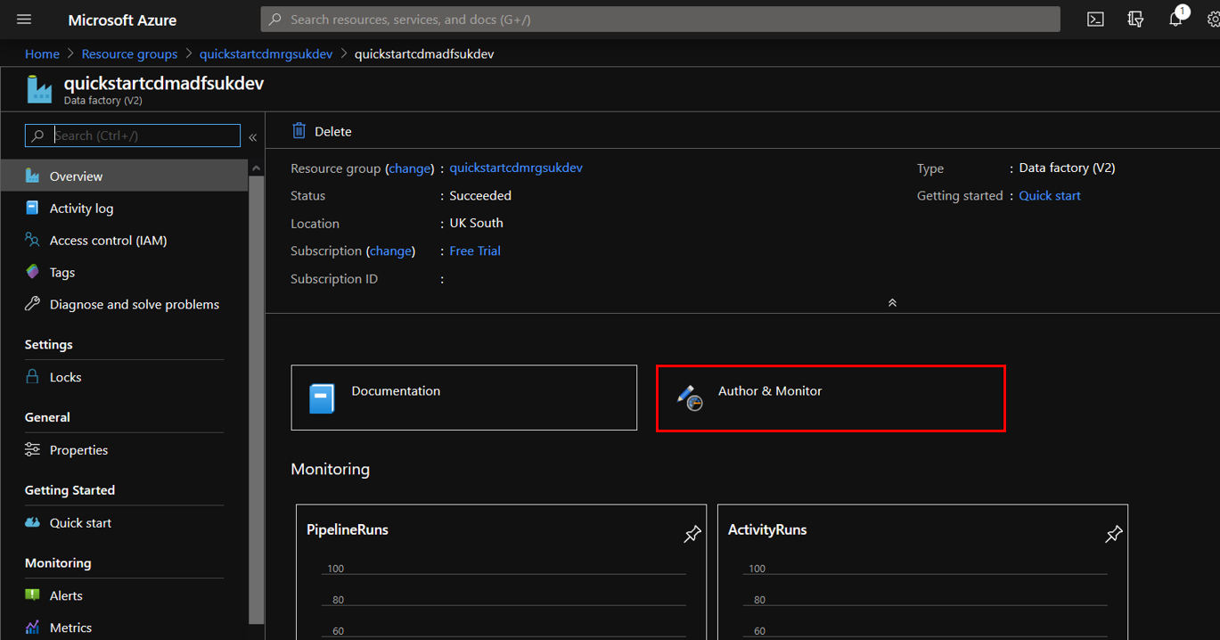

1. When a new portal opens up, click on the Author tab in the sidebar, shown by the pencil icon.

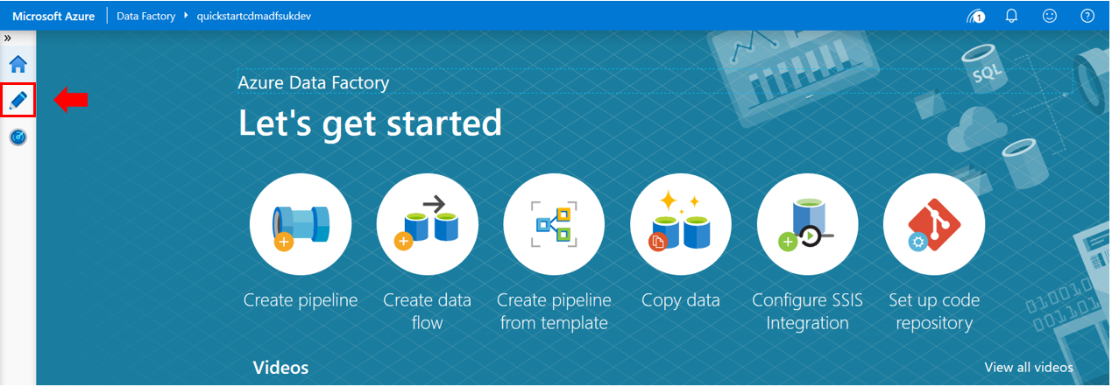

1. The Azure Data Factory resources are displayed as below:  
   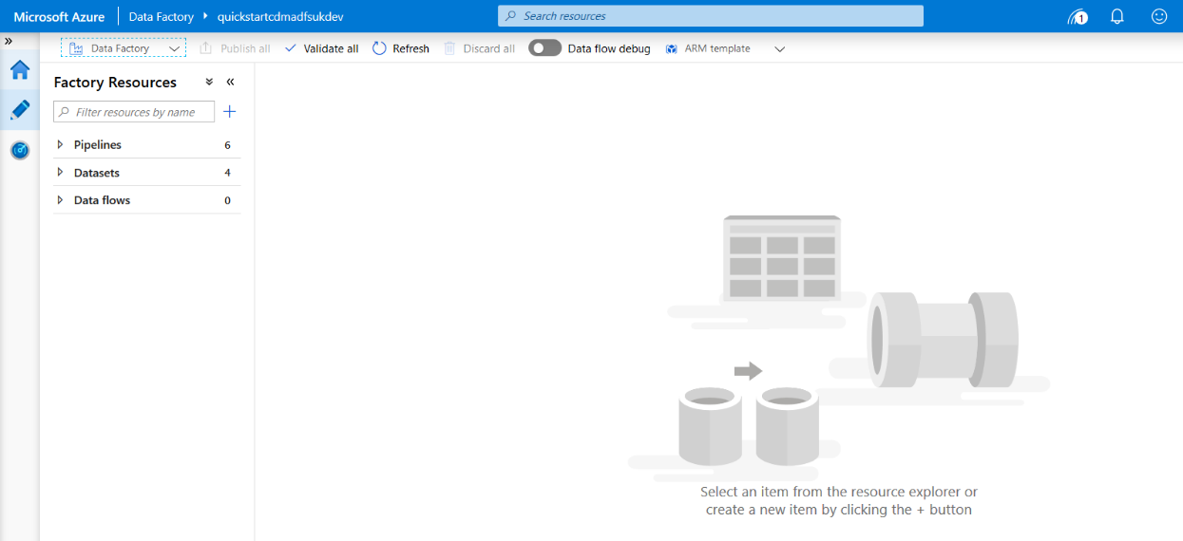
2. This page can be bookmarked (in most browsers ctrl + D) for quicker access.

## Running the solution

### How to manually execute the solution

The solution can be executed by triggering a single master Azure Data Factory orchestration pipeline called PL_MasterOrchestrate. This pipeline does not require any parameters.

To trigger the solution, follow the following steps:

1. Open the Data Factory portal.
2. Go to the Author Page (1).
3. Expand the Pipelines section (2) and chose pipeline (3).

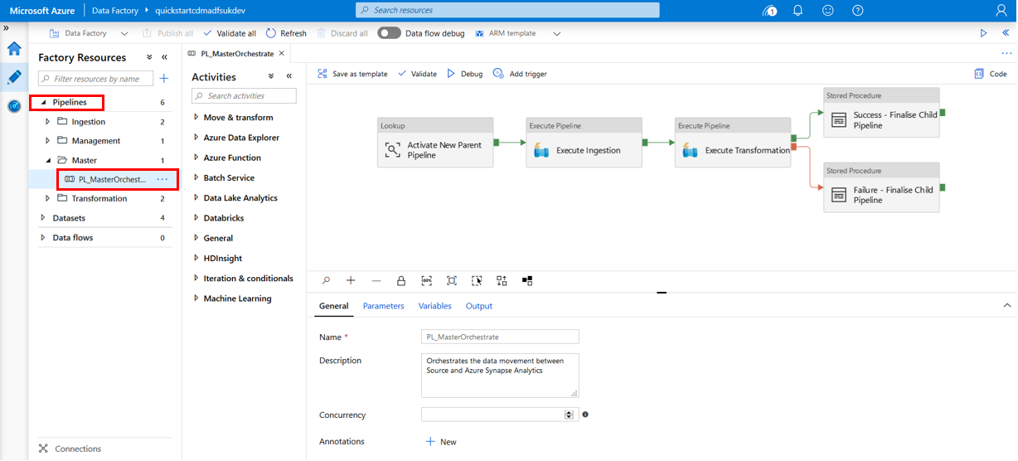

1. Expand “Add Trigger” list and click “Trigger Now” – this will open the parameter tab.

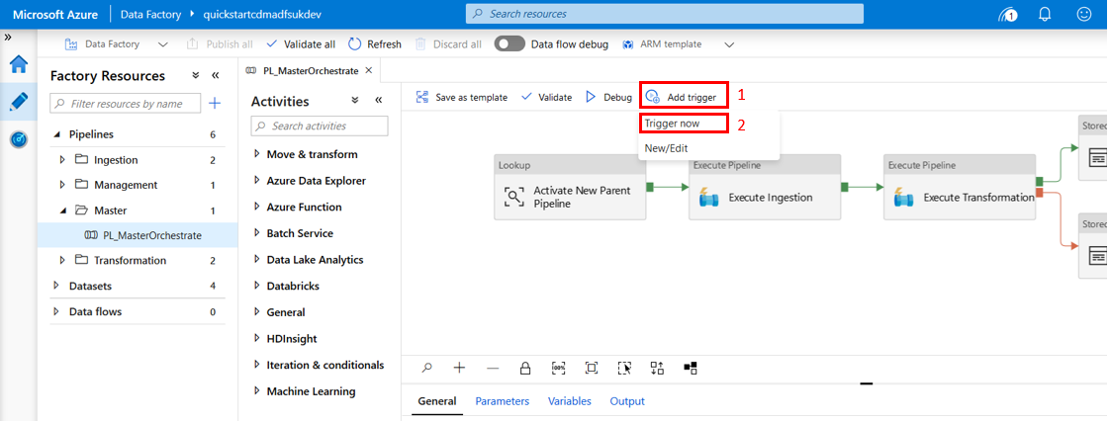

1. Trigger execution by clicking the “Finish” button.

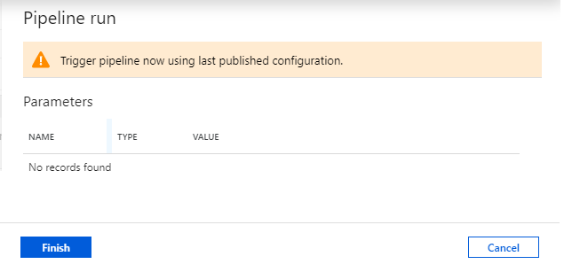

Remarks:

* + A warning advising the last publish pipeline will be executed is displayed. It means the changes applied to ADF that are not published will not be taken into account during execution
  + Master Orchestration pipeline does not require any input parameters, so the message “No records found” should be displayed

1. To check the status of the execution click in the little gauge icon on the Navigation panel

#### How to modify parameters and variables in Azure Data Factory

Updating parameters and variables is not mandatory for the successful execution of the solution, but provides additional configuration.

##### Parameters

There are no active parameters in the main orchestration pipeline. New parameters can be added if required.

##### Variables

There is a single variable called “Environment” that defines the name of the environment the solution is deployed to. This variable has the default value of DEV. This value can be updated to a string that represents the environment the solution is deployed to.

To modify a variable follow the below steps:

1. Go to the “Author” Tab
2. Navigate to the main orchestration pipeline PL_MasterOrchestrate
3. Navigate to the variables tab and modify the value accordingly

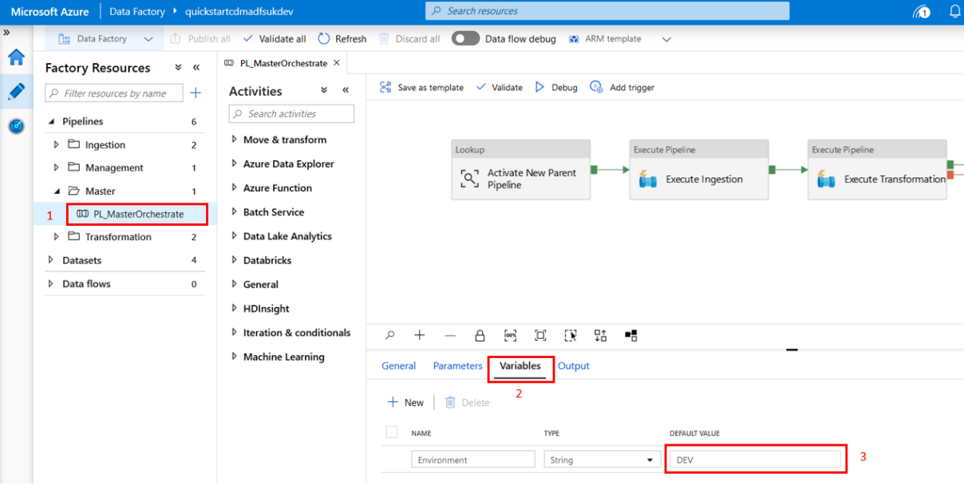

#### How to configure which entities to execute

The Control.Entity table in Synapse Analytics defines which entities will be processed by Azure Data Factory. Refer to section “Configure Synapse Analytics” to understand how to add/update/enable/disable entities.

### How to configure Azure Data Factory Time Triggers

A time trigger can be added to schedule a pipeline run, automating the execution of the ingestion and transformation processes. This can be configured as followed:

1. Login to the Azure Portal and open Data Factory.

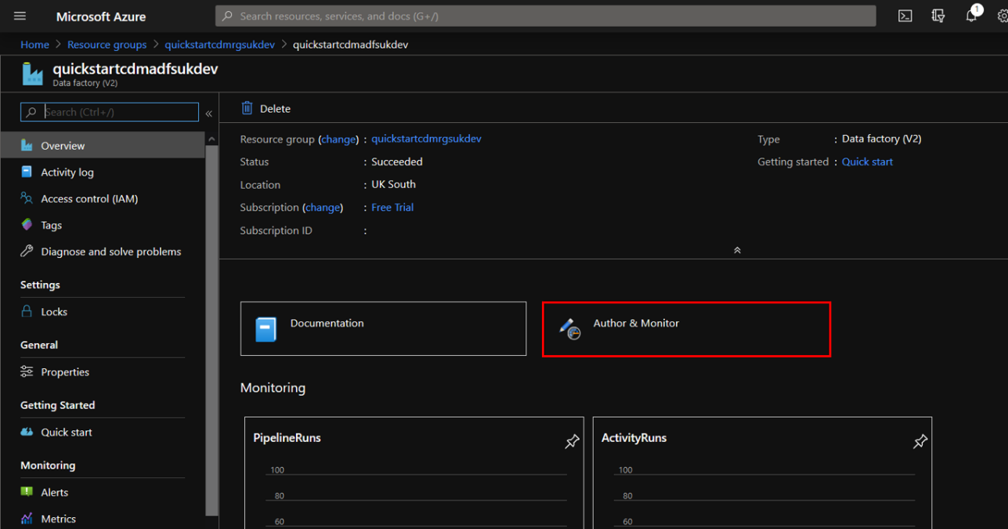

1. Select the ‘Author’ button. The triggering of the processes will take place in the ‘PL_MasterOrchestrate’ pipeline, which can be found within the ‘Master’ folder.



1. Select ‘Add trigger’ and then select ‘New/Edit’ from the drop down menu. Click the drop down menu ‘Choose trigger…’ and then select ‘+ New’ to configure the trigger.

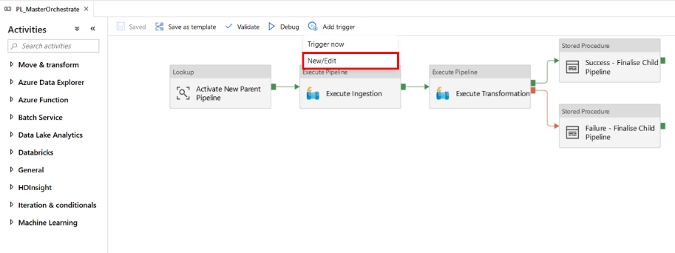

1. Choose a name that describes the trigger – in this example, a daily trigger will be created, so the name will be ‘DailyTrigger’. Additionally, a description can be given. The triggering of the processes can be set on a minute-based, hourly, daily, weekly or monthly schedule within the ‘Advanced recurrence options’.

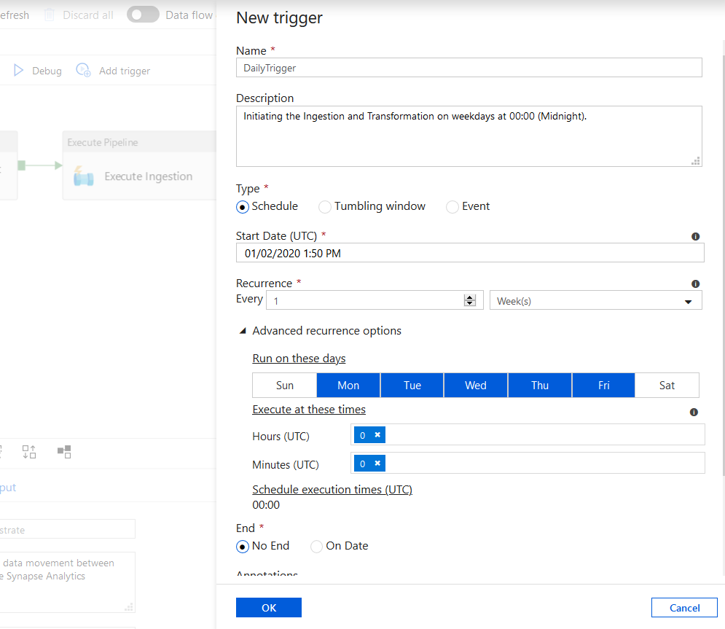

Other available options are end date (when to end the triggering schedule) and whether the trigger will be active immediately (‘Activated’ setting). Once these have been chosen, select ‘OK’.

1. As there are no parameters to be selected, select ‘Save’.

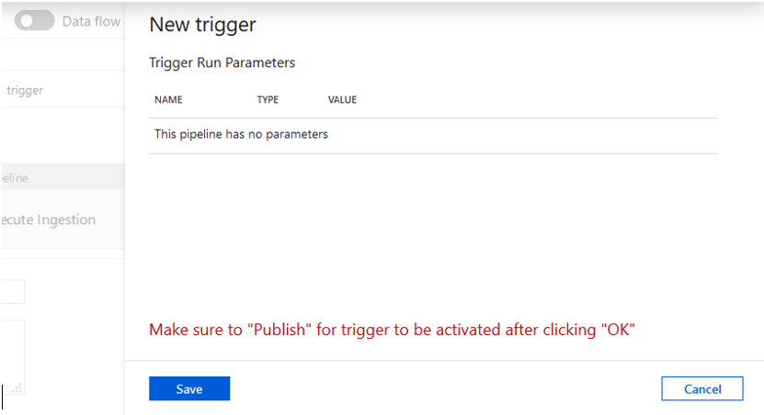

## Logging & Monitoring

This solution has taken a logging light approach, only providing information about what has been executed and the state of the execution. There are two mechanisms that provide these insights:

* + - 1. **Inbuilt ADF Logging** – logging provided by Azure Data Factory by default.
      2. **Custom Logging** – logging implemented as a part of our solution, that logs the execution to a SQL table in Synapse Analytics

The following sections describe how the solution administrator can access the execution logs to discover failures in the executions of the platform.

### ADF in-built logging

Azure Data Factory build in logging is the quickest way to discover failures. This section is going to describe the process of identifying solutions failures.

#### How to check if the solution executed successfully

Azure Data Factory logs by default every execution into its own execution log. This log can be accessed in the Azure Data Factory Portal. This should be the first check after an execution has been triggered. It will show if the solution has finished the current execution and also further details, such as the parameters that have been provided to each activity task.

To get to the Azure Data Factory Log, follow the steps below:

1. Login to the Data Factory Portal.
2. Navigate to the “Monitor” section – this log shows past and current logs. Make sure that the filter date range is appropriate for the task e.g. the last 24 hours.

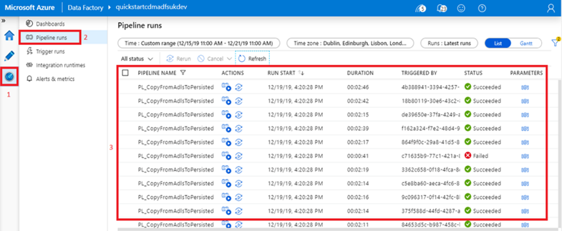

1. Wait until all activities are finished, especially if the execution has just been triggered – if there are activities with an “in progress” state, the solution is still executing.
2. Inspect the execution of the PL_MasterOrchestrate pipeline and all child pipelines – they should all finish successfully with STATUS = Succeeded.



1. If any of the child pipelines fails, the parent pipeline will also fail, therefore the master pipeline will fail as shown in the image below.

#### How to check the details of a failure

If any of the solution pipelines fails, Azure Data Factory execution logs can be used to identify which pipeline execution has failed, the execution context and failure details.

To inspect execution context and failure details follow the following steps:

1. Navigate to the Azure Data Factory Log as described in previous point.
2. Find activities that have a status of “Failed”, accompanied by a red cross.
3. Within the execution log, find the child pipelines that have failed e.g. PL_CopyFromBlobToAdls or PL_CopyFromAdlsToPersisted. There is no need to find the failure details on the master pipeline, as they do not contain error details. Using the name of the pipeline, information about the stage it failed on can be obtained.
4. Left click on the [@] Parameters link to check the input parameters. This should provide insight into which entities failed. In this example, the pipeline was executing the Persisted.ObtainTransaction stored procedure for the Transaction entity.

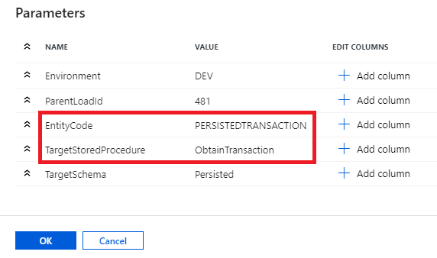

1. Left click on the error message icon. A new window should pop up with the error message like below. This message should provide insight into the reason of failure.

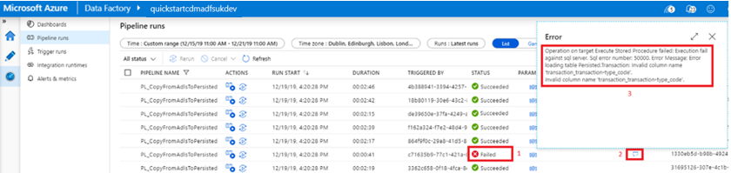

### Custom SQL Logging

When the solution is executed, execution information is also logged in the Synapse Analytics tables. This provides logging that can be fully customised. The current solution only logs the top level details about the execution of entities but it is possible to implement more sophisticated logging, e.g. logging the amount of copied records for each entity. Logged data can be used to analyse patterns in executions or creation of execution dashboards.

#### How to check custom logs

To access the audit tables in Synapse Analytics, follow the steps described below:

1. Open SQL Server Management Studio (SSMS)
2. Connect to Synapse Analytics by providing the connection details (the connection details can be obtained from Key Vault).
3. Open new query editor.
4. Execute below statement to select data from ExecutionLog view in a user friendly form “SELECT * FROM [Audit].[ExecutionLog] ORDER BY LoadId DESC”.
5. Inspect the executions by Pipeline Status.

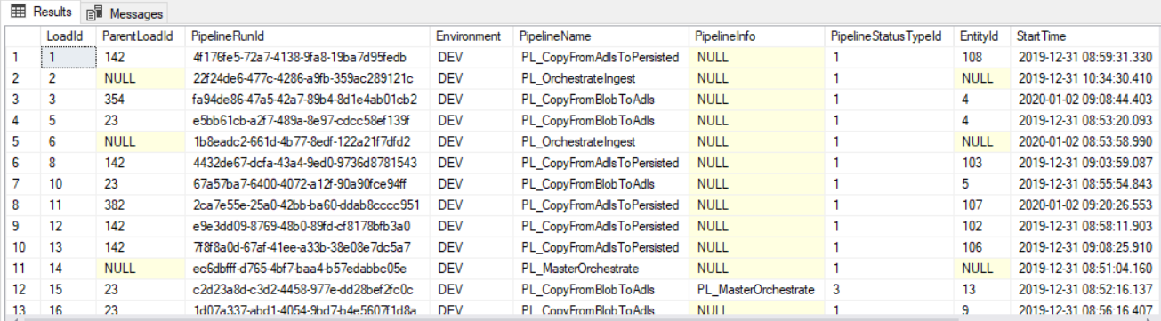

## Turning solution on/off

### Enable/Disable the solution

#### How to enable/disable Synapse Analytics via Azure Portal

Running Synapse Analytics when not required can incur unnecessary costs. The data warehouse created within this solution can be switched on and off manually via the Azure Portal, as shown in the following steps:

1. From the Azure Portal, select the ‘SQL databases’ service.

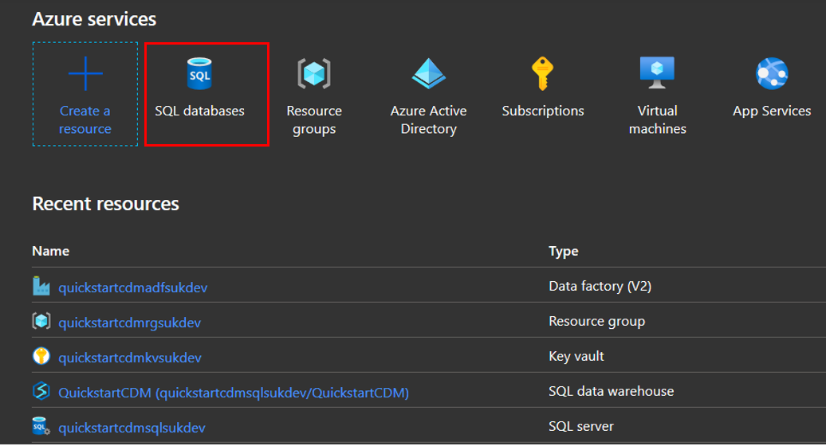

1. Select the SQL Data Warehouse named ‘QuickstartCDM’. The button highlighted in the diagram below shows ‘Resume’ when Synapse Analytics is not running and ‘Pause’ when running. Select this to switch on and off as required. This operation can take some time, especially during the Pausing action.

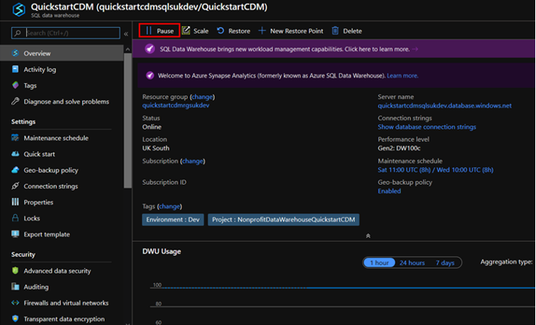

#### How to enable/disable Synapse Analytics via ADF

A pipeline is provided within the ADF solution that allows the ADW to be paused and resumed, which can in turn be used to automate this functionality.

1. Navigate to the “Author” page.
2. Select the ‘PL_ChangeSynapseAnalyticsState’ pipeline from the ‘Management’ folder. The pipeline can be split into two logical parts. The first obtains the required parameters to perform this task and the second performs a Web API call to switch the Synapse Analytics on and off. It also validates the current status and does not perform an action if what is required is already in place (eg. trying to pause Synapse Analytics when it is already paused).

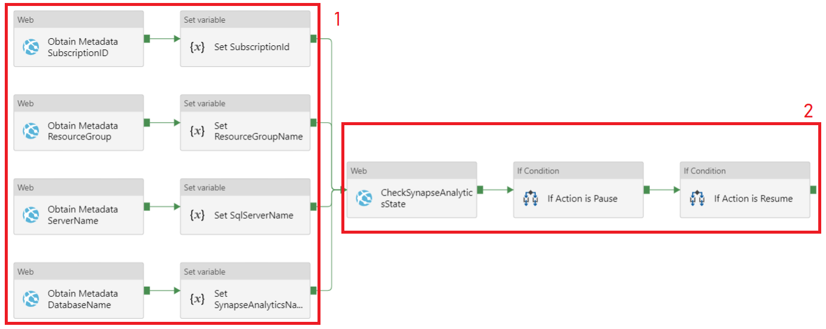

1. While staying in the Author tab (1) check the PL_ChangeSynapseAnlyticsState(2) pipeline’s variable (4) called “KeyVaultName” to ensure that it has the correct name of the key vault as deployed in resource group. In this example the variable has the value of “quickstartkvweudev”. This update should be performed as a post deployment action, however if the value is incorrect, it needs to be updated and ADF needs to be published (5).

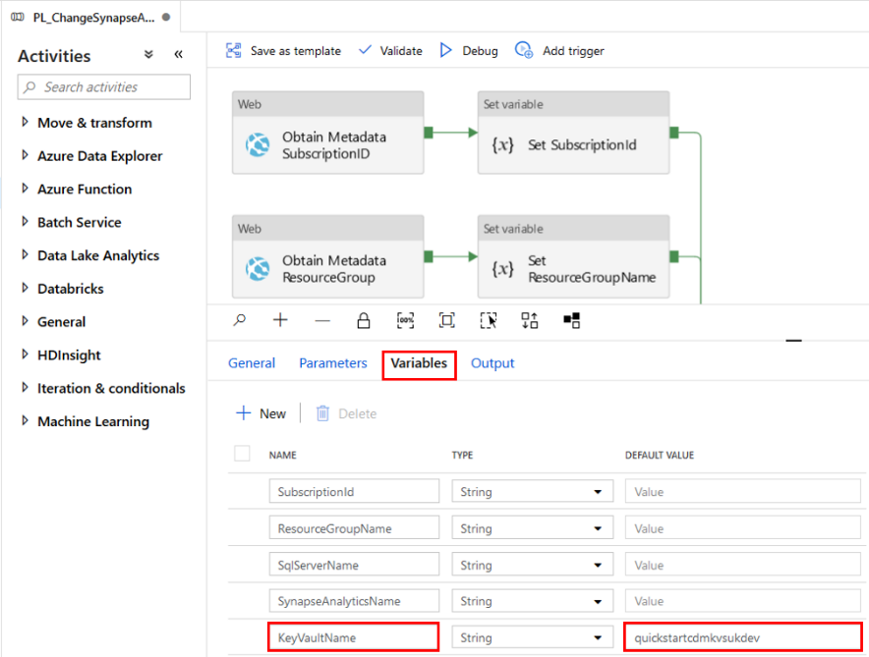

1. To start executing the “PL_ChangeSynapseAnalyticsState”, select “Trigger” and then “Trigger now” from the drop down menu. From here, the parameter “Action” should be provided, which can take the values “resume” (to turn Synapse Analytics on) and “pause” (to turn Synapse Analytics off). Finally, select the “Finish” button.

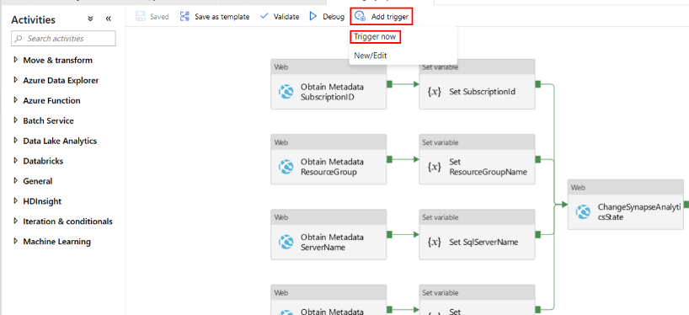

1. This pipeline can be automated by adding time triggers, as described in section ‘How to add a Time Trigger to the solution‘. This is useful in terms of efficiency and to avoid unnecessary costs.

#### How to enable/disable ADF triggers

1. Select the ‘Trigger’ button and then ‘New/Edit’ option.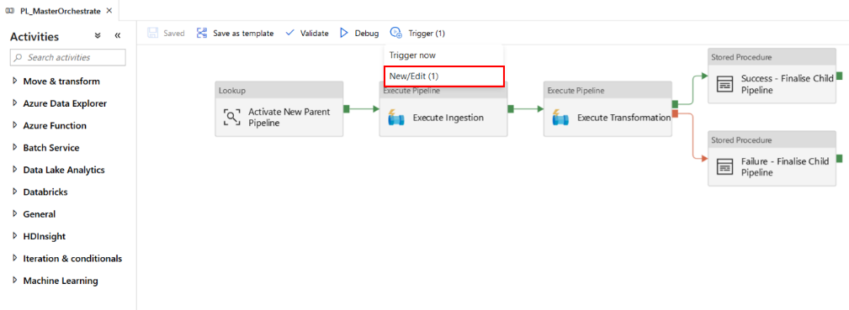
2. Select the trigger to be enabled/disabled. From here, the menu option ‘Activated’ can be used to define if the trigger will be used or not. Select the appropriate option, then select ‘OK’. Following this, complete the parameters page as appropriate and then click save.
3. Finally, select the Publish button to apply the changes on the deployed Azure Data Factory.

## Summary

This section covered all the operational subjects associated with Nonprofit Data Warehouse Quickstart, including how to find the resources, deploy the solution, and check the status of the execution. At this stage, your environment should be executed, and the Power BI reports should be able to refresh processed data from Synapse Analytics.

# How to add your own data

So far, this document provides guidance on how to use Nonprofit Data Warehouse Quickstart with example data provided alongside it. However, the real value comes when you create a data analytics solution with relevant and critical organizational data. This section provides guidance on how to modify the architecture, example data files, and resources you’ve deployed to ingest data relevant to your organization.

First, administrators must move data from a Blob storage data source through to the ADLS solution to modify the data ingestion process. Following this, the changes required to take data from the ADLS solution through to the Synapse Analytics data warehousing solution’s persisted tables has been given. These persisted tables are key in providing the data for modelling and analytical purposes. Finally, a description of the required steps for modelling the data within Power BI has been given, allowing the data to then be used within interactive visualisations and reports.

Adding organisation data into the platform will bring data closer to the business. Ingesting organisation specific data will enable organisations to mashup datasets from different source systems and build a unified data model. The model will become a base for organisations’ specific reporting that could provide additional data analysis and insights to the organisation.

This section describes how to add new data sources to the solution so they can be ingested the same way as the test data provided as a part of this solution.

## Ingestion: Moving data from Source Blob to Azure Data Lake Storage

This section describes how to configure the ingestion stage of the solution so organisation source entities can be ingested to Azure Data Lake Storage.

### Overview

This solution uses a Blob Storage to store sample Common Data Model (CDM) entity files that need to follow CDM specification. In a real world scenario this data can come from systems that are supporting CDM such as Dynamics, Power Apps, etc.

### How to upload files to the Blob Storage

Files uploaded to the blob storage should be added to the container **datasources**. Each data source should be stored in a virtual folder named, in lowercase, after the source system (E.G. iati). Each entity will have a corresponding CSV file, as shown below (E.G. data from the entity Account is stored in the Account.csv file).

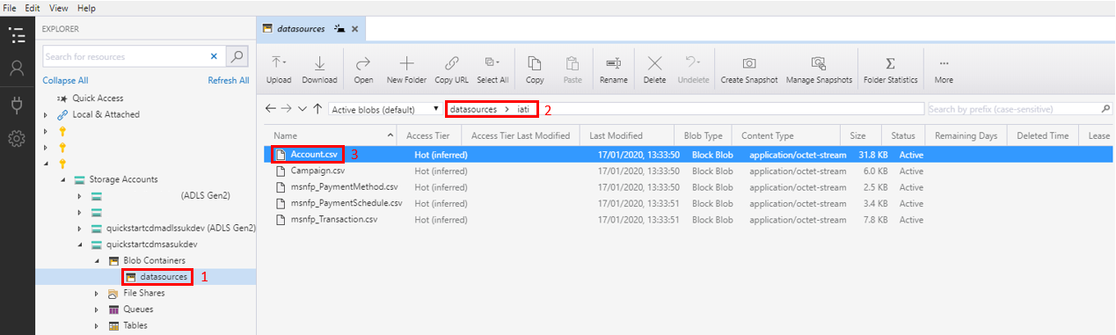

### How to configure Synapse Analytics

The Control tables in Synapse Analytics contain metadata about each entity expected to be processed by the solution. There are two main tables that controls the ingestion process.

**Control.SourceSystem** – holds metadata about source systems. Requires one single record per source system.

|  |  |  |  |
| --- | --- | --- | --- |
| Column Name | Description | Max Characters | Required |
| SourceSystemId | An integer number incremented by 1 that uniquely identifies each source. This value can’t be duplicated. | NA | True |
| SourceSystemCode | A short code that uniquely identifies a source system. Files uploaded to a Blob Storage should be located in the same folder as the Source System Code. | 20 | True |
| SourceSystemName | Descriptive name of the source system. | 50 | True |
| ConnectionStringSecret | Connection string to the source system. Only required if using a new ADF to extract data from the source. | 50 | False |
| UserNameSecret | Name of the KV secret that holds details about a User Name. Only required if using a new ADF to extract data from the source. | 50 | False |
| PasswordSecret | Name of the KV secret that holds details about a Password. Only required if using a new ADF to extract data from the source. | 50 | False |

**Control.Entity** – holds metadata about each entity required to be processed. Requires one single record per entity and stage.

|  |  |  |  |
| --- | --- | --- | --- |
| Column Name | Description | Max Size | Required in ingestion stage |
| EntityId | An integer number incremented by 1 that uniquely identifies each entity. This value can’t be duplicated. | NA | True |
| EntityCode | A short code that uniquely identifies an entity. | 50 | True |
| EntityName | Descriptive entity name. | 100 | True |
| SourceContainer | Name of the container holding the source files.  E.g. for files stored in blob storage with the path: “**datasources**/iati/entity.csv“  Source Container is datasources. | 50 | True |
| SourceFolderPath | Name of the virtual folder mentioned in the section ‘Uploading Files to the Blob Storage’  E.g. for files stored in blob storage with the path: “datasources/**iati**/entity.csv”  Source Folder Path is iati. | 200 | True |
| SourceFileName | Name of the source file, including the extension.  E.g. for files stored in blob storage with the path: “datasources/iati/**entity.csv”**  Source File Name is entity.csv | 75 | True |
| TargetContainer | Name of the target container. In this solution, the files are stored in Azure Data Lake Storage  E.g. for files stored in azure data lake storage with the path: “**powerbi**/CDM/Account/Account.csv“  Target Container is powerbi. | 50 | True |
| TargetFolderPath | The folder path where files are going to be stored  E.g. for files stored in azure data lake storage with the path: “powerbi/**CDM/Account**/Account.csv“  Target folder Path is CDM/Account. | 200 | True |
| TargetFileName | The name of the target file, including the extension. A wildcard can be used to select all files available in the directory  E.g. for files stored in azure data lake storage with the path: “powerbi/CDM/Account/**Account.csv**“  Target File Name is Account.csv | 75 | True |
| TargetSchema | Not populated when defining ingest Entity. Value is NULL. | 50 | False |
| TargetTable | Not populated when defining ingest Entity. Value is NULL. | 50 | False |
| TargetStoredProcedure | Not populated when defining ingest Entity. Value is NULL. | 50 | False |
| SourceSystemId | SourceSystemId from Control.SourceSystem table. | NA | True |
| CurationStageId | CurationStageId from Control.CurationStage. | NA | True |
| Active | Controls if an entity will be processed when Azure Data Factory executes. Only entities with a value of 1 will be processed. | NA | True |

Entity table should look like below:



Data can be inserted to this table by using SQL Server Management Studio. To connect to Synapse Analytics, follow the steps described in “How to connect to Synapse Analytics”.

## Transformation: Moving data from Azure Data Lake Storage to Synapse Analytics

### Overview

This stage copies the data from Azure Data Lake Storage (ADLS) to Synapse Analytics. The process uses Polybase and External Tables to read the data, Create Table as Select (CTAS) statements to save it to Persisted tables and Presentation views to abstract the data and make it available to Power BI reports.

To bring in new source entities, the below steps should be followed:

1. Configure Azure Data Lake Storage.
2. Create new entity objects in Synapse Analytics.
3. Configure Synapse Analytics Control tables.

### How to configure Azure Data Lake Storage

The solution requires a hierarchical folder structure and a model definition file to be created in the Azure Data Lake Storage (ADLS) to support the Common Data Model (CDM).

The CDM is composed of a set of entity files and a model.json definition file. The model has to be an exact reflection of the file structure defined in ADLS. If the structure of the model.json does not match the data lake structure, external consumers will not be able to read the data correctly.

Within the solution, there are 5 IATI entity files provided: Account, Campaign, msnfp_PaymentMethod, msnfp_PaymentSchedule and msndfp_Transaction.

There should be a single root folder called CDM created in the “powerbi” (1)(2) ADLS file system. This folder is a parent folder for entities. Each entity must have a folder in the CDM folder and a single CSV file with the actual data.

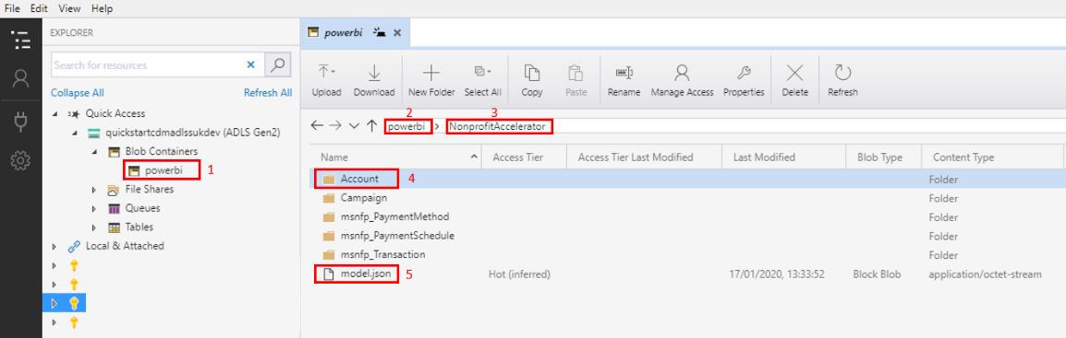

Each entity folder (4) should look like below:

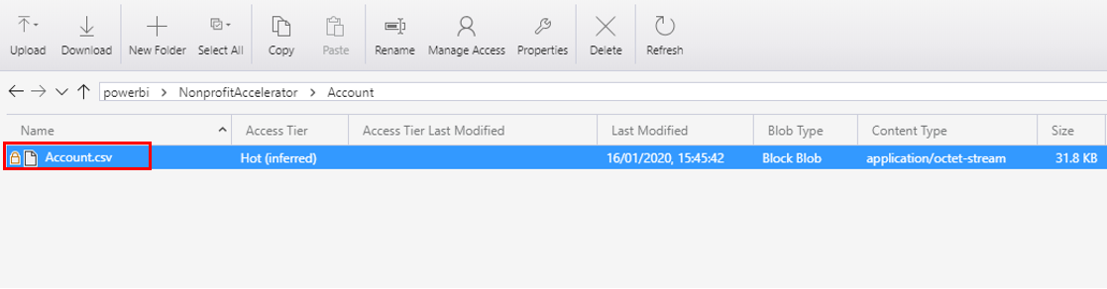

The solution will already contain a CDM folder configured with all the relevant permissions, so it is advised to not create new root folders. If a new folder is created, then permissions will have to be added accordingly.

The definition of the model is present in the model.json file (6), which needs to be placed directly in the CDM folder. This model provides details about all available entities in the model, such as the logical structure of each entity (the names of columns and their data types) and the physical location of the entity file or files. The Nonprofit Accelerator model has been uploaded to ADLS during the deployment stage and is displayed below:

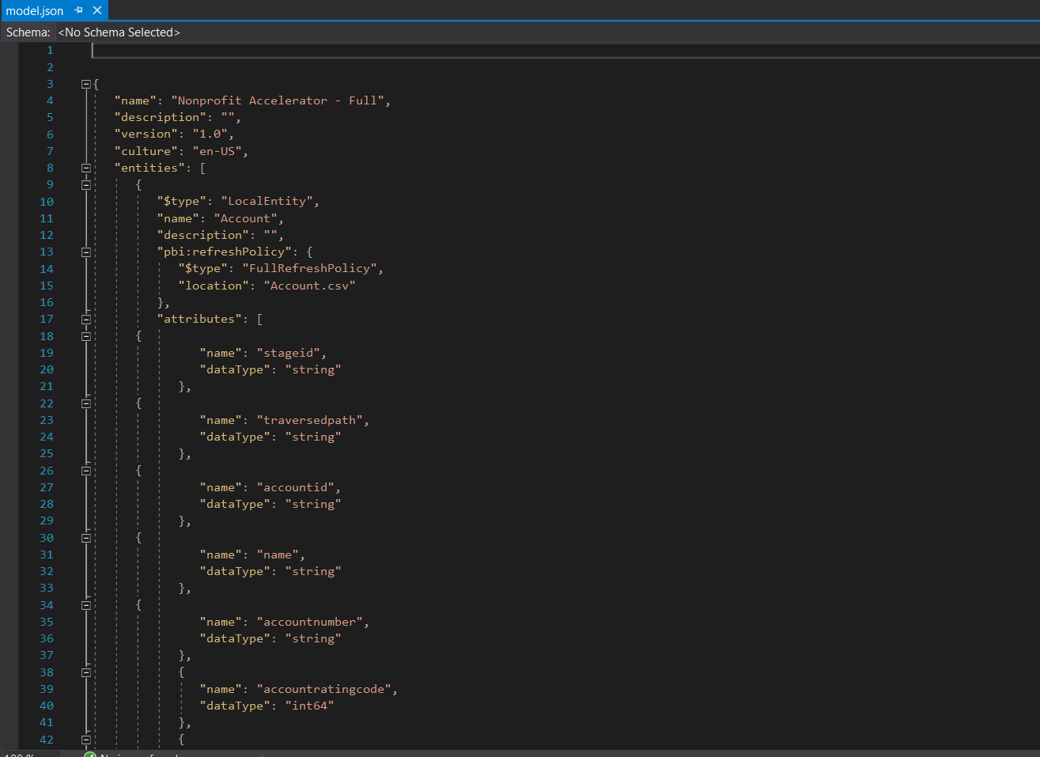

The model file is composed of multiple sections, which have been described below.

| Section | Attribute | Description |
| --- | --- | --- |
| Model | name | The name of the model or accelerator used. |
| Model | description | The description of the model. |
| Model | version | The version of the model. |
| Model | culture | The culture code for the file “en-US”. |
| Model | entities | Array of all entities defined in the document. |
| Entity | $type | Type of the entity. Can either be a Local Entity or Reference Entity. |
| Entity | name | The name of the entity. |
| Entity | description | The description of the entity. |
| Entity | pbi:refreshPolicy | Defines how the entity is refreshed. The value “FullRefreshPolicy” defines the entity contains a single file with all the data. |
| Entity | attributes | Array of attribute objects that defines the schema of the entity. |
| Attribute | name | Name of the column – name and order have to conform to the file defined. |
| Attribute | dataType | Type of the column e.g  string – attributes that can store string character values (NVARCHAR).  int64 – attributes that can store integer values (BIGINT)  double – attributes that can store decimal values (DECIMAL) |

A full description regarding the model definition can be find in this [link](https://docs.microsoft.com/en-us/common-data-model/model-json).

To extend the CDM with new entities, the process below must be followed:

* + - 1. Update the model.json. The new entity is added by creating a new JSON object (2) in the “entities” json array (1).

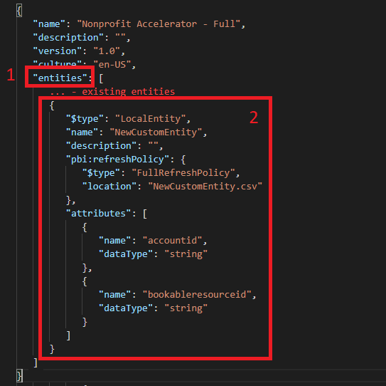

* + - 1. Create a new entity folder
      2. Add new metadata to the control tables, as described in the previous section

### How to create Synapse Analytics Objects

#### External Table

External tables allow Synapse Analytics to read data from Azure Data Lake Storage (ADLS). External tables do not store data, as they only contain metadata for defining the structure of the entity files in ADLS. The solution will have a single external table per entity. External tables need to strictly conform with the schema of the entity file read. Any difference between a file schema and its external table will cause the read operation to fail.

A definition for an external table is shown below:

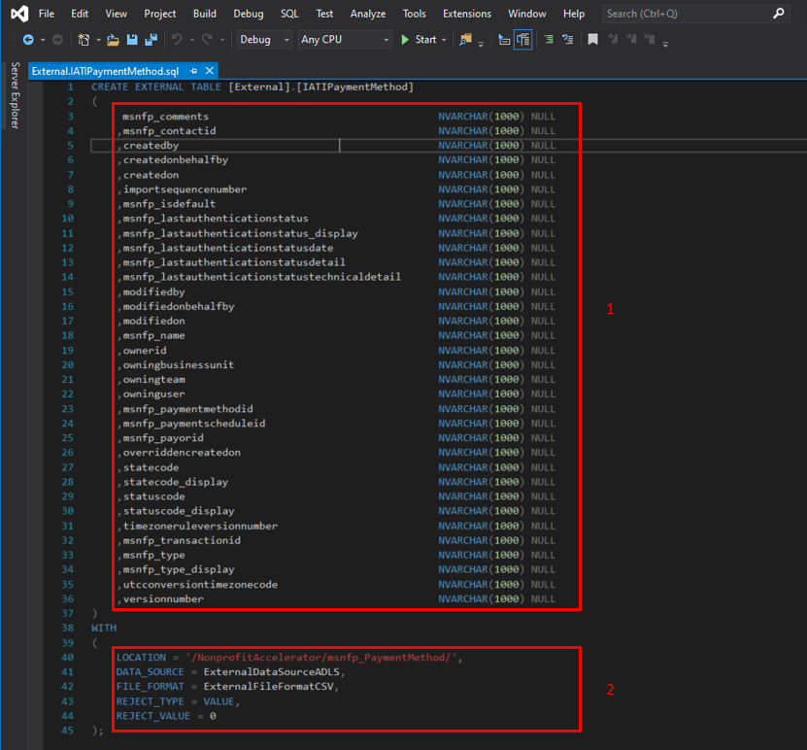

External tables need to define all the columns (1) of the entity file in ADLS, stating if a column is mandatory, the data type and the maximum length. The external tables in this solution use NVARCHAR data type for all columns, to avoid loading errors if the data type does not match.

The external tables also contains additional metadata (2), as described below.

|  |  |
| --- | --- |
| Parameter | Description |
| LOCATION | Defines the location of the Entity folder in Azure Data Lake Storage. |
| DATA_SOURCE | External Data Source Name. The external data source defines the connection details to ADLS. |
| FILE_FORMAT | External File Format Name. External file format defines the type of the file read. In this solution, all files stored in ADLS are in a parquet format. |
| REJECTED_TYPE  REJECTED_VALUE | Specifies the number of records that can be rejected before the read query fails. For all tables this value will be 0. |

#### Persisted Table

Data in Synapse Analytics is saved to tables with Persisted schema using Create Table as Select (CTAS) statements.

Data stored in persisted tables are strongly typed, meaning all columns are no longer of NVARCHAR data type and have their target data types specified e.g. Date, Decimal, Integer etc. There is a single table per entity.

Persisted tables are created in Visual Studio as table objects.

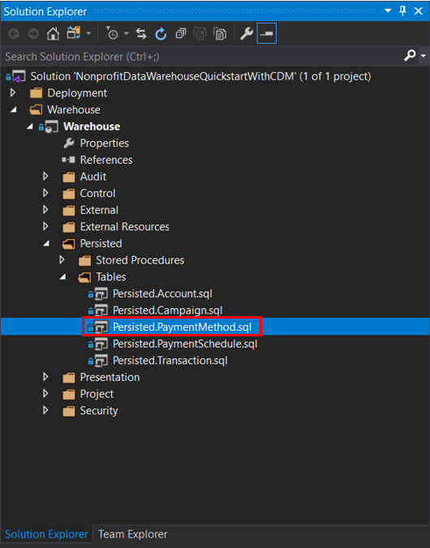

The table definition needs to follow the example below:

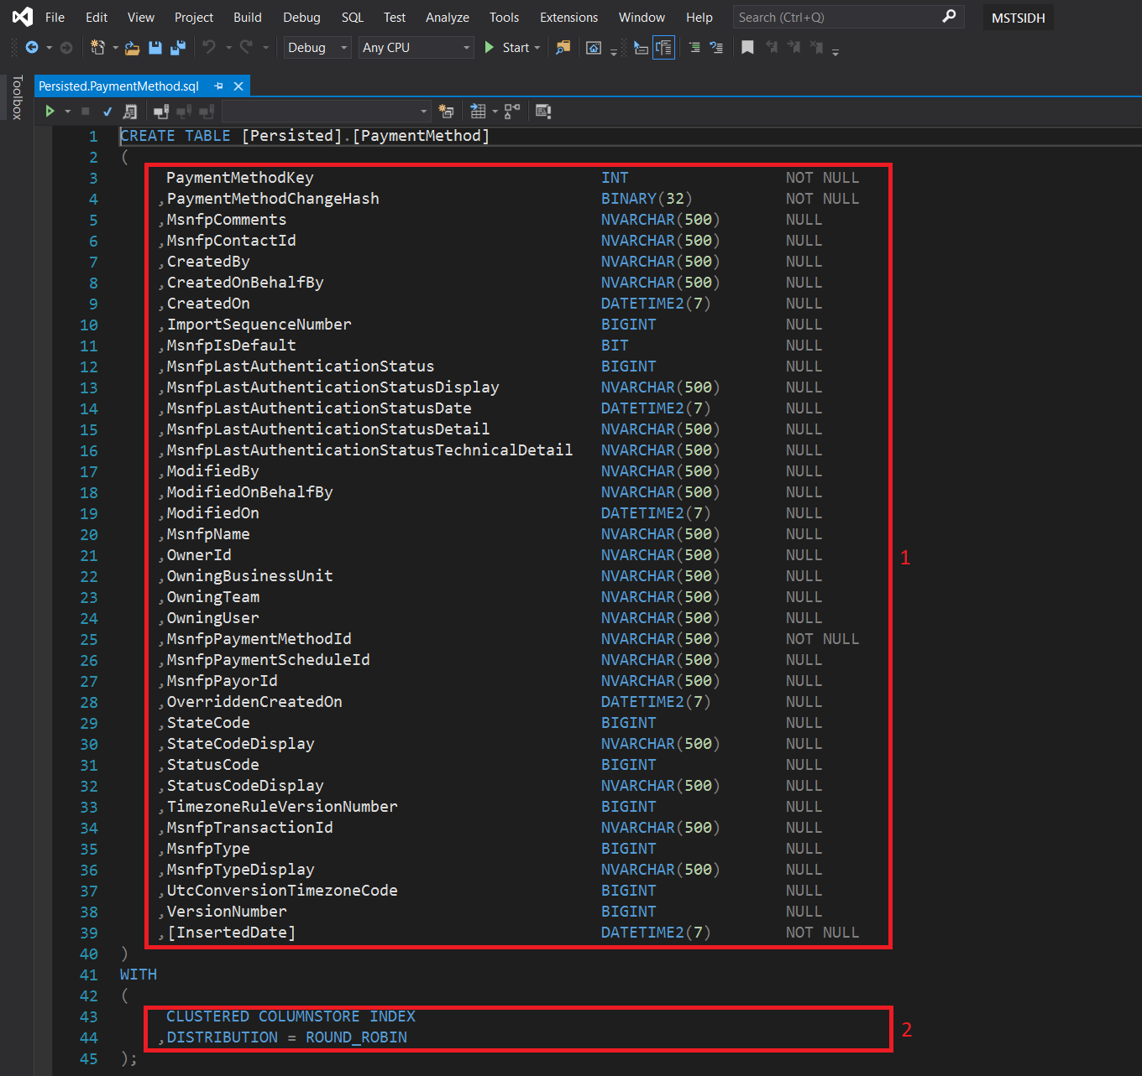

A table definition will have two sections. In the first section (1) all columns need to be defined with the expected data type, the maximum length and if the column is mandatory. In the second section (2) the index type needs to be defined alongside with the distribution type.

#### Stored Procedure

The data stored in a persisted table is loaded and transformed via Stored Procedure. The Stored Procedure performs a full data load, as there is no support in the solution for incremental loads.

To create a new stored procedure, follow the steps below:

1. Open the solution’s database project with Visual Studio 2019.
2. Navigate to the Stored Procedures folder in Persisted.
3. Right click on “Stored Procedures” folder, “Add” and then choose “Stored Procedure…” from the list presented.

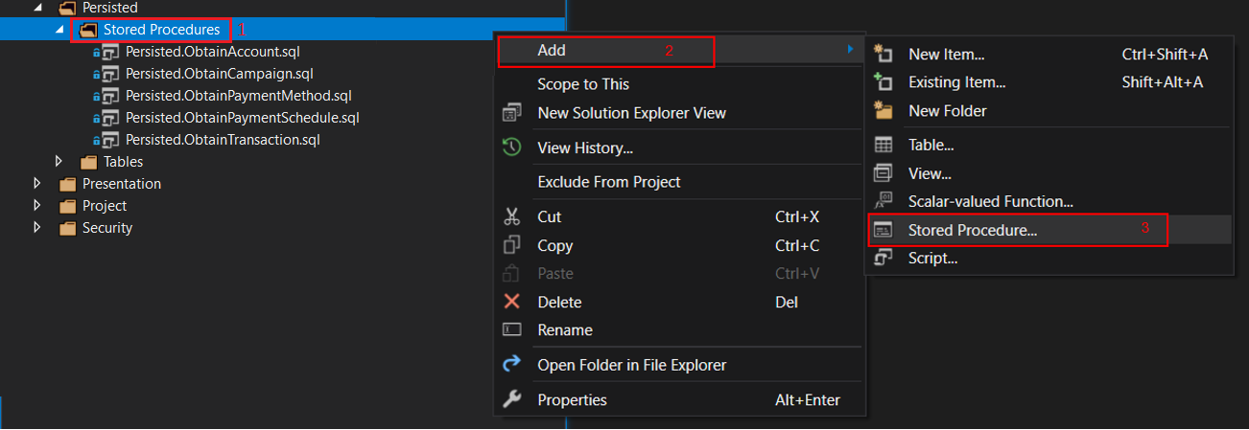

1. Within the solution explorer, double click on the file that has been created and replace the content of the file with template code of the stored procedure. This stored procedure will need to be updated to reflect the entity to be processed.

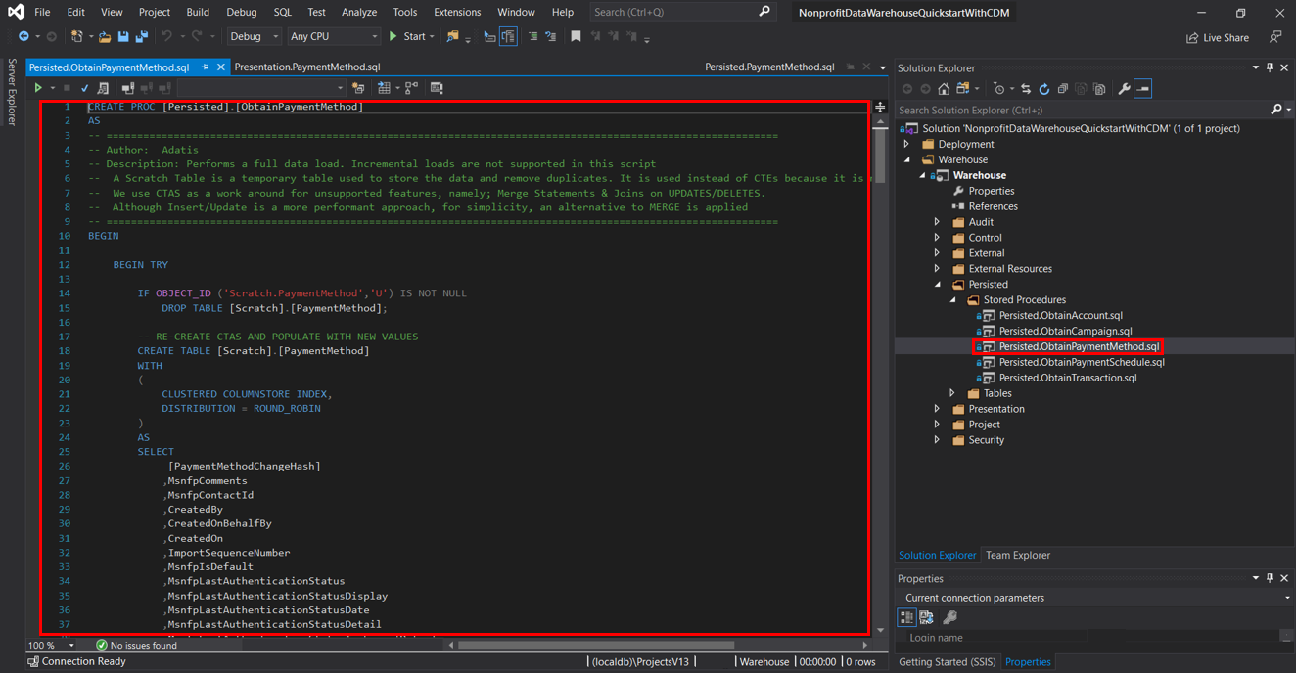

1. Save the code.
2. Open SQL Server Management Studio, deploy the created stored procedure to Synapse Analytics.

The Stored Procedures generally follow the same pattern as outlined below.

The first part of the Stored Procedure makes use of nested tables, where Table A is the innermost table, followed by table B. The result set of Table B is then used in the CTAS statement.



Table A does the following;

1. Queries the metadata stored in the external table to retrieve data from ADLS.
2. Uses ROW_NUMBER (windowing function) to ensure the uniqueness of records.

The trick is to ensure that the columns used to “partition by” are sufficient to uniquely identify each record. Additionally, the column(s) used to “order by” should be the ones that help you obtain the latest record. Date and ID columns are usually appropriate.

Table B then does the following:

1. Returns columns from Table A.
2. Adds a hash column, which will be used to compare existing records in the persisted table with incoming records in the Scratch table.
3. Only selects the latest unique records.

The CTAS statement does the following:

1. Drops pre-existing transient table.
2. Creates transient table under the “Scratch” schema.
3. Populates the Scratch table with records from Table B.

It should be noted that the pattern used for loading data takes advantage of Synapse Analytics’ parallelisation capabilities through the use of the CTAS statement. Whilst it needs the creation of a transient table to temporarily store data, the performance gains obtained by processing data in parallel are significant enough to warrant this approach.

The second part of the stored procedure also uses CTAS to create another transient table. On this occasion, the transient table {Persisted}.{EntityName_Upsert} will hold the result set of a vertical join (Union) between the incoming records (Scratch) and pre-existing records (Persisted).



The union between Scratch and Persisted does the following:

1. Keeps original rows currently in the Persisted table.
2. Uses the hash column created in Table B to append only New/Changed records from Scratch table.
3. Adds a Primary Key (PK) by adding the last PK in Persisted table and incrementing by 1.

The CTAS statement does the following:

1. Creates a transient table within the Persisted schema in the following manner {Persisted}.{EntityName_Upsert}.

The last section involves renaming tables, to swapping in the new table and then dropping the old table.

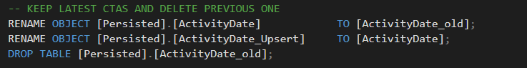

#### Presentation View

The data stored in Synapse Analytics is accessed by Power BI via a set of SQL views. Views are created in the Presentation schema. There will be a single view per entity.

To create a new view, follow the steps below:

Open solution’s database project with Visual Studio 2019.

Navigate to View folder in presentation.

Right click on “View” folder, “Add” and choose from the list “View…”

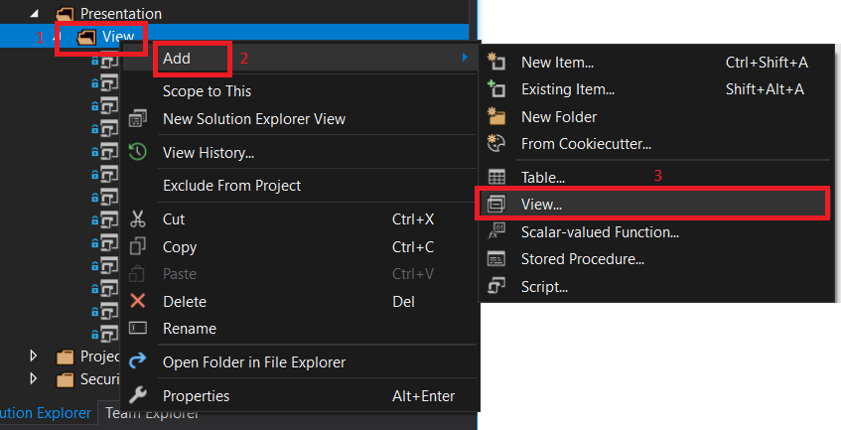

Then on the solution explorer double click on the file that has been created and replace the content of the file with the template code of the view. This view will need to be updated to reflect the entity to be processed.  
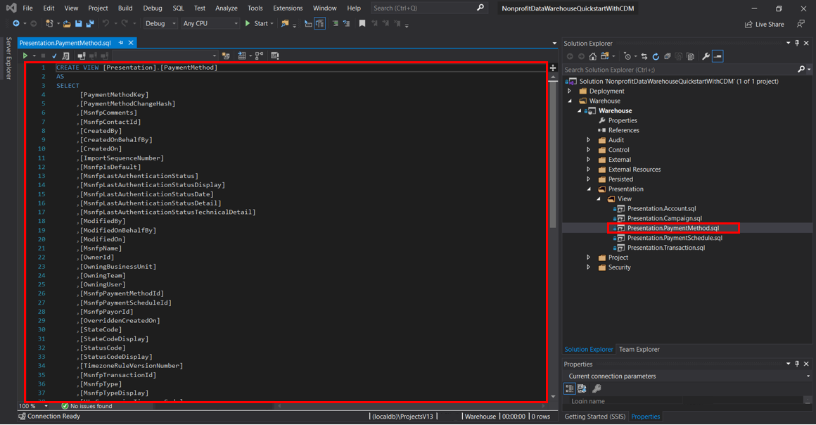

Save the code.

Open SQL Server Management Studio and deploy the created view to Synapse Analytics.

### How to configure Synapse Analytics

The transform stage uses the same orchestration mechanism, as described in the “Configure Synapse Analtyics” Ingestion section. This stage uses the same Control.Entity table as ingestion, just with different columns being populated. Control.SourceSystem should be already populated as Source System record has been created for Ingestion.

Provide the following details to add a new transformation entity.

|  |  |  |  |
| --- | --- | --- | --- |
| Column Name | Description | Max Characters | Required in Transform stage |
| EntityId | An integer number incremented by 1 that uniquely identifies each source. This value can’t be duplicated. | NA | True |
| EntityCode | A short code that uniquely identifies a source system. Files uploaded to a Blob Storage should be located in the same folder as the Source System Code. | 50 | True |
| EntityName | Descriptive name of the source system. | 100 | True |
| SourceContainer | Not populated when defining transformation Entity. Value is NULL. | 50 | False |
| SourceFolderPath | Not populated when defining transformation Entity. Value is NULL. | 200 | False |
| SourceFileName | Not populated when defining transformation Entity. Value is NULL. | 75 | False |
| TargetContainer | Not populated when defining transformation Entity. Value is NULL. | 50 | False |
| TargetFolderPath | Not populated when defining transformation Entity. Value is NULL. | 200 | False |
| TargetFileName | Not populated when defining transformation Entity. Value is NULL. | 75 | False |
| TargetSchema | Specifies the target SQL schema where data will be processed. | 50 | True |
| TargetTable | Specifies the target table where data will be persisted. | 50 | True |
| TargetStoredProcedure | Specifies the target stored procedure that will process the data. | 50 | True |
| SourceSystemId | SourceSystemId from Control.SourceSystem table. | NA | True |
| CurationStageId | CurationStageId from Control.CurationStage. | NA | True |
| Active | Controls if an entity will be processed when Azure Data Factory executes. Only entities with a value of 1 will be processed. | NA | True |

This will result with values for transform entities in the Control.Entity table that look like the example below:



### Power BI Model

The Power BI Template provided as part of the solution contains the layout, data model and queries necessary to visualize the data. The template omits the report’s underlying data as this is imported when the template is initially opened. It is required to point Power BI to the instance of Synapse Analytics.

When opening the template, it is requested to provide values for the Synapse Analytics Server and Database, specific to your resources as shown in the figure below. These values are stored as parameters and can be amended by selecting **Home > Edit Queries > Edit Parameters**, or in Power Query under the Other Queries folder (see section 3.1.3.2)

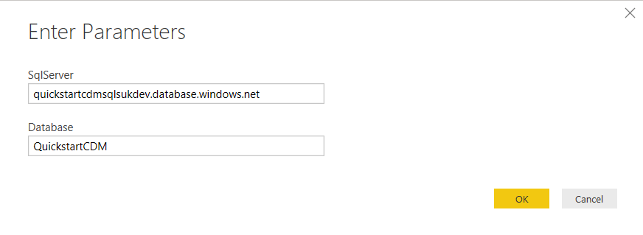

Upon successful authentication, the report’s data gets loaded into the Data Model.

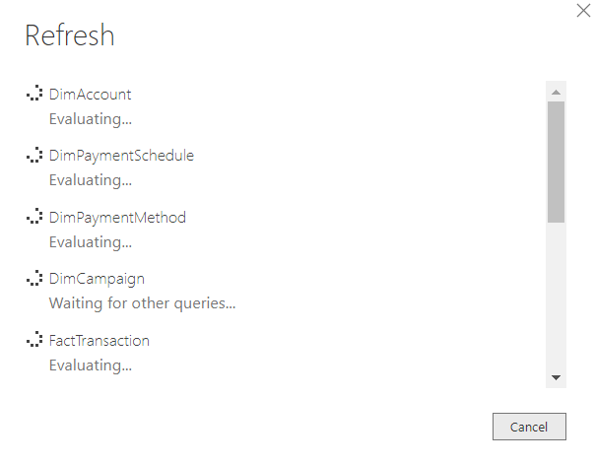

This prompts the creation of the report including all the pages, visuals, data model artefacts, and queries which the report is based on.

#### How to add a Presentation view from an existing connection

1. To add a new data source from an existing connection, navigate to the Home Tab under external data and click “Get data”, as shown below.

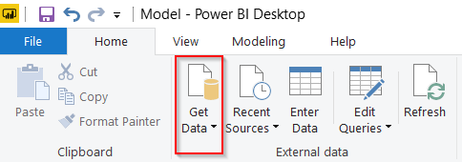

To select Azure SQL Data Warehouse (previous name for Synapse Analytics), click on more to get access to a wider range of sources. Navigate to Azure and select Azure SQL Data Warehouse.

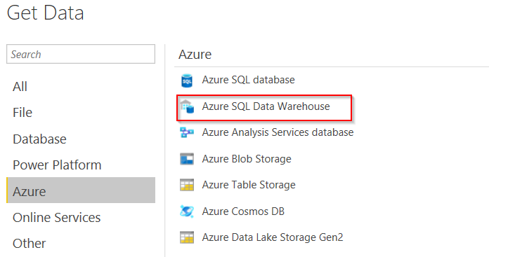

1. A dialog box asking to confirm the Server and Database details is prompted. These details are stored in parameters. Once mapped, leave the default Data Connectivity mode selected.

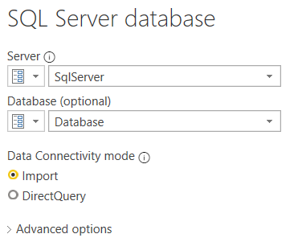

1. The Navigator menu allows the selection of new entity/entities.

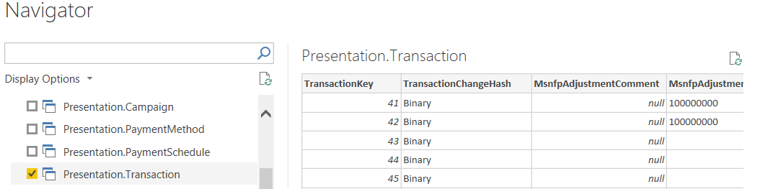

It is possible to either load the data into the Model without Transforming it (Load) or Transforming the data in Power Query before Loading it into the Model (Transform Data). Select “Transform Data” as the next section is carried out in the Power Query environment.

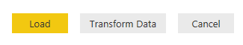

Power Query has been setup with the following folder structure to house the various Data model artefacts.

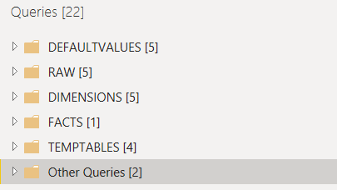

**DEFAULTVALUES**  - contains all the default values that will be used in place of null values.

**RAW** – contains all the entities in their raw form without any transformations.

**DIMENSIONS** – contains transformed Dimensional entities stored as query references to the underlying raw entity.

**FACTS** – contains transformed Fact entities stored as query references to the underlying raw entity.

**TEMPTABLE –** contains temporary tables that facilitate lookups between the Facts and Dimensions in order to store FK.

**Other Queries**  - contains values for the Server and Database parameters used when connecting to Synapse Analytics.

#### How to add a Dimension table from a Presentation view

Once the entity has been imported into Power Query, it can be transformed. This section outlines the pattern used to create Dimension tables from the underlying Presentation View.

1. Create a reference table as shown below. After that, move the newly created reference table into the DIMENSIONS folder as shown in the second step.

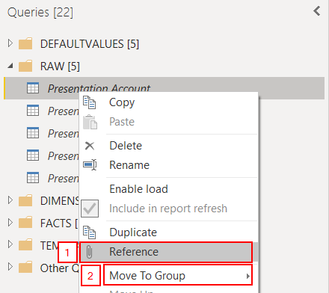

1. Rename the new reference table as {Dim}{EntityName}. The pattern for creating dimension tables is:
   1. Select only descriptive attributes which will be used to slice and dice the data. Do this by navigating to the manage columns section and remove columns as shown in the first step. Then, select the appropriate option (remove columns or remove other columns).

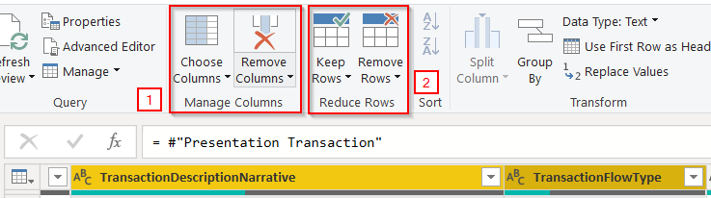

* 1. Remove duplicates to ensure that all records are unique. Do so by selecting the remaining columns and navigating to the reduce rows section and then remove rows as shown in the second step. It should be possible to select remove duplicates from the drop down menu as shown below.

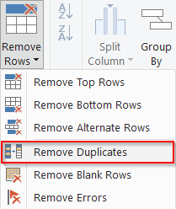

Alternatively, select the table icon above row numbers and choose Remove Duplicates.

* 1. Finally, add an index column starting from 1. This will be the primary key that uniquely identifies each row. This can be done by navigating to the Add Column menu, selecting the index column option and choose “From 1”.

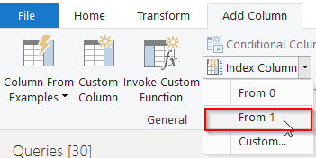

Be sure to rename the index in this manner {EntityName}{PK}.



1. You also need to create a corresponding default record in a separate table which will hold default values. The record will also contain a Primary Key with the value, -1. This will be specified in the Fact Table’s Foreign Key for the respective dimension. As a result, whenever the Foreign Key is null, the default record is used. This prevents the appearance of blank values.
   1. In order to create a default record, navigate to Enter Data (as below)

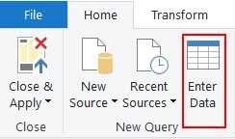

* 1. Manually enter a default record as below.
     1. Strings will default to “Unknown”,
     2. Dates with default to 01/01/1900 00:00:00
     3. Integers and decimals will default to 0
     4. GUIDs will default to “10036B69-E773-F24B-CB98-E5EF201D4AA3”, which is a hashed value for “Unknown”.
     5. Primary Key defaults to -1

You need to ensure that the columns in your default table match the columns in your dimension table. Here is an example of the corresponding default record for the DimAccount table.

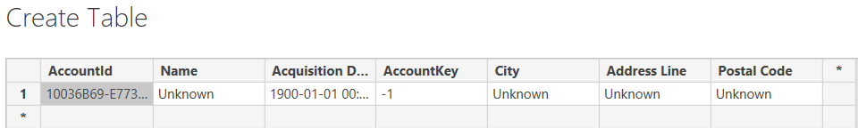

* 1. When you create the table you can use the following naming convention Dim{entity}Unknown. Make sure you move the table to the DEFAULTVALUES folder.
  2. Assuming that the column names in your Dim{entity}Unknown table match the respective dimension tables, you can go ahead and append the queries together.
  3. With your dimension table selected, navigate to append queries (as below)

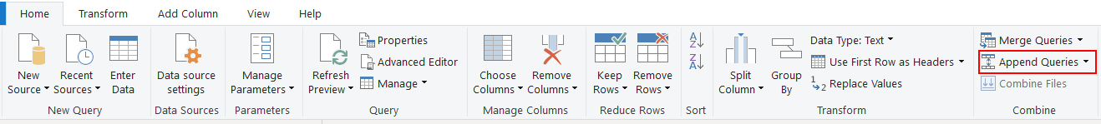

* 1. Make sure you select the corresponding tables (as below)

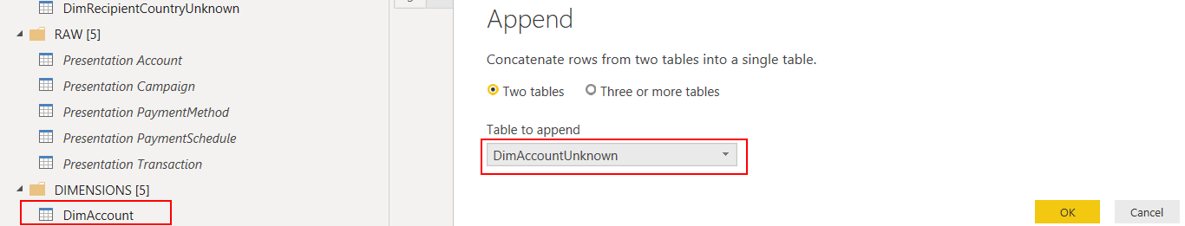

1. After appending your default record to your dimension, you’re almost done. For completion, you need to ensure that any remaining null values that appear in your dimension are replaced based on the strategy outlined in step 3b (above). Also ensure that you rename to ensure that they are user-friendly.

#### How to add a Fact table from a Presentation view

1. Create a reference table similar to the one created in step 1 of the previous section and move it under the FACTS folder. Rename the table in this manner {Fact}{EntityName}.
2. Remove the relevant attributes, similar to step 2a of the previous section, only this time the main focus should be on including additive data. Keep the pre-existing surrogate keys which were generated in Synapse Analytics as this will ensure the records are unique. In addition, keep the business keys as it will provide the necessary reference to join the temp table.

The next section covers how to relate fact and dimension tables together to create a star schema.

#### How to create a relationship between a Fact and a Dimension table

The pattern used to create this relationship relies on a temp table that contains the lookup values used to join back to the dimension table.

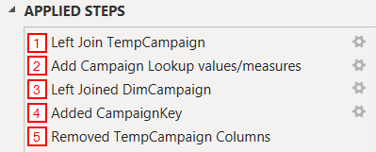

1. To carry out step 1, create a temp table. For that, create a reference table similar to the one created in step 1 of the previous section and move it under the TEMPTABLE folder. Rename the table in this manner {Temp}{EntityName}.

Make sure the temp table contains all the columns in the Dimension table as it will need to be mapped back at a later stage. In addition, retain the relevant business key, so that a left join from the temp table to the fact table can be applied.

1. Once the temp table is ready, merge it into the fact table by performing a left join. With the fact table selected, navigate to the home tab, and go to the combine section. Select Merge queries, and select the first option, merge queries.

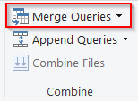

It is required to merge the fact table to the temp table based on the business key. The join kind used is Left Outer.

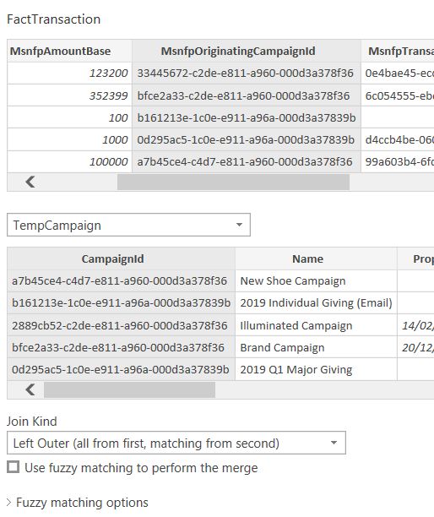

Once joined, expand the temp table.

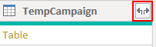

Select all the columns that will be used to link back to the Dimension table.

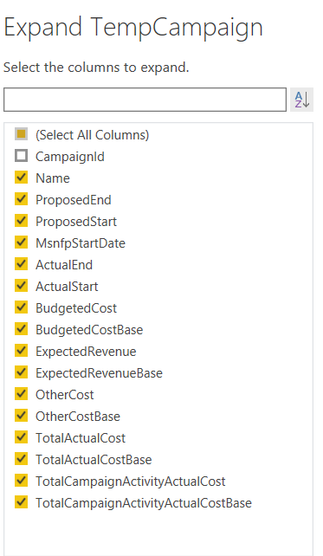

1. Perform another merge, this time to the Dimension table. The merge is based on the Lookup columns obtained from the temp table. The objective here is to obtain the primary key created in step 2c of the previous section.

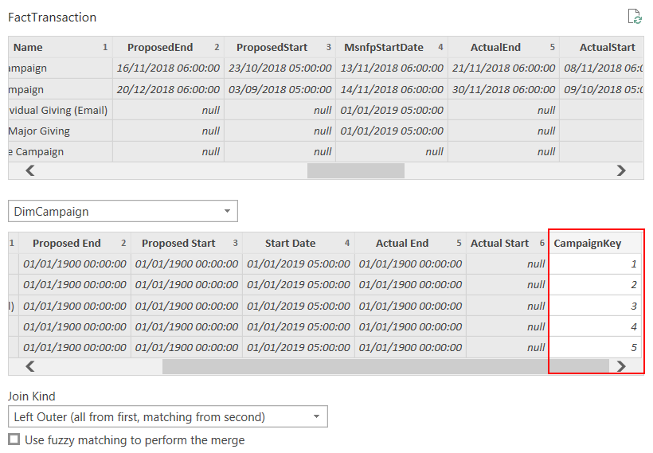

1. Once merged, simply retrieve the ActivityKey.

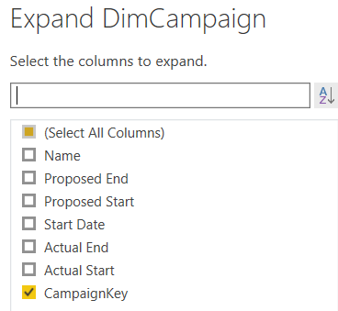

1. Remove all the Lookup attributes in the Fact table that were obtained from the temp table. You then need to replace any null keys with -1 so that they can link back to the default record created in step 3 under section 4.2.5.2
2. Finally Apply the changes as shown below.

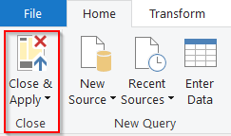

All that remains at this point is to create a physical relationship between the two tables (see below). Notice that the relationship has a one-to-many cardinality. As such, the filter propagates in one direction, from the dimension to the Fact. This allows to slice and dice the additive attributes in the fact table by the descriptive attributes in the dimension table.

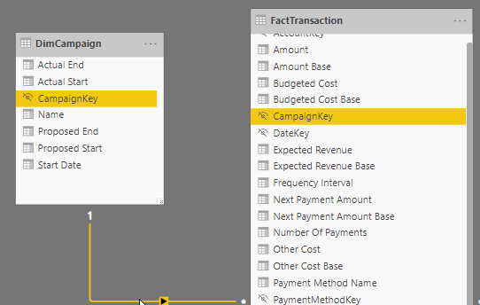

TIP 1: To enhance usability, hide any columns which don’t support analysis. This pertains to columns that contain keys or metadata. This reduces clutter as well as improve user experience

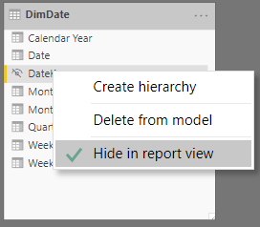

TIP 2: You can also enhance usability by hiding all the intermediary transformation tables used in the construction of the data model. This can be achieved by simply unchecking “enable load”. This reduces clutter as well as increases performance as the additional data in no longer loaded into memory, making the model more performant.

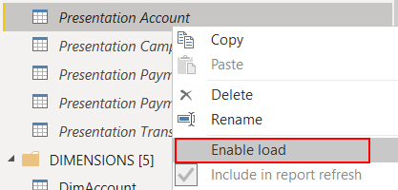

## Summary

This section demonstrated how to add organisational specific data sources into the solution. By this stage users should be able to add new entities to be ingested and transformed in the solution. Users should also understand how to add data into the Power BI model to enable access to data from Power BI reports.

# Power BI Dataflows and the Common Data Model

This section demonstrates how to enhance this solution with Power BI Dataflows and the Common Data Model (CDM). It starts detailing how to configure Dataflows and Azure Data Lake Storage (ADLS) in the Power BI Admin portal and how to configure Power BI workspaces to use dataflow storage to store the organisation data in the CDM format in ADLS. This is followed by covering how to leverage dataflows to integrate CDM data, either by attaching existing CDM folders or by connecting to Microsoft and third-party data sources and mapping the data to standard CDM entities. The section finishes with a detailed overview on how to connect to dataflows in Power BI Desktop, allowing users to create datasets, reports and dashboards based on the data stored in ADLS.

## How to configure Dataflows and Azure Data Lake Storage integration

### Connecting Azure Data Lake Storage for Dataflow storage

By default, data used with Power BI models is stored in the internal storage provided by Power BI. With the integration of dataflows and Azure Data Lake Storage (ADLS), it is now possible to store the dataflows in the organisation's ADLS account.

Please be aware that, at the time of writing, once a dataflow storage location is configured, it cannot be changed. For further considerations and limitations, follow this [link](https://docs.microsoft.com/en-us/power-bi/service-dataflows-connect-azure-data-lake-storage-gen2#considerations-and-limitations).

The deployment scripts already performed the initial required steps to allow ADLS to be configured as the Dataflow storage, namely:

* Grant Power BI Service a reader role in the ADLS Access Control (IAM)

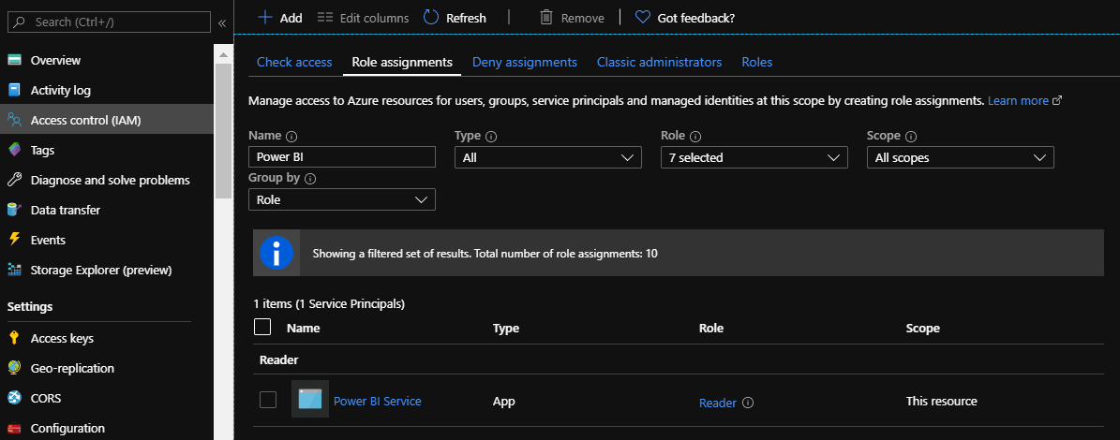

* Create an ADLS file system for Power BI named “powerbi“
* Grant Power BI permissions to the ADLS file system

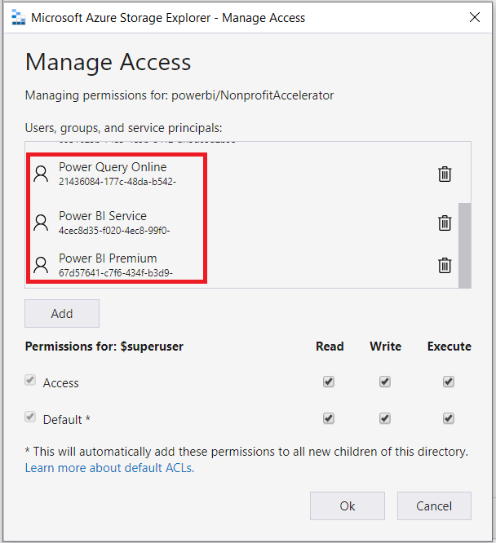

The next steps require Global Administrator permissions in the Power BI admin portal.

* Navigate to the Power BI Portal ([link](https://app.powerbi.com/home)), select the gear on the top right corner and open Admin portal

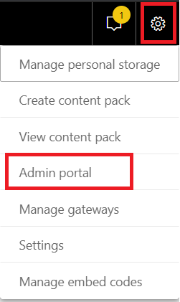

* Navigate to the Dataflow settings and select “Connect your Azure Data Lake Storage Gen2”

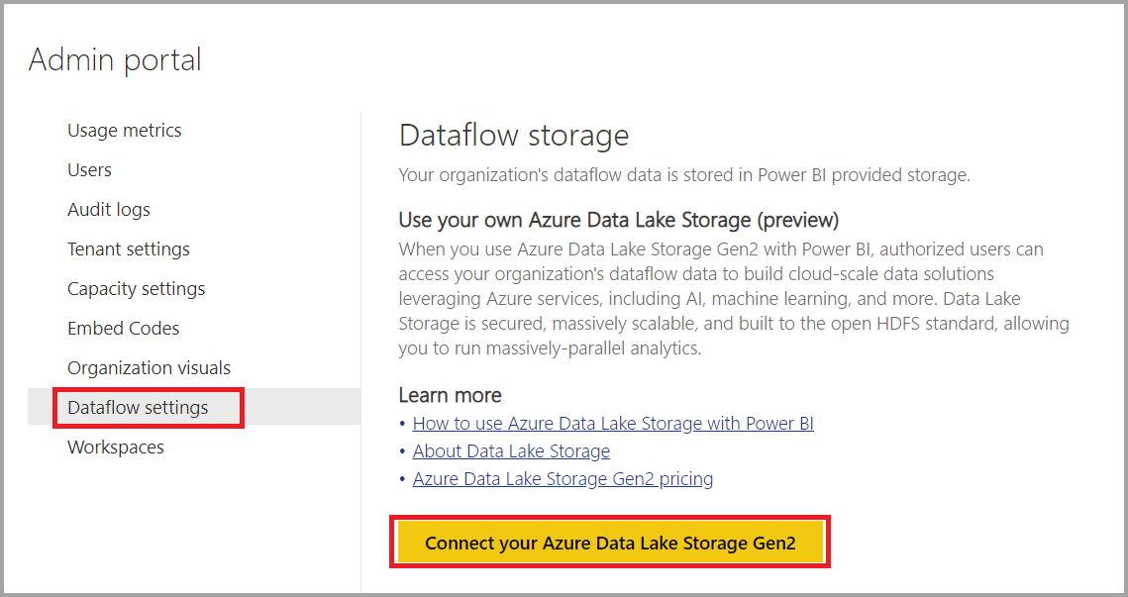

* Provide the requested details and select “Continue”

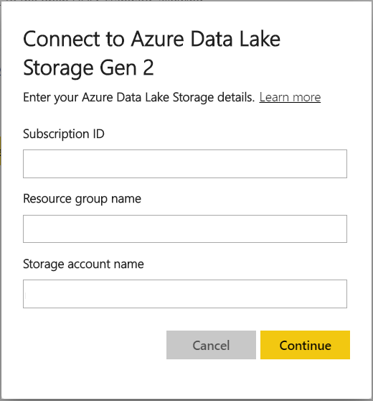

* By default, Power BI will allow workspace admins to assign workspaces to the storage account. If there is a need to have further control, set the setting to “Don’t allow”

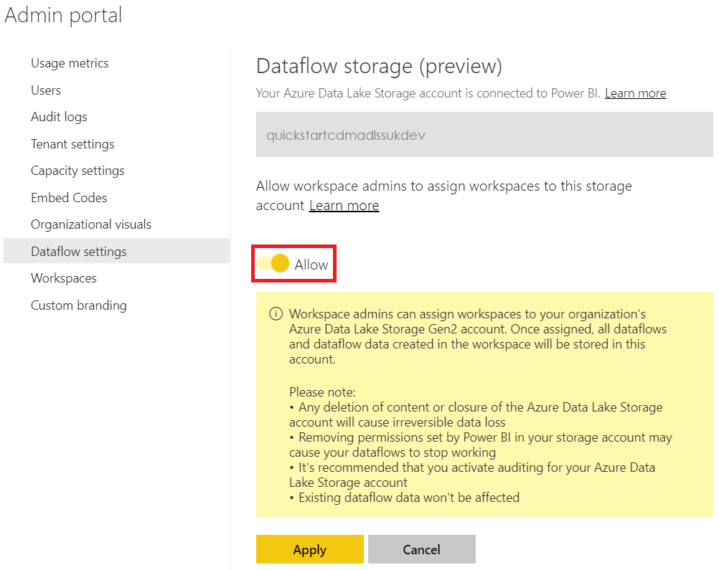

### Configuring workspace Dataflow settings

After the Dataflow storage is configured, the next step is to allow people in the organisation to configure their workspaces, which enables them to use the storage account for dataflow definition and data storage.

There are two ways to configure the workspace dataflow storage settings:

* During the creation of the workspace
* By editing an existing workspace

To create a new workspace in the Power BI service, select **Workspaces** > **Create workspace**.

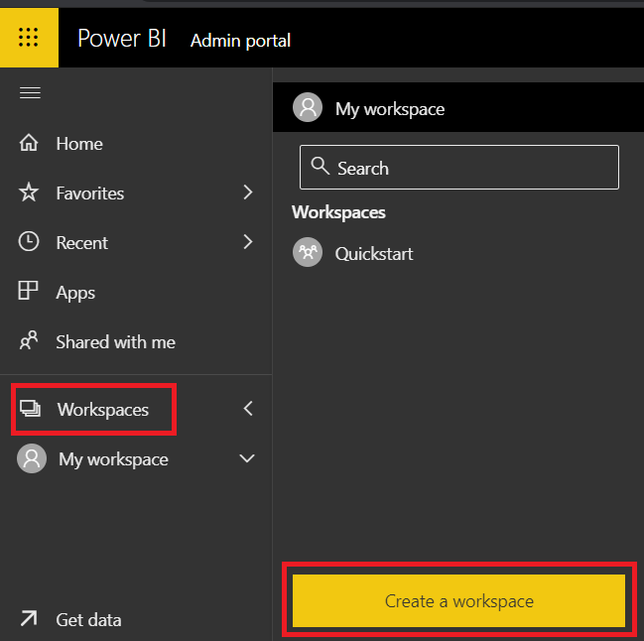

* Provide a unique name and expand the “Advanced” area.

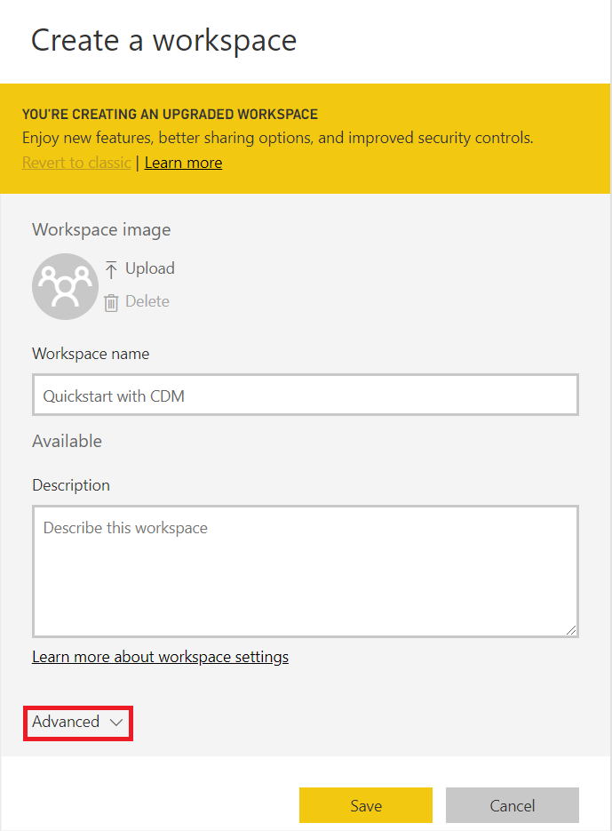

* Enable “Dataflow storage” and select “Save” to create the new workspace.

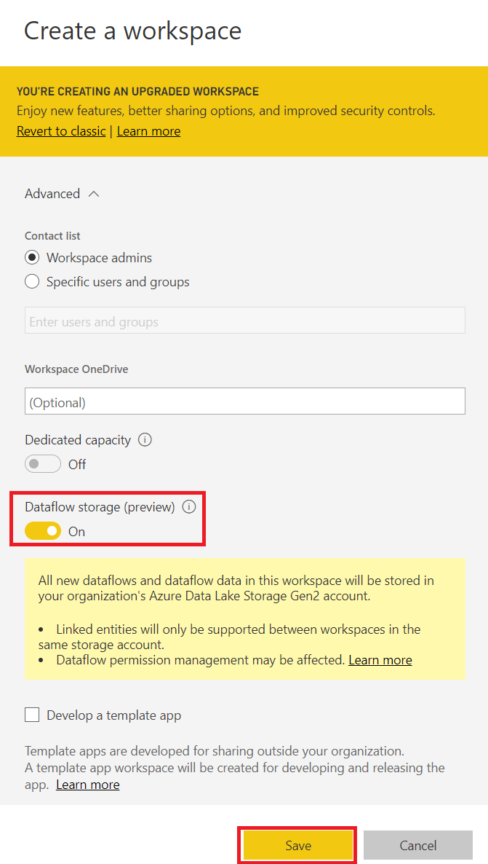

* To update the dataflow storage for an existing workspace, select **Workspaces** > **Workspace to change** > **Workspace settings**.

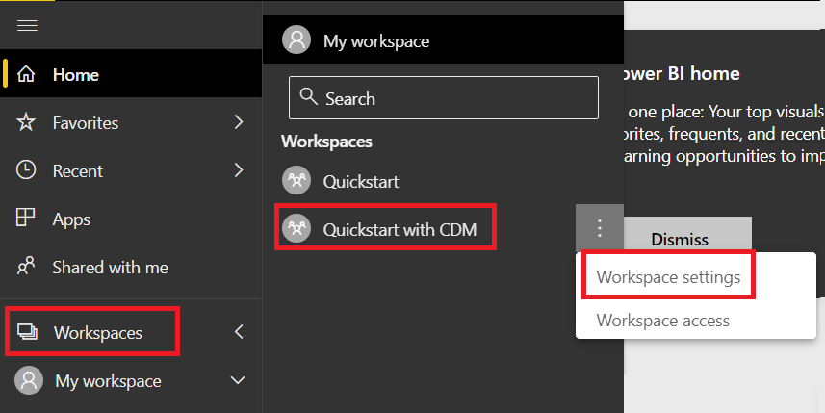

* Navigate to “Storage” and enable “Dataflow storage”

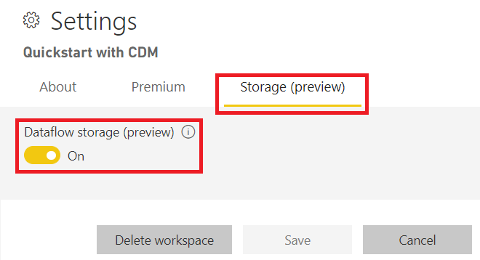

## How to map external data sources to a CDM entity using a Dataflow

Dataflows entities include new tools to easily map business data to the Common Data Model (CDM), enrich it with Microsoft and third-party data, and gain simplified access to machine learning. These new capabilities can be leveraged to provide intelligent and actionable insights into business data.

Dataflows can connect to a variety of data sources (E.G. entities managed by the Common Data Service (CDS)) and map the data to standard CDM entities or to define custom entities instead.

The following steps demonstrate how to connect to CDS, a service that securely stores and manages data that's used by business applications, and saves the data to ADLS in the CDM format.

* Navigate to the Power BI Portal, select a workspace that has been configured with dataflow storage and select **Create** > **Dataflow.**

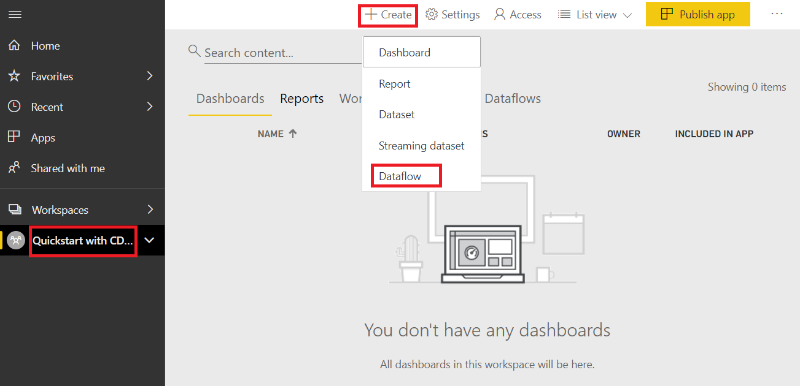

* Select “Add new entities”

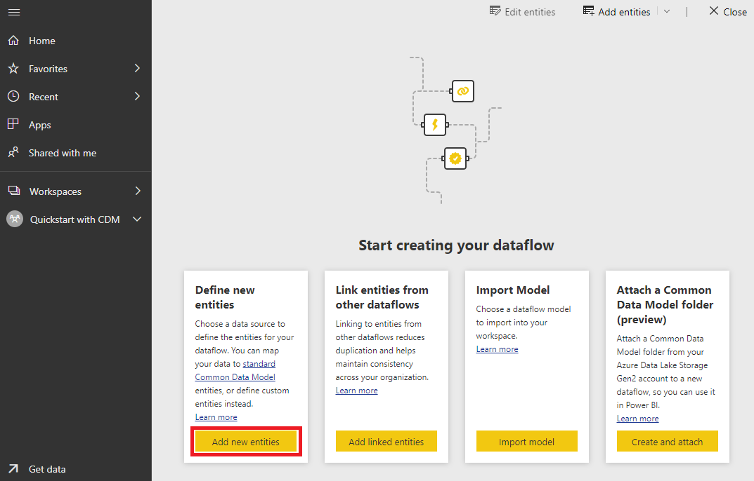

* Navigate to the “Power Platform” tab and select “Common Data Service”

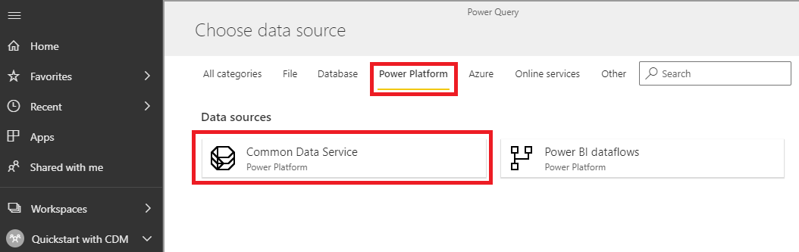

* Provide the “Server Url”, sign in with an account that has access to the application and select “Next”

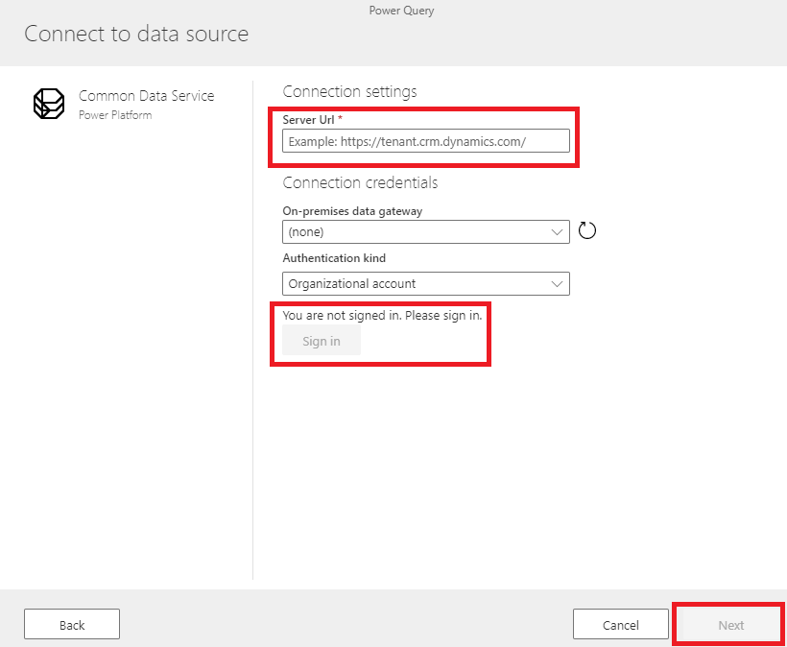

* Expand the “Entities” folder, select the entities you would like to include and click “Transform data”

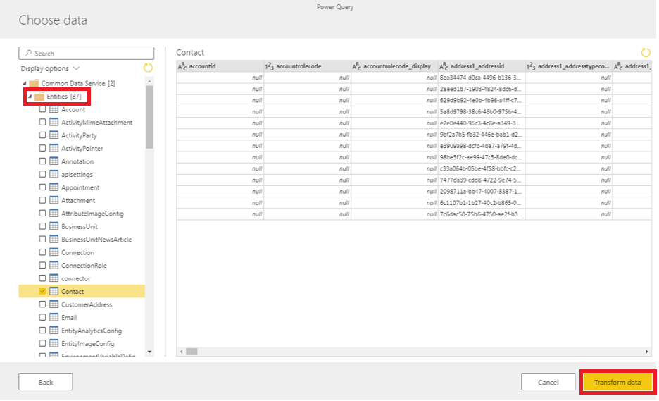

* This step gives the ability to apply different transformation actions using Power Query. In this example, no transformations are carried out. Select “Map to standard” to map the entity to a standard CDM entity

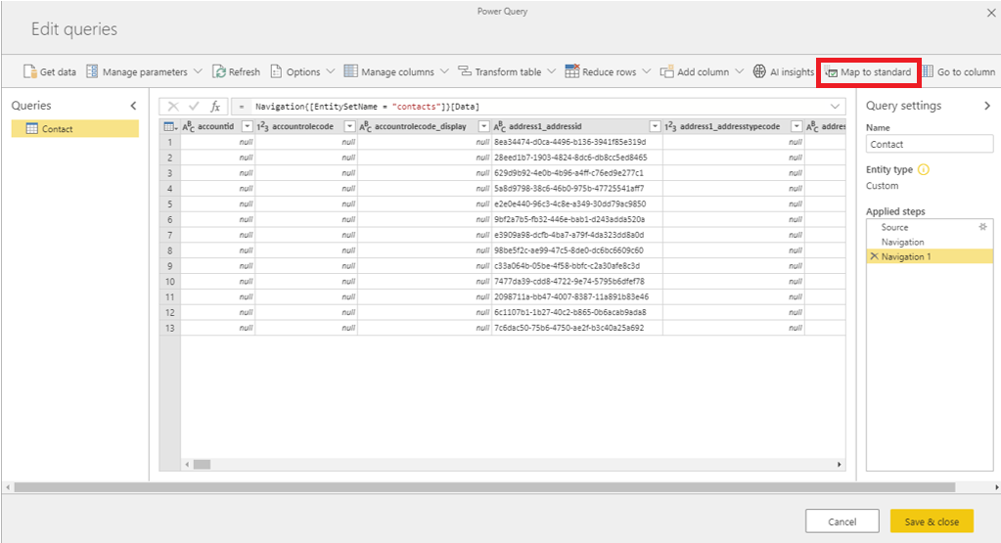

* Search for the required entity and select “Auto map”. This action will map the source entity to the standard CDM entity as long as the column names match. Alternatively, map each column manually. Select “OK” once the mapping exercise is completed

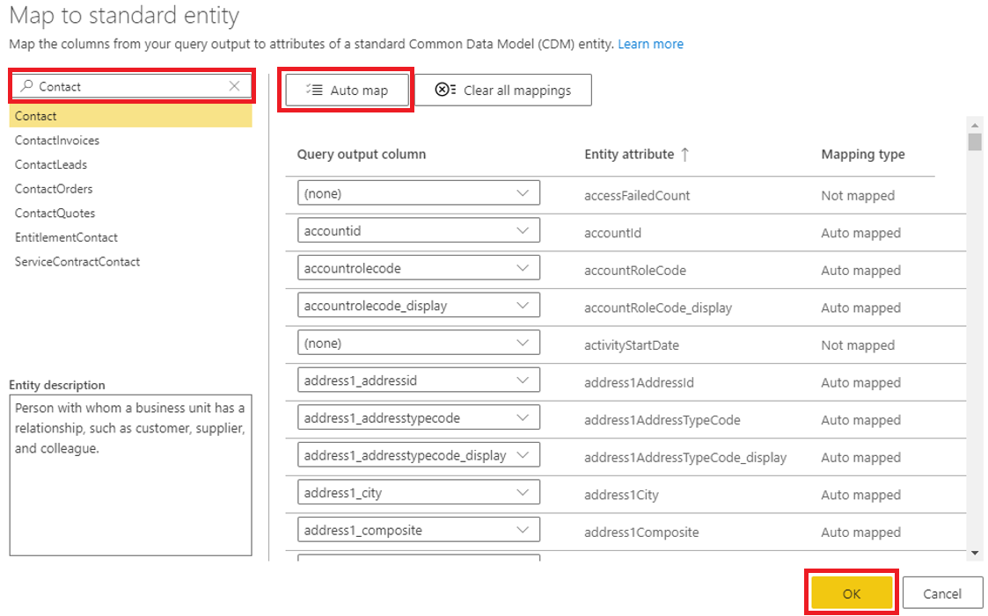

* Select “Save & close”, provide a name to the dataflow and select “Save”

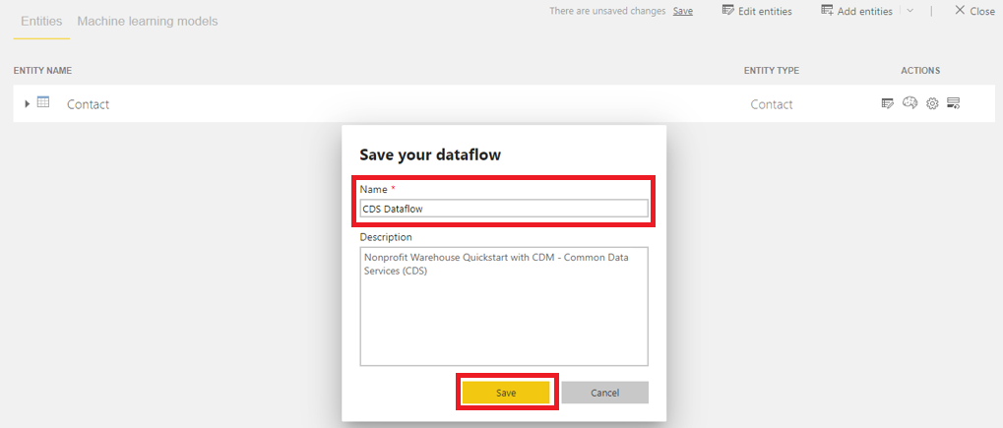

* Once the dataflow is created, Power BI offers the option to either “Refresh now” or to “Set a refresh schedule”. The first option will trigger an update and create the entity/entities in ADLS. The second option is required if there’s a need to frequently update the data by setting a schedule. If a schedule is not set, then the entity will have to be manually refreshed. These two options can be triggered right after the creation of the dataflow or later by navigating to Dataflows and selecting the required action.

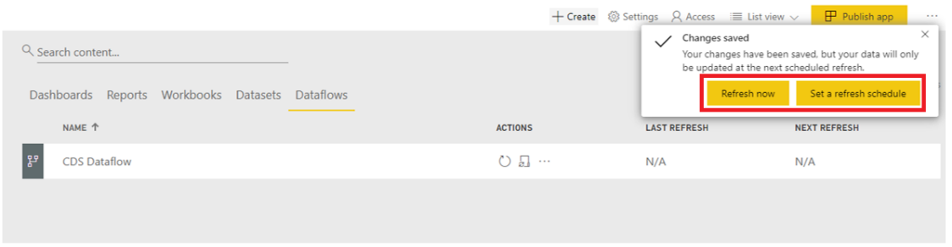

* To manually refresh the dataflow, select the circular arrow. To set a schedule, select the ellipsis and then “Settings”

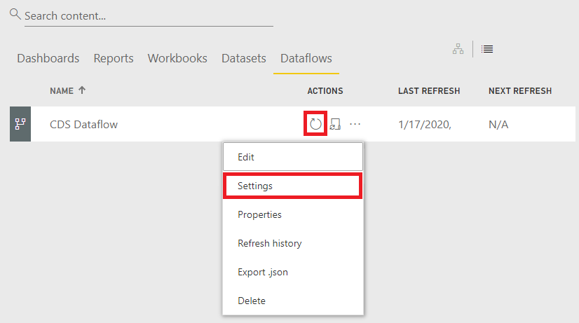

* Expand the “Scheduled refresh” area and select how frequently the data should be refreshed. Select “Apply” to confirm the changes

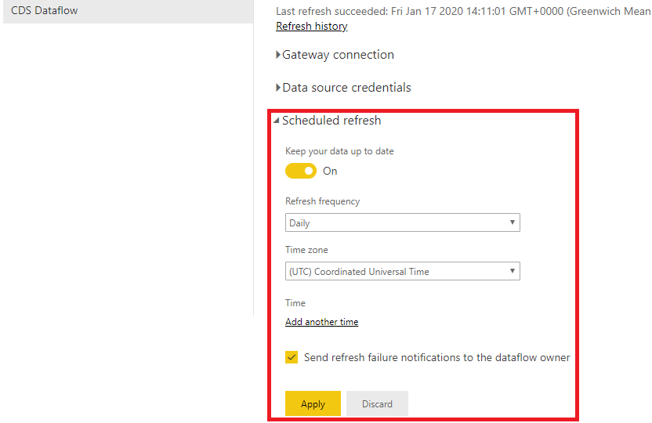

* Once the data is refreshed, a new CDM folder structure is created in ADLS. There are 4 levels:
  + Level 1 –Workspace folder. For each new workspace, a new folder is added at this level
  + Level 2 –Dataflow folder. For each new dataflow, a new folder is added at this level
  + Level 3 – Entity folders and model.json file. Each time the dataflow is refreshed, a snapshot of the model.json file is taken and added to the “model.json.snapshots” folder
  + Level 4 – Entity files. Each time the dataflow is refreshed, a snapshot of the entity file is taken. Snapshot files allow consumers to incrementally load the data and keep a history track

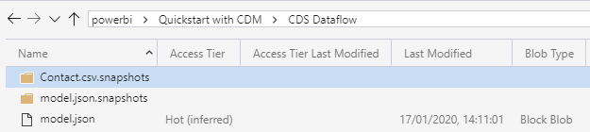

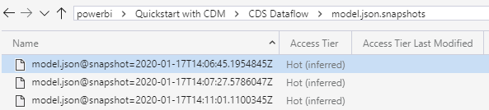

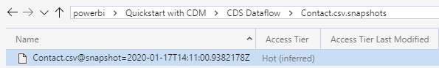

## How to add a CDM folder to Power BI as a Dataflow

In Power BI, it is possible to add Common Data Model (CDM) folders stored in the organisation’s ADLS as dataflows. Once created, the dataflow can be used to create datasets, reports and dashboards via Power BI Desktop or the Power BI Service. There are three important requirements to consider before attempting to attach a CDM folder:

* Creating dataflows from CDM folders is only available in the new workspace experience.
* Adding a CDM folder to Power BI requires the user adding the folder to have authorization for the CDM folder and its files.
* Read and execute permissions must be granted on all files and folders in the CDM folder, to add them to Power BI.

As previously covered in this document, upon deployment, a model.json containing a set of entities that form the Nonprofit Accelerator is uploaded to ADLS. This model contains metadata that allows Power BI to understand the structure of each entity and how it is partitioned in ADLS, however, the model is not completed until the location is provided. The partition section of the model.json should reference each csv file available within an entity. At the time of writing, it is not possible to use wildcards to specify multiple files.

The uploaded model.json file already contains a placeholder for the sample entities, however, the storage account name needs to be updated before attaching the CDM folder to Power BI.

* Using Azure Storage Explorer, navigate to ADLS and download the model.json

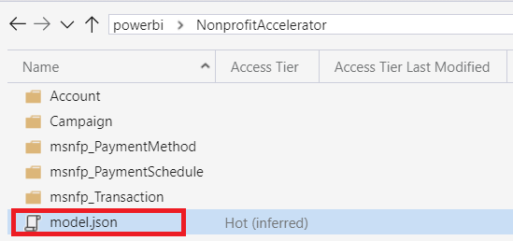

* Open the file with Notepad++ (download available [here](https://notepad-plus-plus.org/downloads/)) and select Ctrl + H to replace the placeholder with the name of the storage account.

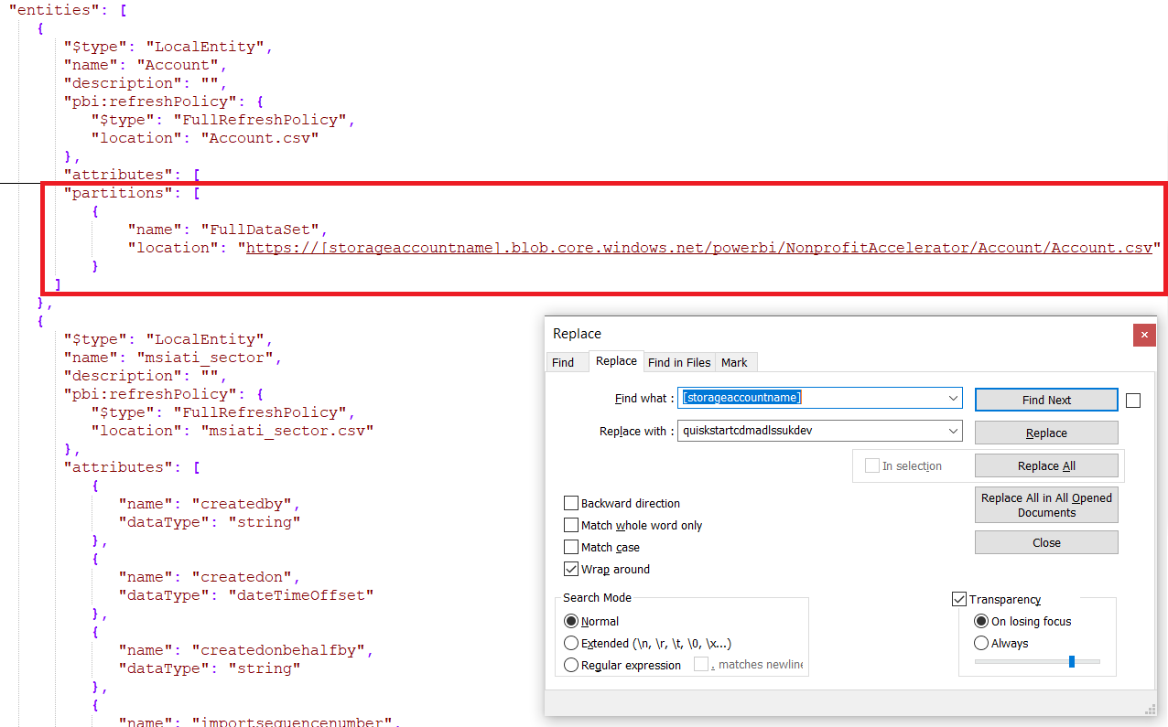

As demonstrated, the location attribute expects the Uri to the Account.csv file.

As the CDM folders are populated via Data Factory, the model.json must be updated manually every time a new entity is created/updated, I.E. either when a new csv file is added to an existing entity or when a new entity folder and file is created.

* Save the file and upload it to ADLS using Azure Storage Explorer. When prompted with the below window, select “Apply”.

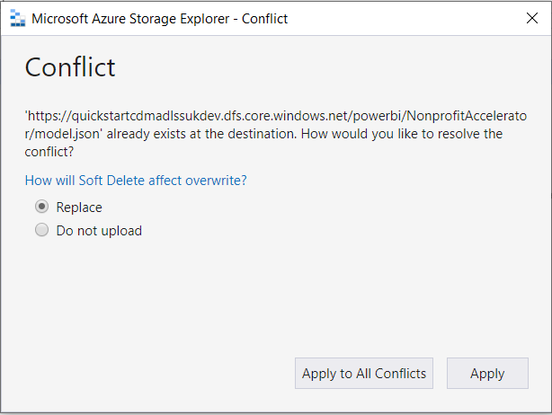

* Navigate to the Power BI Portal, select a workspace that has been configured with dataflow storage and select **Create** > **Dataflow.**



* Select “Create and Attach”

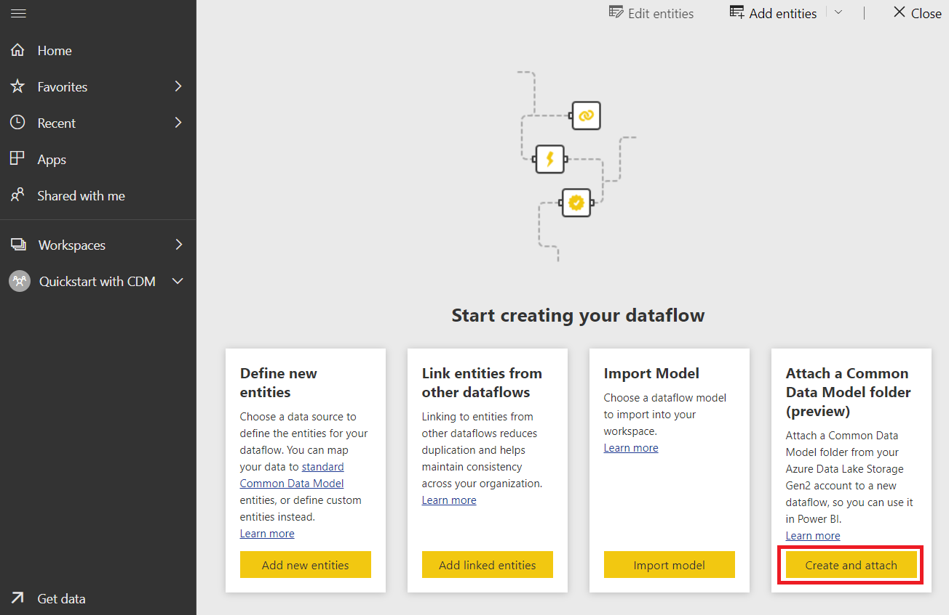

* Provide the details as demonstrated below and select “Create and attach”. The CDM folder path should be a Uri to the model.json file stored in ADLS.

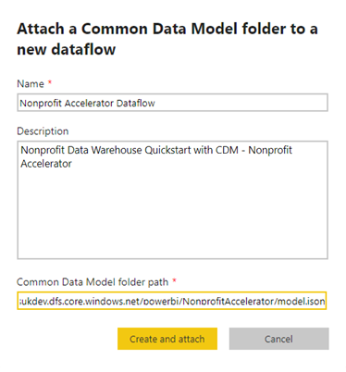

* Dataflows from CDM folders are marked with “External” icon when displayed in Power BI.

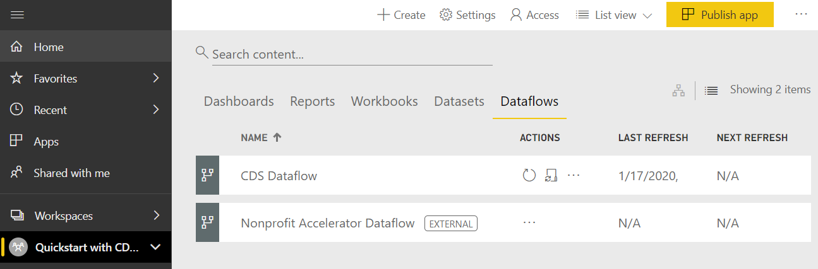

## How to connect to Dataflows in Power BI Desktop

A dataflow can be used in Power BI Desktop or Power BI service to create new datasets, reports and dashboards. To connect to a dataflow using Power BI Desktop follow the steps detailed below.

* Open Power BI Desktop
* Select **Get Data** > **Power BI dataflows**

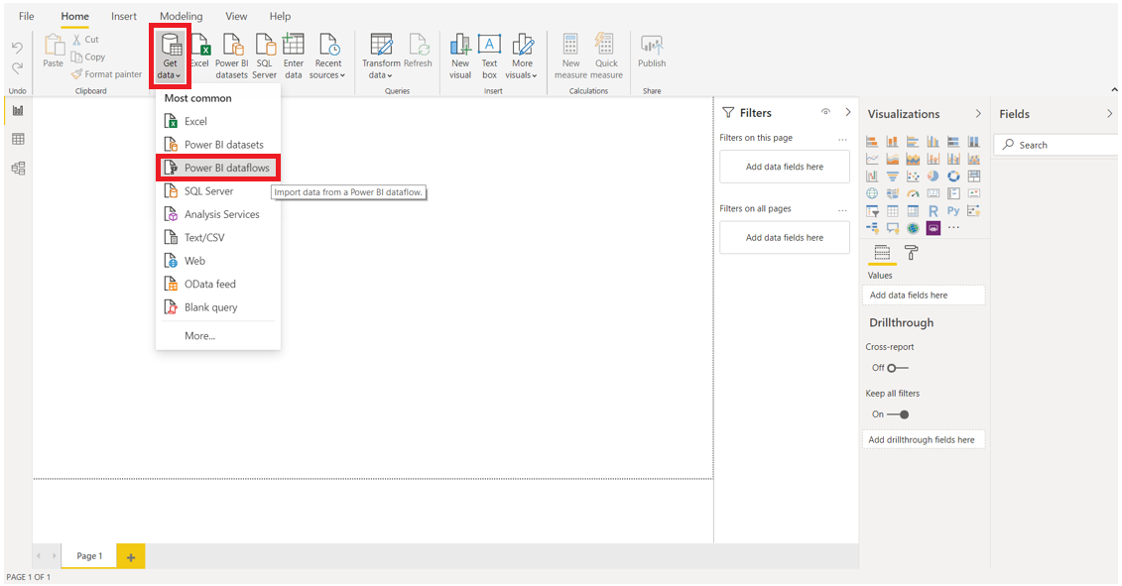

* Sign in with an account that has access to the workspace where the dataflow was created

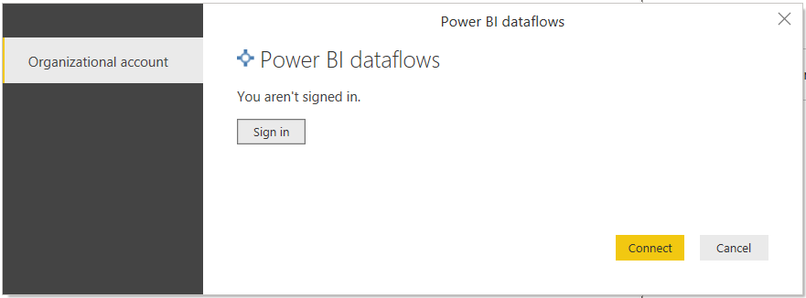

* Expand the folder structure and select entities accordingly. The data can either be directly loaded to Power BI Desktop or further transformed with Power Query (further details about working with Power Query can be found [here](https://docs.microsoft.com/en-us/power-query/power-query-quickstart-using-power-bi))

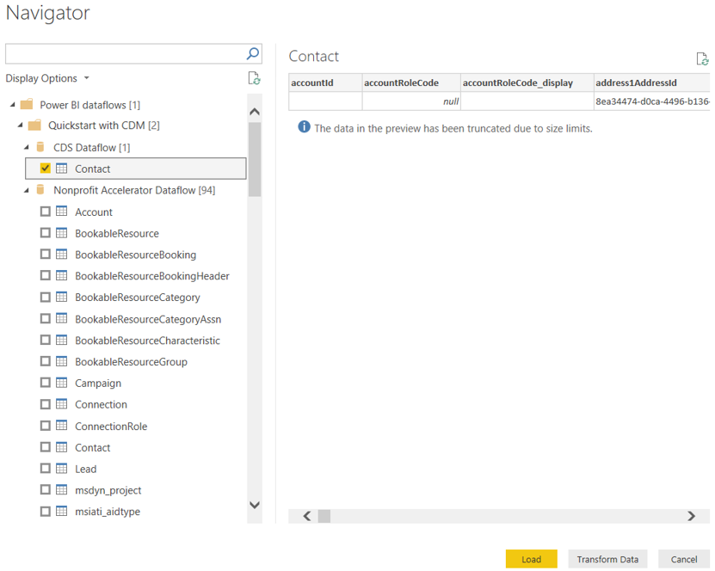

# FAQ’s

This section is going to cover topics that should help resolve questions Release Managers (or users taking on this role) may have when deploying the solution. It covers a variety of topics, including the most commonly seen issues that can be met during the deployment.

The solution has been designed and implemented with a focus on ease of use, seeking to allow a user with minimal experience of the Azure platform and its constituent technologies to be able to create a data analytics platform. However, there can be issues found in the deployment and use of the solution, due to the multiple resources being required to interact with each other in order to ingest, transform and present the data. Furthermore, there can be additional issues when making modifications to the solution, particularly for ingestion of user data.

To overcome this, this section will provide solutions to common issues that could arise, covering general issues, refreshing data within Power BI, removing resources from the solution, questions associated with the cost of the solution and finally problems with accessing the different resources within the solution.

## Resolving Issues

It is very common in a solution with multiple moving parts to encounter issues after the solution has been deployed.

### What are the most common execution issues

This section cover the most probable issues Release Managers may have after the deployment or when adding new source entities to the solution. It may help to resolve issues with Connection between resources, or to reset the solution to its original state if it gets broken after deployment.

#### Azure Data Factory or Synapse Analytics fails to connect to Azure Data Lake Storage

When Azure Data Factory (ADF) ingests data from Azure Data Lake Storage (ADLS) into Synapse Analytics, it uses the Managed Service Identities (MSI) of SQL Server and ADF MSI to authenticate to ADLS. There may be situations where this connection does not work correctly. The most likely cause is by missing permissions on the folder structure.

To inspect the folder structure permissions, follow the below steps:

1. Connect to Azure Data Lake Store Gen 2 with Storage Explorer and connect to “quickstart” (1) filesystem.
2. Navigate to the RAW (2) top level of the folder structure in the data lake, and check permissions by clicking “Manage Access” (4) on the Storage Explorer panel. Check if all MSI users and AAD Groups has been assigned to the folder
3. Navigate to the lower level of the folder structure in the data lake to check permissions via “Manage Access”, as before.
4. Check that the folder structure has the appropriate read, write or execute permissions as required.

Remarks:

Access – configure access to current folder.

Default – configure access to future subfolders - assign the same set of permissions as set on parent folder to all subfolders created after permissions have been assigned.

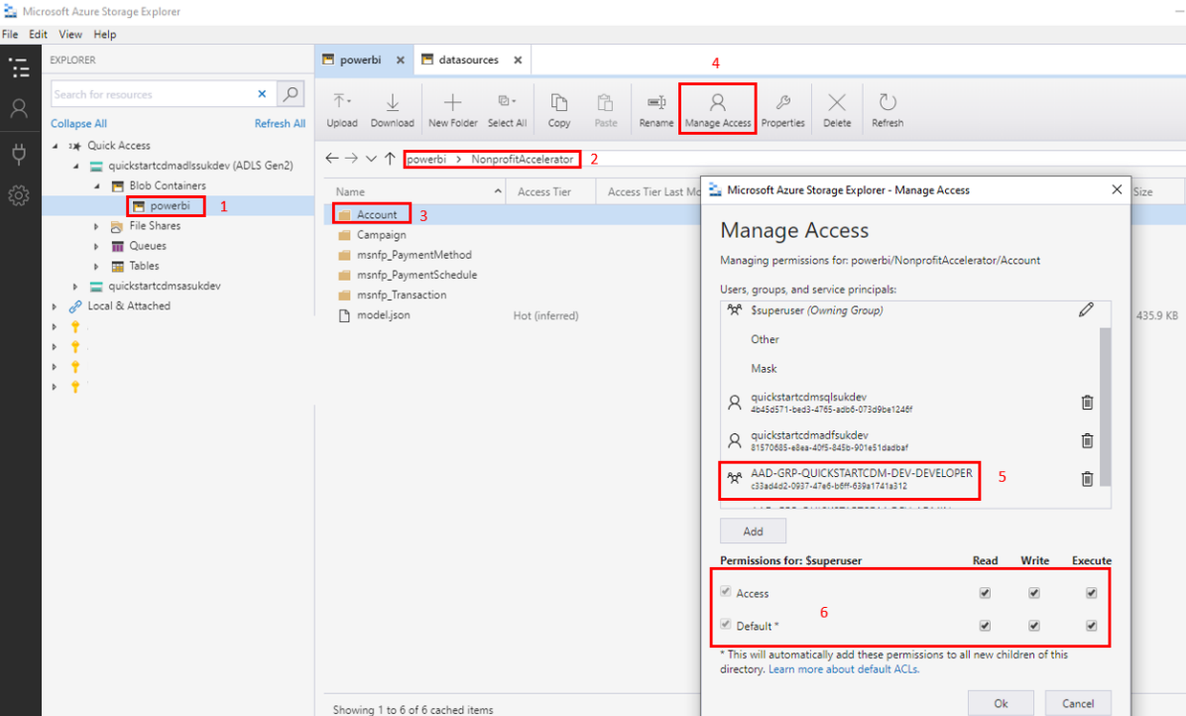

Permissions:

Read – permissions to read file and folder (require execute on itself and all parents to the root of the Azure Data Lake Store).

Write – permissions to write file and create folders (require execute on itself and all parents to the root of the Azure Data Lake Store).

Execute – permissions to list files in the folder.

#### Synapse Analytics fails to read data from Azure Data Lake Storage or records are being rejected

Data extracted to ADLS should conform with the Synapse Analytics External Entities.

Entity files present in ADLS should have:

1. The same number of columns as specified in Synapse Analytics External
2. Matching headers with the Synapse Analytics External Table (case sensitive)
3. Data types matching the types defined in Synapse Analytics Persisted Tables (e.g. Data that expects a decimal number should not have text characters present etc.)
4. Text columns wrapped with text qualifiers of a double quotation mark

If schema of the file does not conform, a failure may happen when reading the data. If the load of the data partially succeeds, then it is likely files are being rejected into the /RAW/{Entity}/_rejected folder in ADLS. This can be inspected with Azure Storage Explorer.

In order to manually check entity columns definitions, the external table definitions stored in Visual Studio should be compared with the extracted files in the Azure Data Lake Store. Files stored in ADLS are Parquet files with snappy compression applied, meaning they will not be human readable. These files can be viewed by using the ADF preview functionality on the dataset. A new temporary Parquet dataset is required to be created that points to the file under investigation.

Read operations should be executed in order to check if Synapse Analytics can access the Azure Data Lake Store, using the query “SELECT * FROM External.{*EntityName}*”. If the query returns results, and none of the records are rejected, then the problem is solved.

If data is rejected, it is likely that the data quality is low and data should be cleaned before processing.

#### Connection issues in Synapse Analytics

There may be situations where connection to the Azure Synapse Analytics is not possible. This may cause failure during various steps of the execution:

1. Azure Data Factory Execution.
2. Refreshing of the Power BI Reports.
3. Direct connection to Synapse Analytics.

If this happens, most likely Synapse Analytics is switched “Off”. In order to switch it “On”, the process described in paragraph called How to enable/disable Synapse Analytics via Azure Portal needs to be followed.

If this does not resolve the issues, ensure that the SQL Server the Synapse Analytics is hosted on has the correct IP Address configured in “Firewalls and virtual networks” tab.

In order to check and configure the IP address, follow the steps described below:

1. Navigate to Azure Portal by following this [link](https://portal.azure.com/#home).
2. Navigate to Resource Group where the solution is deployed.
3. Navigate to the SQL Server instance where Azure Synapse Analytics is deployed to.
4. Go to Firewalls and virtual networks tab (1).
5. Check if the Client IP Address (2) is in range of IP addresses listed (3). If it is in the list, the firewall is not blocking the connection.
6. If IP is missing then click “+ Add client IP” (4)
7. Click “Save” (5) button

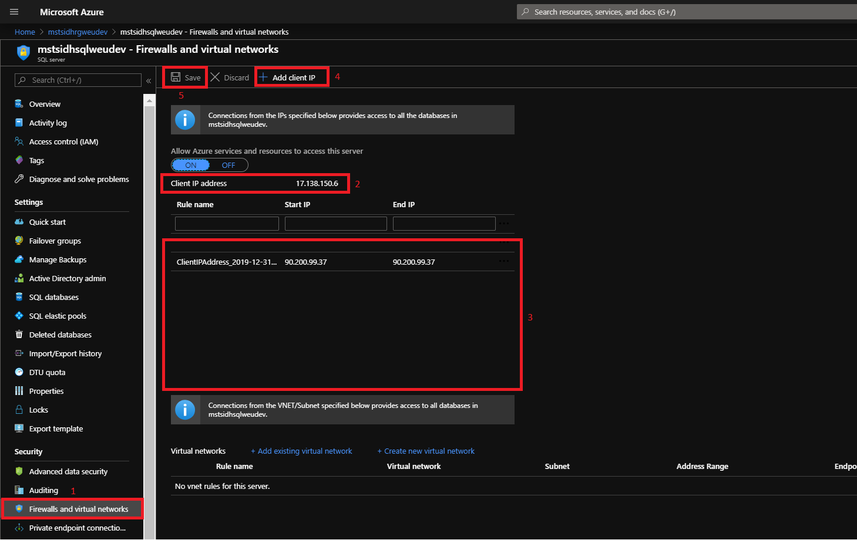

### How to reset the solution to the original state

The easiest way to reset the solution to its original state is to delete Resource Group, as described in section “Removing Solution Resources”, and re-deploy solution by following steps described in How to deploy from GitHub section, ensuring there are no deployment failures during deployment process.

## Data Refresh

### How to refresh Power BI report with fresh data

In a real life scenario, data processed by the solution may change or increase on a daily basis. Below steps will be necessary to be carried out in order for PowerBI reports to reflect the changes:

1. Connect to Azure Blob Storage with Azure Storage Explorer.
2. Upload new files to Blob storage.
3. Execute processing of the platform as described in “How to run the solution” paragraph.
4. Open Power BI PBIX report/Power BI Report deployed Quickstart with CDM workspace in Power BI Portal and refresh it – depending on which report we are trying to refresh it is going to require different refresh procedure. These process have been described below.

#### How to refresh a Power BI Report PBIX file

If the Power BI PBIX file is used to view the reports these steps need to be followed in order to refresh report data:

1. Navigate to folder where solution was downloaded.
2. Open Power BI report/Presentation/IatiAndWhoShowcaseReports.pbix.
3. Click the Refresh button.
4. Save the file.

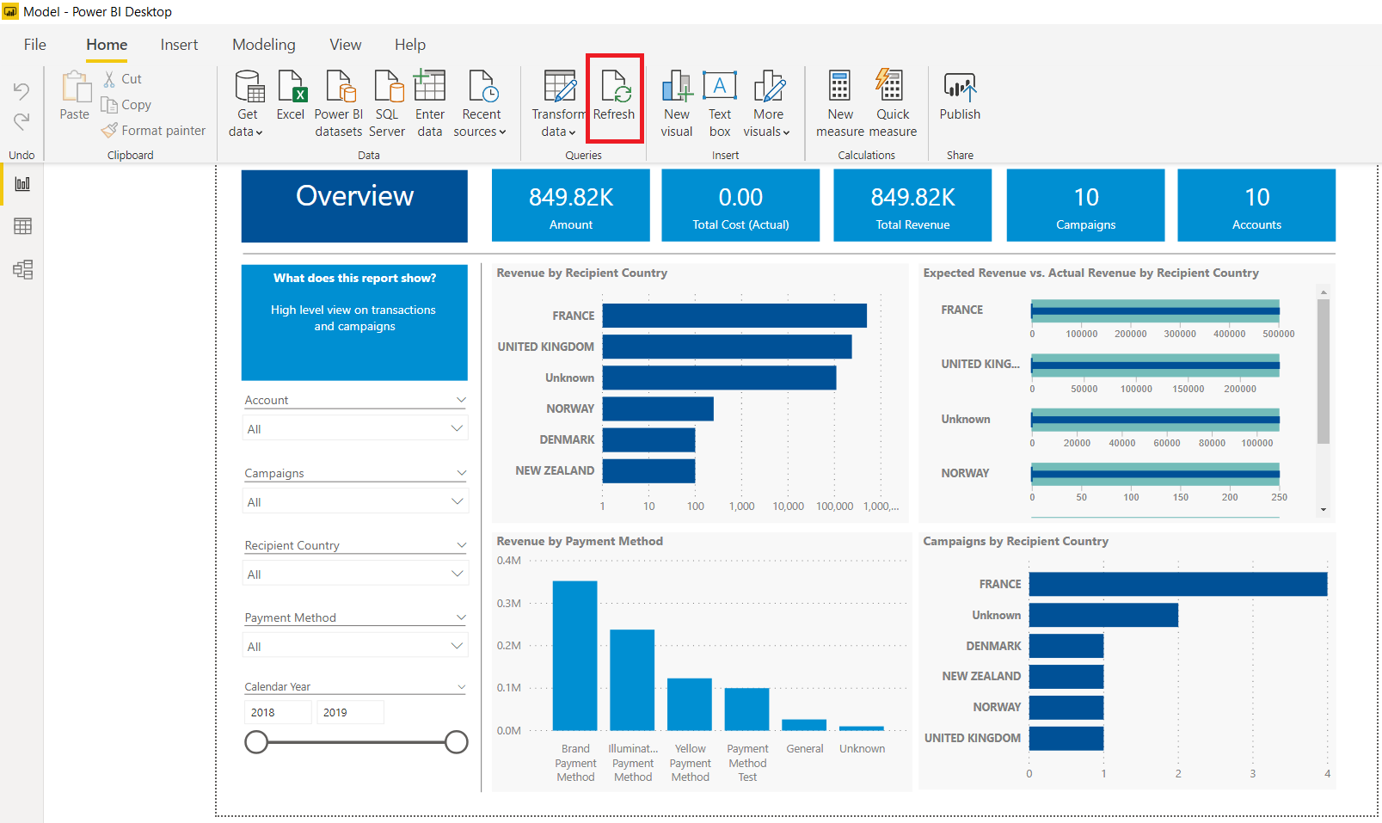

#### How to refresh a Power BI Report in the Web Portal

Reports that have been deployed into Power BI Portal can be refreshed without modifying the PBIX file. To refresh data, follow the steps provided below.

1. Login to Power BI.
2. Find workspace where Power BI report has been deployed (1).
3. Click on the active workspace (2).
4. Navigate to Dataset Tab (3).
5. Hit Refresh button.
6. Check refresh date stamp to ensure refresh has occurred (5).

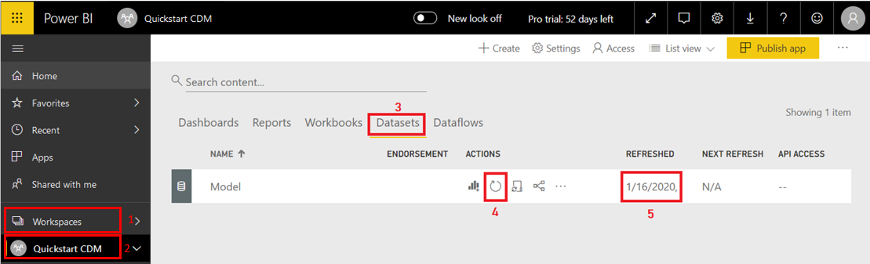

## Removing Solution Resources

### How to remove the solution from the Azure Portal

The solution can be completely removed by deleting the Resource Group where the solution is deployed. Please note that this operation is irreversible and will lead to data loss.

To delete the Resource Group, follow the steps described below:

1. Login to Azure Portal using the following [link](https://azure.microsoft.com/)
2. Navigate to the Resource Group where the solution is deployed.
3. Double check if the correct resource group has been chosen, and if resources that are present can be deleted.
4. Select Delete Resource Group (this operation is irreversible and will lead to data loss). Hit Delete Resource Group.
5. When the Deletion confirmation panel shows up - Confirm Deletion by typing the resource group name in the text box and accept delete.

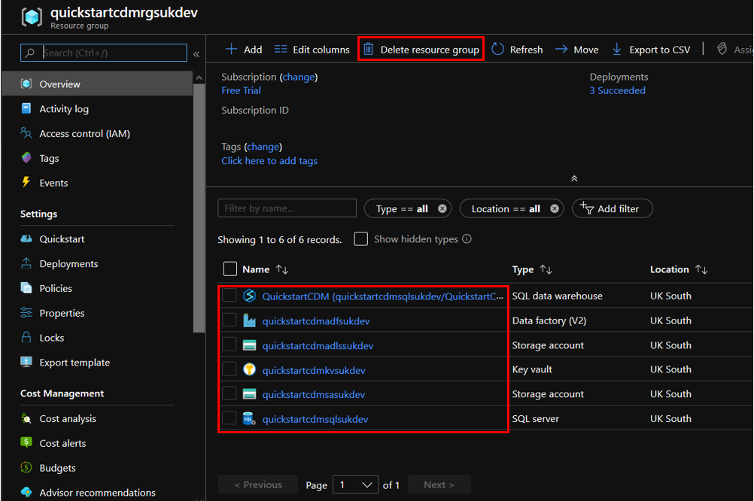

## Costs

Running costs are strictly dependant on the amount of data that is being processed and also on the duration of the execution.

There are two factors that have influence on the solution cost:

1. Storage – size of the datasets stored statically in Storage Account, Data Lake Storage and Synapse Analytics database.
2. Compute - processing time of the datasets and amount of entities processed (depends on the size of the data as well) – Synapse Analytics and Azure Data Factory.

Note: If users make architectural changes or add their own data to this solutions, costs may vary from what is outlined below.

The compute typically drives the majority of the costs. Storage is fairly inexpensive in comparison. The smallest billing unit for the most expensive resource (Synapse Analytics) will be a single hour, irrespectively of running 2 minutes or 59 minutes.

### What are the average running costs

Costs can be estimated using the Azure Pricing Calculator ([link](https://azure.microsoft.com/en-gb/pricing/calculator/)). The values provided below were based on the test datasets provided as a part of the solution. The cost remains around the same as the estimates below, as long as the data doesn’t grow beyond 10GB and execution time is no longer than 1 hour per day.

**Number of Sources:** 2

**Dataset Size:** 250MB

**Number of entities:** 26

**Average execution time with minimum compute capabilities (100 DWU):** 7 minutes

**Single Execution**: US$ 6

**Monthly:** US$ 226

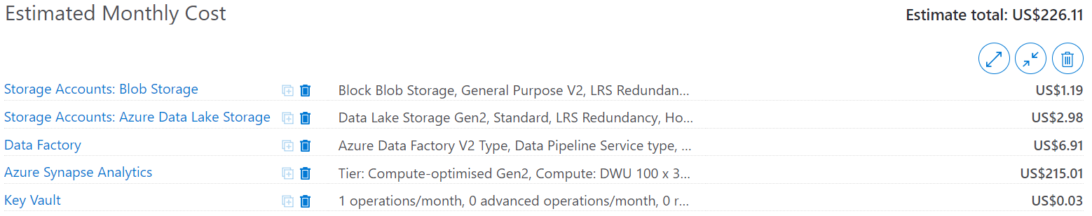

### How to minimize running costs

#### Running costs can generally be reduced on the compute side.

1. Expensive Compute Resources like Synapse Analytics should be “switched on” only when required:
   1. Deployment
   2. ETL process running
   3. Data being refreshed by Power BI report
   4. End users querying database directly
2. Limit the number of daily executions.
3. Allow incremental loads to reduce execution times.

## Accessing Azure Resources

### How to connect to Synapse Analytics

To obtain the Synapse Analytics connection details follow the below steps:

1. Login to Azure Portal.
2. Navigate to Key Vault.
3. Open Key Vault secrets tab and check for the relevant secret values:
   1. SqlServer-Name
   2. SynapseAnaytics-AdminLogin
   3. SynapseAnalytics-AdminPassword
   4. SynapseAnalytics-Name
4. Open SQL Server Management Studio (SSMS) and hit “Connect” or press the “F8” key.

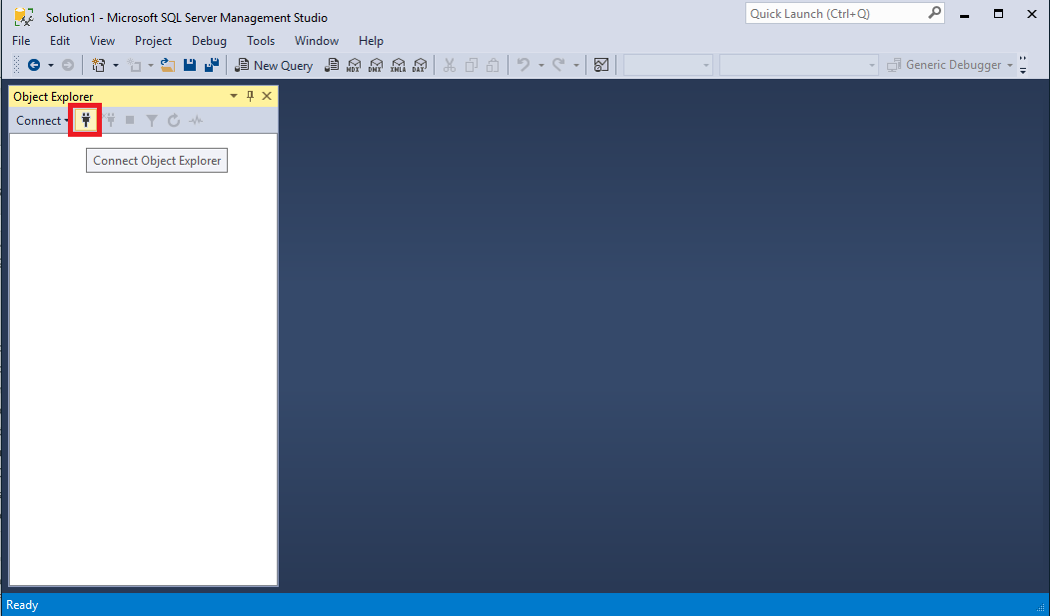

1. Provide connection details as demonstrated.

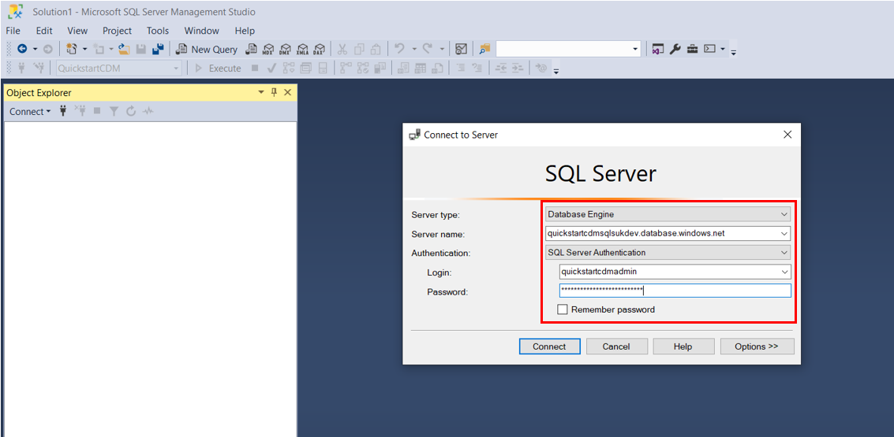

Provide values from Key Vault in the format specified below. Curly brackets means that this value needs to be manually obtained from Key Vault.

**Server name:** {SqlServer-Name}.database.windows.net e.g. mstsidhsqlweudev.database.windows.net

**Authentication:** Sql Server Authentication

**Login:** {SynapseAnaylytics-AdminLogin}

**Password:** {SynapseAnalytics-AdminPassword}

1. The database can be specified in the Option tab although it is not mandatory for admin users.
2. Click “Connect”– Database will be visible in the Object Explorer. If the Object Explorer is not available then go to Menu/View/Object Explorer or press “F8”.

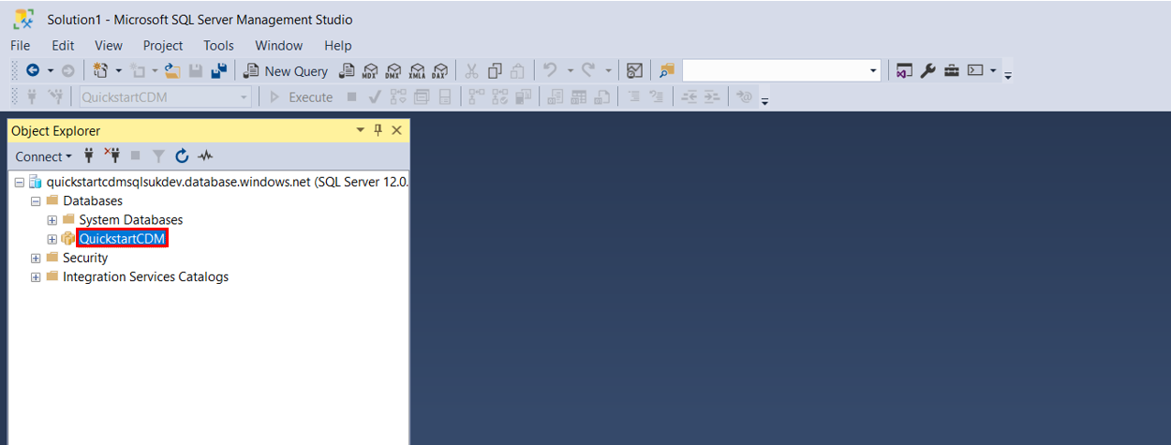

### How to obtain secrets from Key Vault

To obtain values from Key Vault follow the below steps:

1. Login to the Azure Portal.
2. Navigate to Key Vault.
3. Navigate to Secrets (1).

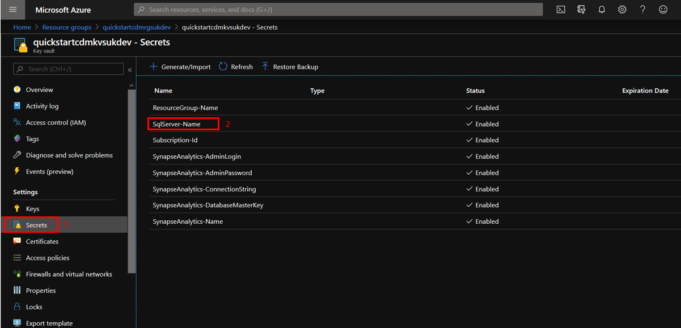

1. Navigate to the latest version of each secret - To check a secret value, left click on the name of the secret e.g. SynapseAnalytics-AdminPassword (2) and then left click on the hash of the current version.

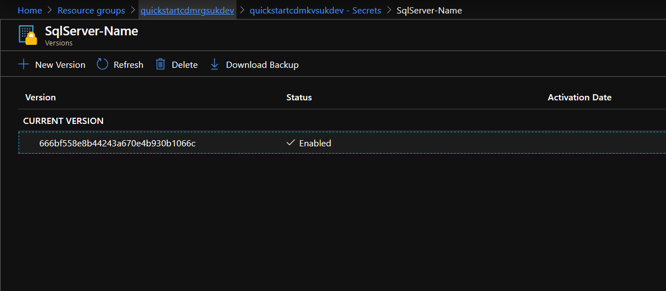

1. When the secret window is open, left click “Copy to clipboard” as indicated on the image below.

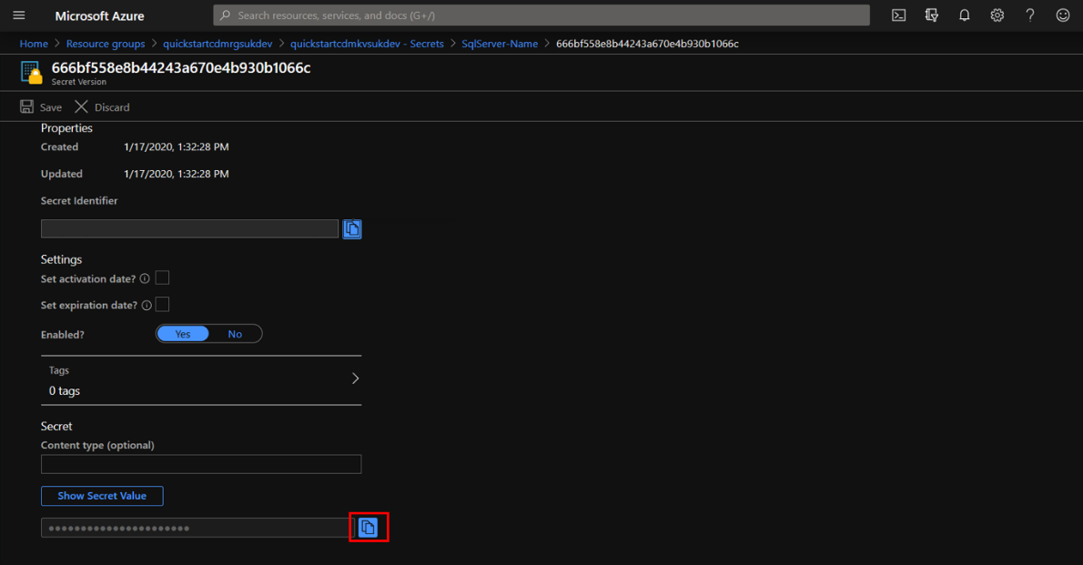

## How to add new Nonprofit Common Data Model (CDM) Entities

One of the most valuable benefits of the Nonprofit Data Warehouse Quickstart is its integration with the nonprofit industry developed and Microsoft governed Nonprofit Accelerator and Nonprofit Common Data Model (CDM). Today, Nonprofit Data Warehouse Quickstart contains only a few sample data entities from the Nonprofit Accelerator. It’s important to note that the included model.json file contains all 1300+ entities from the Nonprofit CDM, meaning that any nonprofit administrator consuming the Nonprofit CDM has the capacity to read the model.json file, become familiar with the existing entities and data model structure (if they don’t physically exist in ADLS as a CDM folder), and build their Quickstart environment from this model.

To add Nonprofit Common Data Model entities to ADLS, start by creating a new folder with the name defined in the model.json:

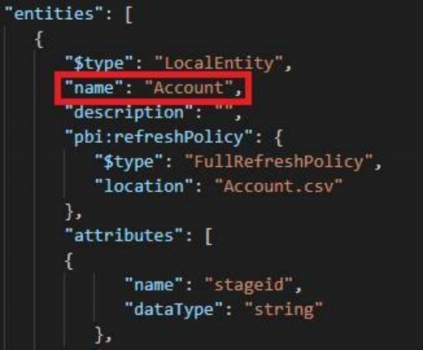

Next, add a partitions property after the attribute’s property, which allows consumers to understand how the entities are partitioned. At the time of writing, it is not possible to use wildcards, therefore, each file within an entity must be added. If this step is not performed, consumers will only return the metadata available in the model.json and no data will be loaded.

The example below demonstrates how the partitions property is structured. Each partition should have a descriptive name and a location with an entity file Uri.

<https://[storageaccountname].[blob].core.windows.net> – The ADLS Uri. The placeholder [storageaccountname] should be replaced with the name of the ADLS resource.

powerbi – the name of the container. This name can’t be changed. Doing so will block CDM Producers to populate ADLS.

NonprofitAccelerator – Root folder

Account –Entity folder

Account.csv – Entity file

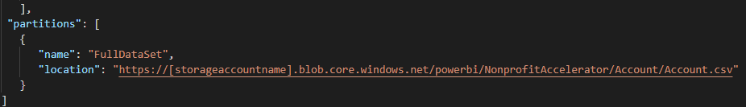

The Nonprofit CDM also has a far wider breadth of entities outside of the Nonprofit Accelerator that can also be utilised. See here ([https://docs.microsoft.com/en-us/common-data-model/](https://nam06.safelinks.protection.outlook.com/?url=https%3A%2F%2Fdocs.microsoft.com%2Fen-us%2Fcommon-data-model%2F&data=02%7C01%7CErin.Mchugh%40microsoft.com%7Cbfd9e729f84149fc859a08d7a0f0bb0a%7C72f988bf86f141af91ab2d7cd011db47%7C1%7C0%7C637154829121362552&sdata=7q5WLZ6xYN5Fmxvs1tB829hNzuFasmnos0v2hcrtMJM%3D&reserved=0)) for more details on the full scope of the CDM.

To understand how to extend the Nonprofit Accelerator with other entities and integrate them in the solution, refer to the section 5.2.2. How to configure Azure Data Lake Storage.

## Summary

This section covered the most frequently asked questions, including how to resolve issues with the platform and understanding factors that impact solution costs. For issues not described in this document, please seek help on the GitHub site for this project or online Azure Resource documentation.